Comparing Cells and Organisms
There are tiny, nearly invisible organisms everywhere in water. When conditions are right for them, they are very numerous. When the water is dirty, they die and become scarce. Some of these organisms have only one cell. They are called protists. With its single cell a protist does everything that you do in order to keep alive.
There are seven processes that all living things do. They must respire, digest, grow, move, respond to stimuli, excrete and reproduce. If something does not do even one of these processes it is not considered to be alive.
A one-celled protist moves. It eats. It breathes. It excretes wastes. It reproduces. It senses what is going on around it. There are all the functions that all living things must do.
Cilia mouth opening food vacuole
Cytoplasm nucleus cell membrane
Contracting vacuole waste opening
Like other cells, a protist has a cell membrane, cytoplasm and a nucleus or several nuclei. Because the protist has to do everything with its single cell, there are many other structures within the cell.
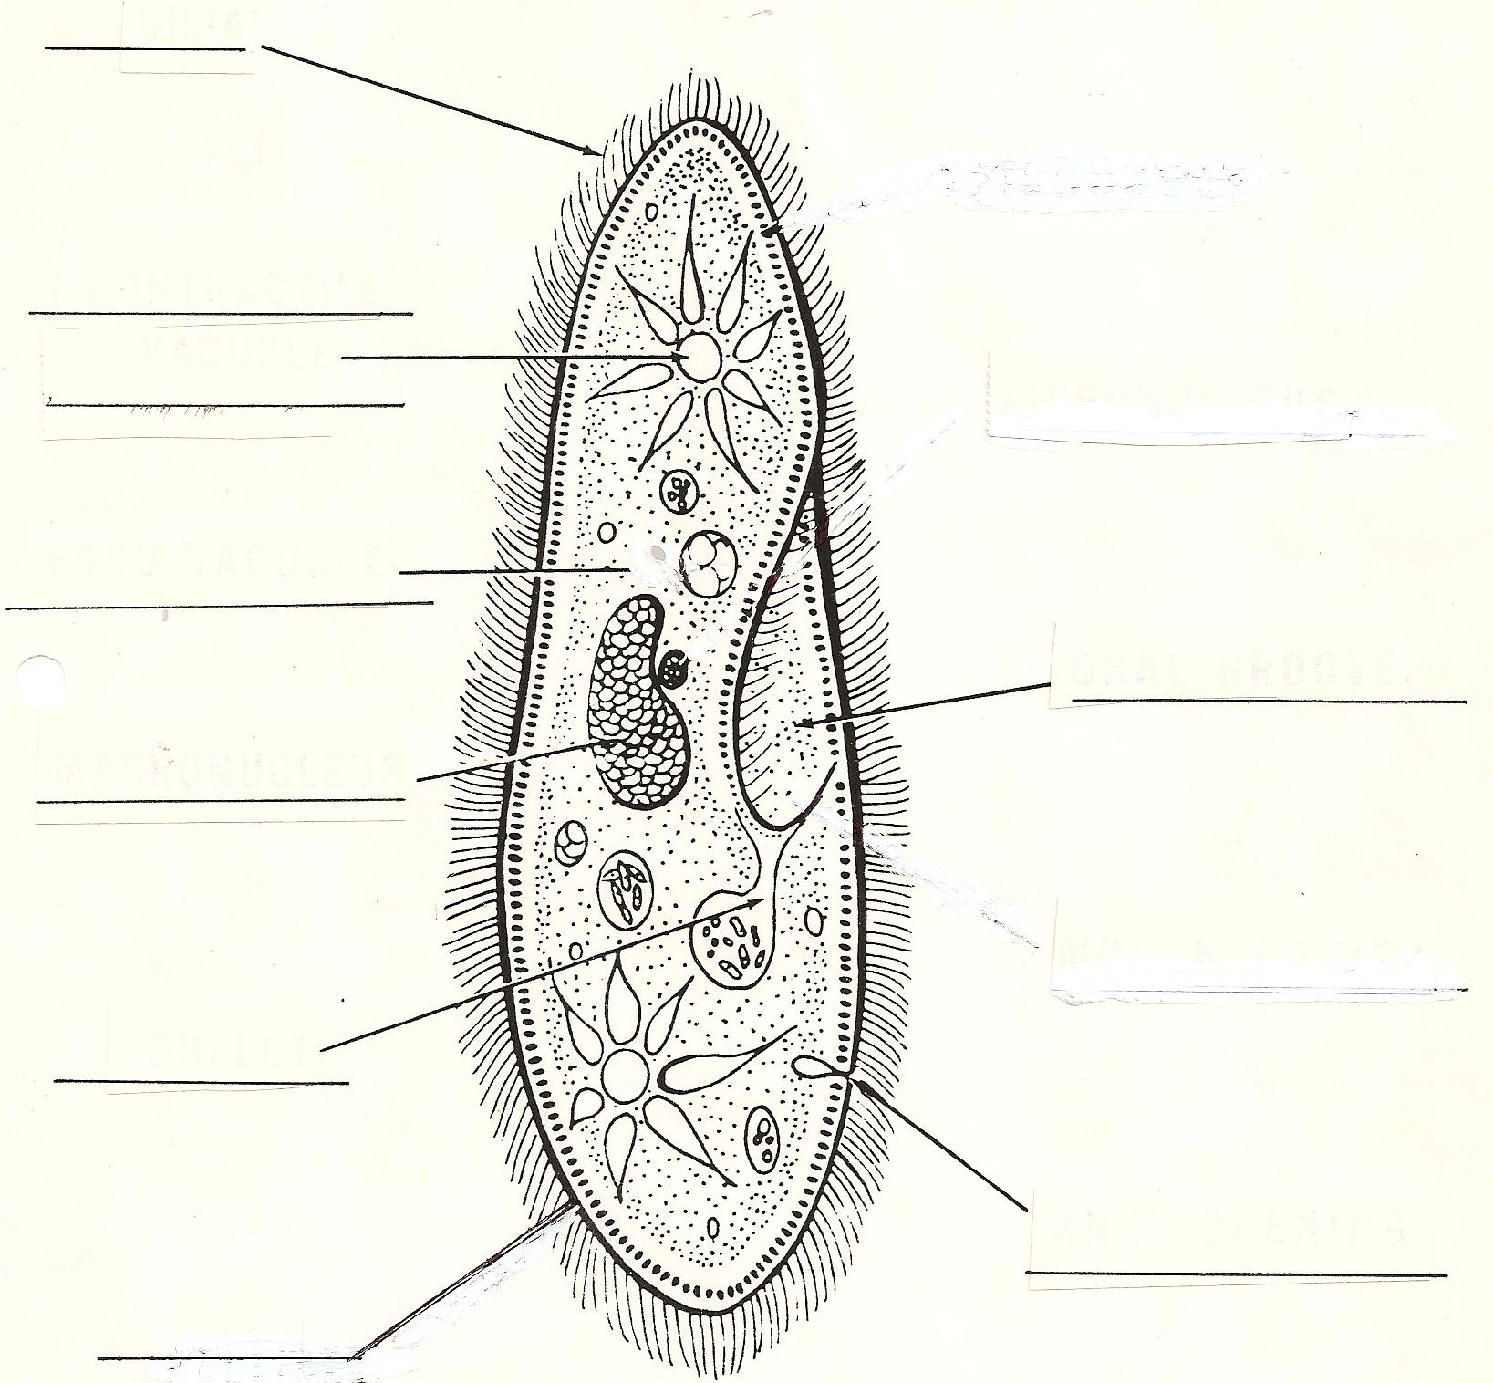
Read the descriptions of the protists below. Match them with the pictures. Write the name of the protist on the line.
- The euglena has a whip like structure to help move in the water.
- The paramecium is slipper shaped and has short hairs to it move in the water.
- The amoeba looks like a blob of jelly.
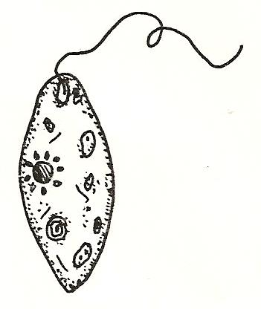
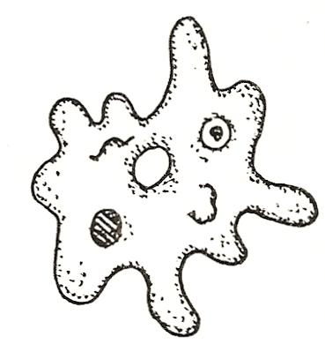
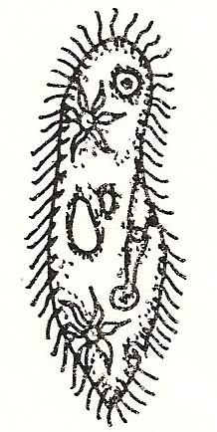

__________ ___________ ____________

Paramecium is one of the most common protists. However, making it hold still long enough to examine it is not easy. Look at the picture below and find the tiny little hairs called cilia. It swims with the cilia. It also spins, bends and flops around.
Paramecia also eat with their cilia. They sweep food into their mouth opening and into bubbles called vacuoles. The food is digested in these vacuoles. Then the vacuole bursts and the wastes pass out. Notice the star-shaped vacuoles. They are called contracting vacuoles. They fill with water and then squeeze the water out.

Label the following structures of the paramecium.

The amoeba has no definite shape and no cilia. It moves by stretching out “false feet” and flowing into them. This shapelessness helps the amoeba eat. The amoeba flows around bacteria, smaller protists, or small plants. The amoeba encloses the food in a vacuole and digests it.

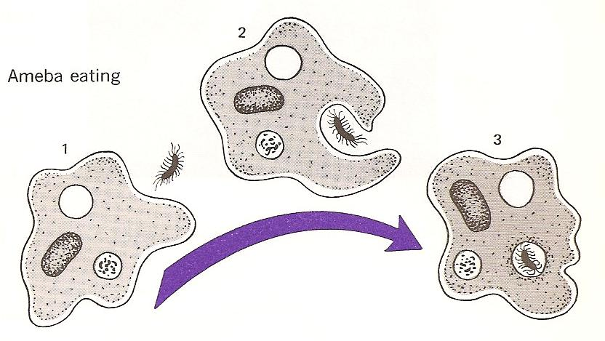

Identify and label the following structures in the amoeba;

Nucleus cytoplasm food vacuole

The euglena swims by twirling a long whip called a flagellum that stretches out in front and pulls it through the water. The protist is very colorful. It has green chloroplasts just like a plant cell. With these chloroplasts it can make its own food. It also has a red eyespot that helps it detect light.

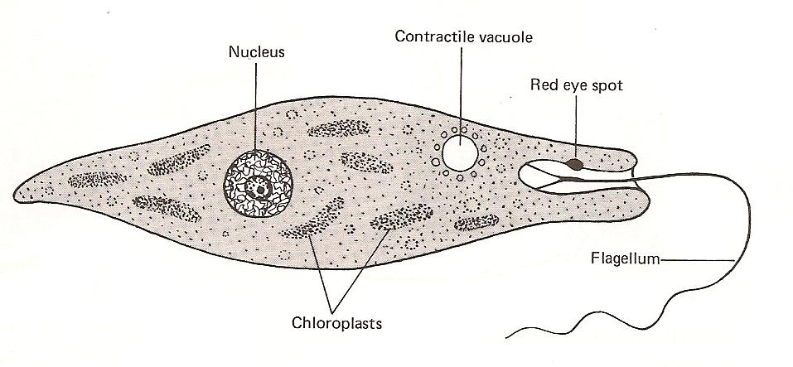

Color the chloroplasts green and the eyespot red.

Materials: prepared slides of paramecia, amoeba and euglena, depression slides, cover slips, live cultures of each protist, microscope, lens paper

What To Do:
1. Set up your microscope.
2. Observe each of the prepared slides of the protists.
3. Draw and color what you observe below.
4. Be sure to label each circle with the name and the magnification.

___________ __________ __________
___________ __________ __________

5. Make a wet mount slide of the live culture.
6. Draw what you observe in the circle below.

___________
Questions:
1. How does the paramecium eat? _______________
2. How do other organisms such as humans eat? ____
3. What structure in the euglena allows it to sense light?
_________________
4. How do other organisms such as humans sense light?
__________________________________
5. How do protists get rid of wastes? _____________
6. How do other organisms such as humans get rid of
wastes? __________________________________

Name ________________ period ______
EXIT TICKET
Comparing Cells and Organisms
1. Which of the following functions do all organisms share?

A. They make their own food
B. They must get rid of waste material
C. They must hunt and chase their food

2. How are the amoeba, paramecium and euglena similar?

A. They all move the same way.
B. They all get their food the same way.
C. They all carry on the same functions as other
living organisms.

3. How is the euglena different from the paramecium?

A. It can make its own food.
B. It can move.
C. It can get rid of waste materials.

4. Which structure in each cell controls the functions?

A. Chloroplasts
B. Cytoplasm
C. Nucleus

5. Which of the following structures is NOT used for
movement?

A. Cilia
B. Flagellum
C. Chloroplast

Name ________________ period ______
EXIT TICKET
Comparing Cells and Organisms
1. How is the euglena different from the paramecium?

A. It can make its own food.
B. It can move.
C. It can get rid of waste materials.

2. Which structure in each cell controls the functions?

A. Chloroplasts
B. Cytoplasm
C. Nucleus

3. Which of the following structures is NOT used for
movement?

A. Cilia
B. Flagellum
C. Chloroplast

4. Which of the following functions do all organisms
share?

A. They make their own food
B. They must get rid of waste material
C. They must hunt and chase their food

5. How are the amoeba, paramecium and euglena
similar?

A. They all move the same way.
B. They all get their food the same way.
C. They all carry on the same functions as other
living organisms.

