Learning About Genetics

When a baby is born, the parents, families and their friends try to determine whom the baby looks like. Chances are good that the baby will look a little like both parents. That is because parents pass their characteristics to their offspring. The process of passing genetic instructions from parent to offspring is called heredity. The scientific study of heredity is called genetics.
The shape of a baby’s nose and their hair color are traits. Traits are an organism’s physical characteristics. Genetic materials in its cells control an organism’s traits. The genetic material is found in structures called chromosomes, which are located in the nucleus of the cell. Chromosomes control an organism’s inherited traits. Each chromosome is made up of segments called genes. Each gene governs a specific trait such as the shape of your chin and the color of your eyes.

Juan, Peter and Andy are humans. They are about the same age. They all have traits that humans share. Yet, they are different from one another.
What To Do:
1. Look at the descriptions of the traits for each picture.
2. Match the boys with their descriptions.

1. Juan is short and thin. He has dark,
straight hair and light-brown skin.
Which drawing shows Juan? _______
2. Peter is tall and heavy. He has dark-
brown skin and dark curly hair.
Which drawing shows Peter? _______

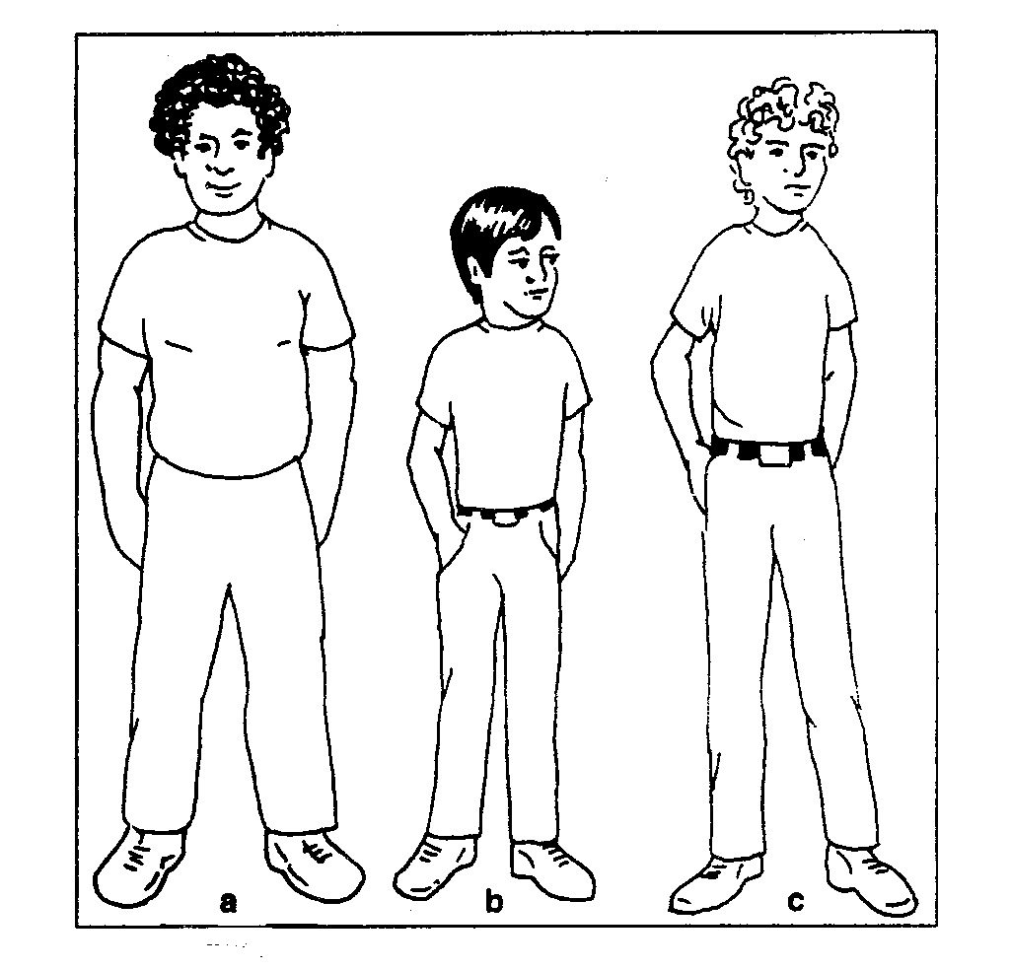

3. Circle the traits listed below that Andy has.
Tall short light skin dark skin curly hair
straight hair thin heavy

Plants also have traits they share and are different from one another. The picture below has two different types of pea pods. They have similar and different traits.
What To Do:
1. Match the statements below to the peas.

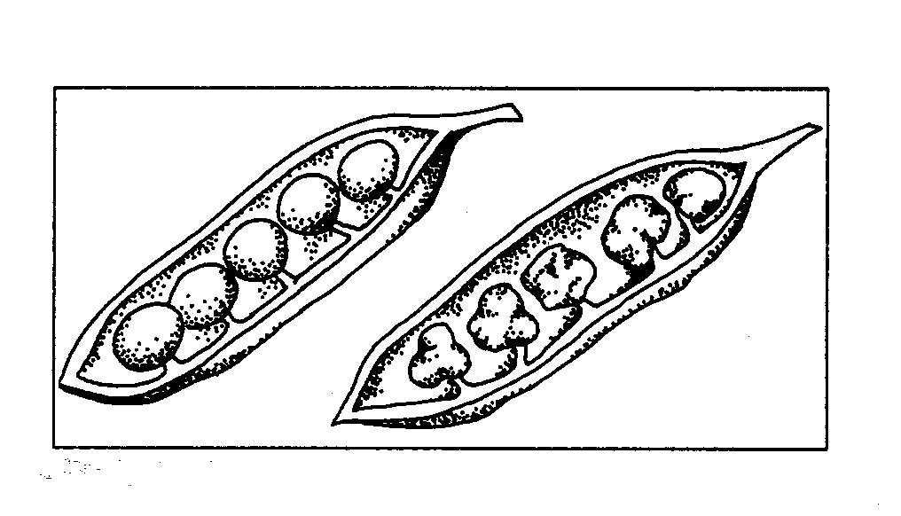
1. Peas are smooth. _____
a
b
2. Peas are wrinkled. ____
3. Has 5 peas. __________
4. Peapod looks like a boat.
__________

We inherit our traits through the chromosomes passed to us by our parents. The chromosomes are found in the nucleus of the cell. In body cells, chromosomes are found in pairs. Each kind of organism has a specific number of chromosomes. For example, every body cell of the human has 46 chromosomes (23 pairs) and the garden pea has 14 (7 pairs). We receive half our chromosomes from our mother and half our chromosomes from our father. All of the chromosomes except the last two of any organism are called autosomes. The last two chromosomes are called the sex chromosomes. These last two chromosomes determine the sex of the organism.

Along each chromosome there are many dark bands. Each band is a small part of a chromosome called a gene. There are many, many genes, at least one million in every nucleus. Genes determine the traits of an organism.

The picture to the right shows a representation of a pea plant’s chromosomes with bands of genes. Each chromosome has an exact match in length and location of
the genes (dark lines and bands).

1. Draw lines to the chromosomes that match
each other.
2. If the last two chromosomes match each other the
pea plant is a girl. If the last two chromosomes do
not match each other the pea plant is a boy.

Question:
1. Is this plant a boy or a girl? __________
2.Why? ____________________________________

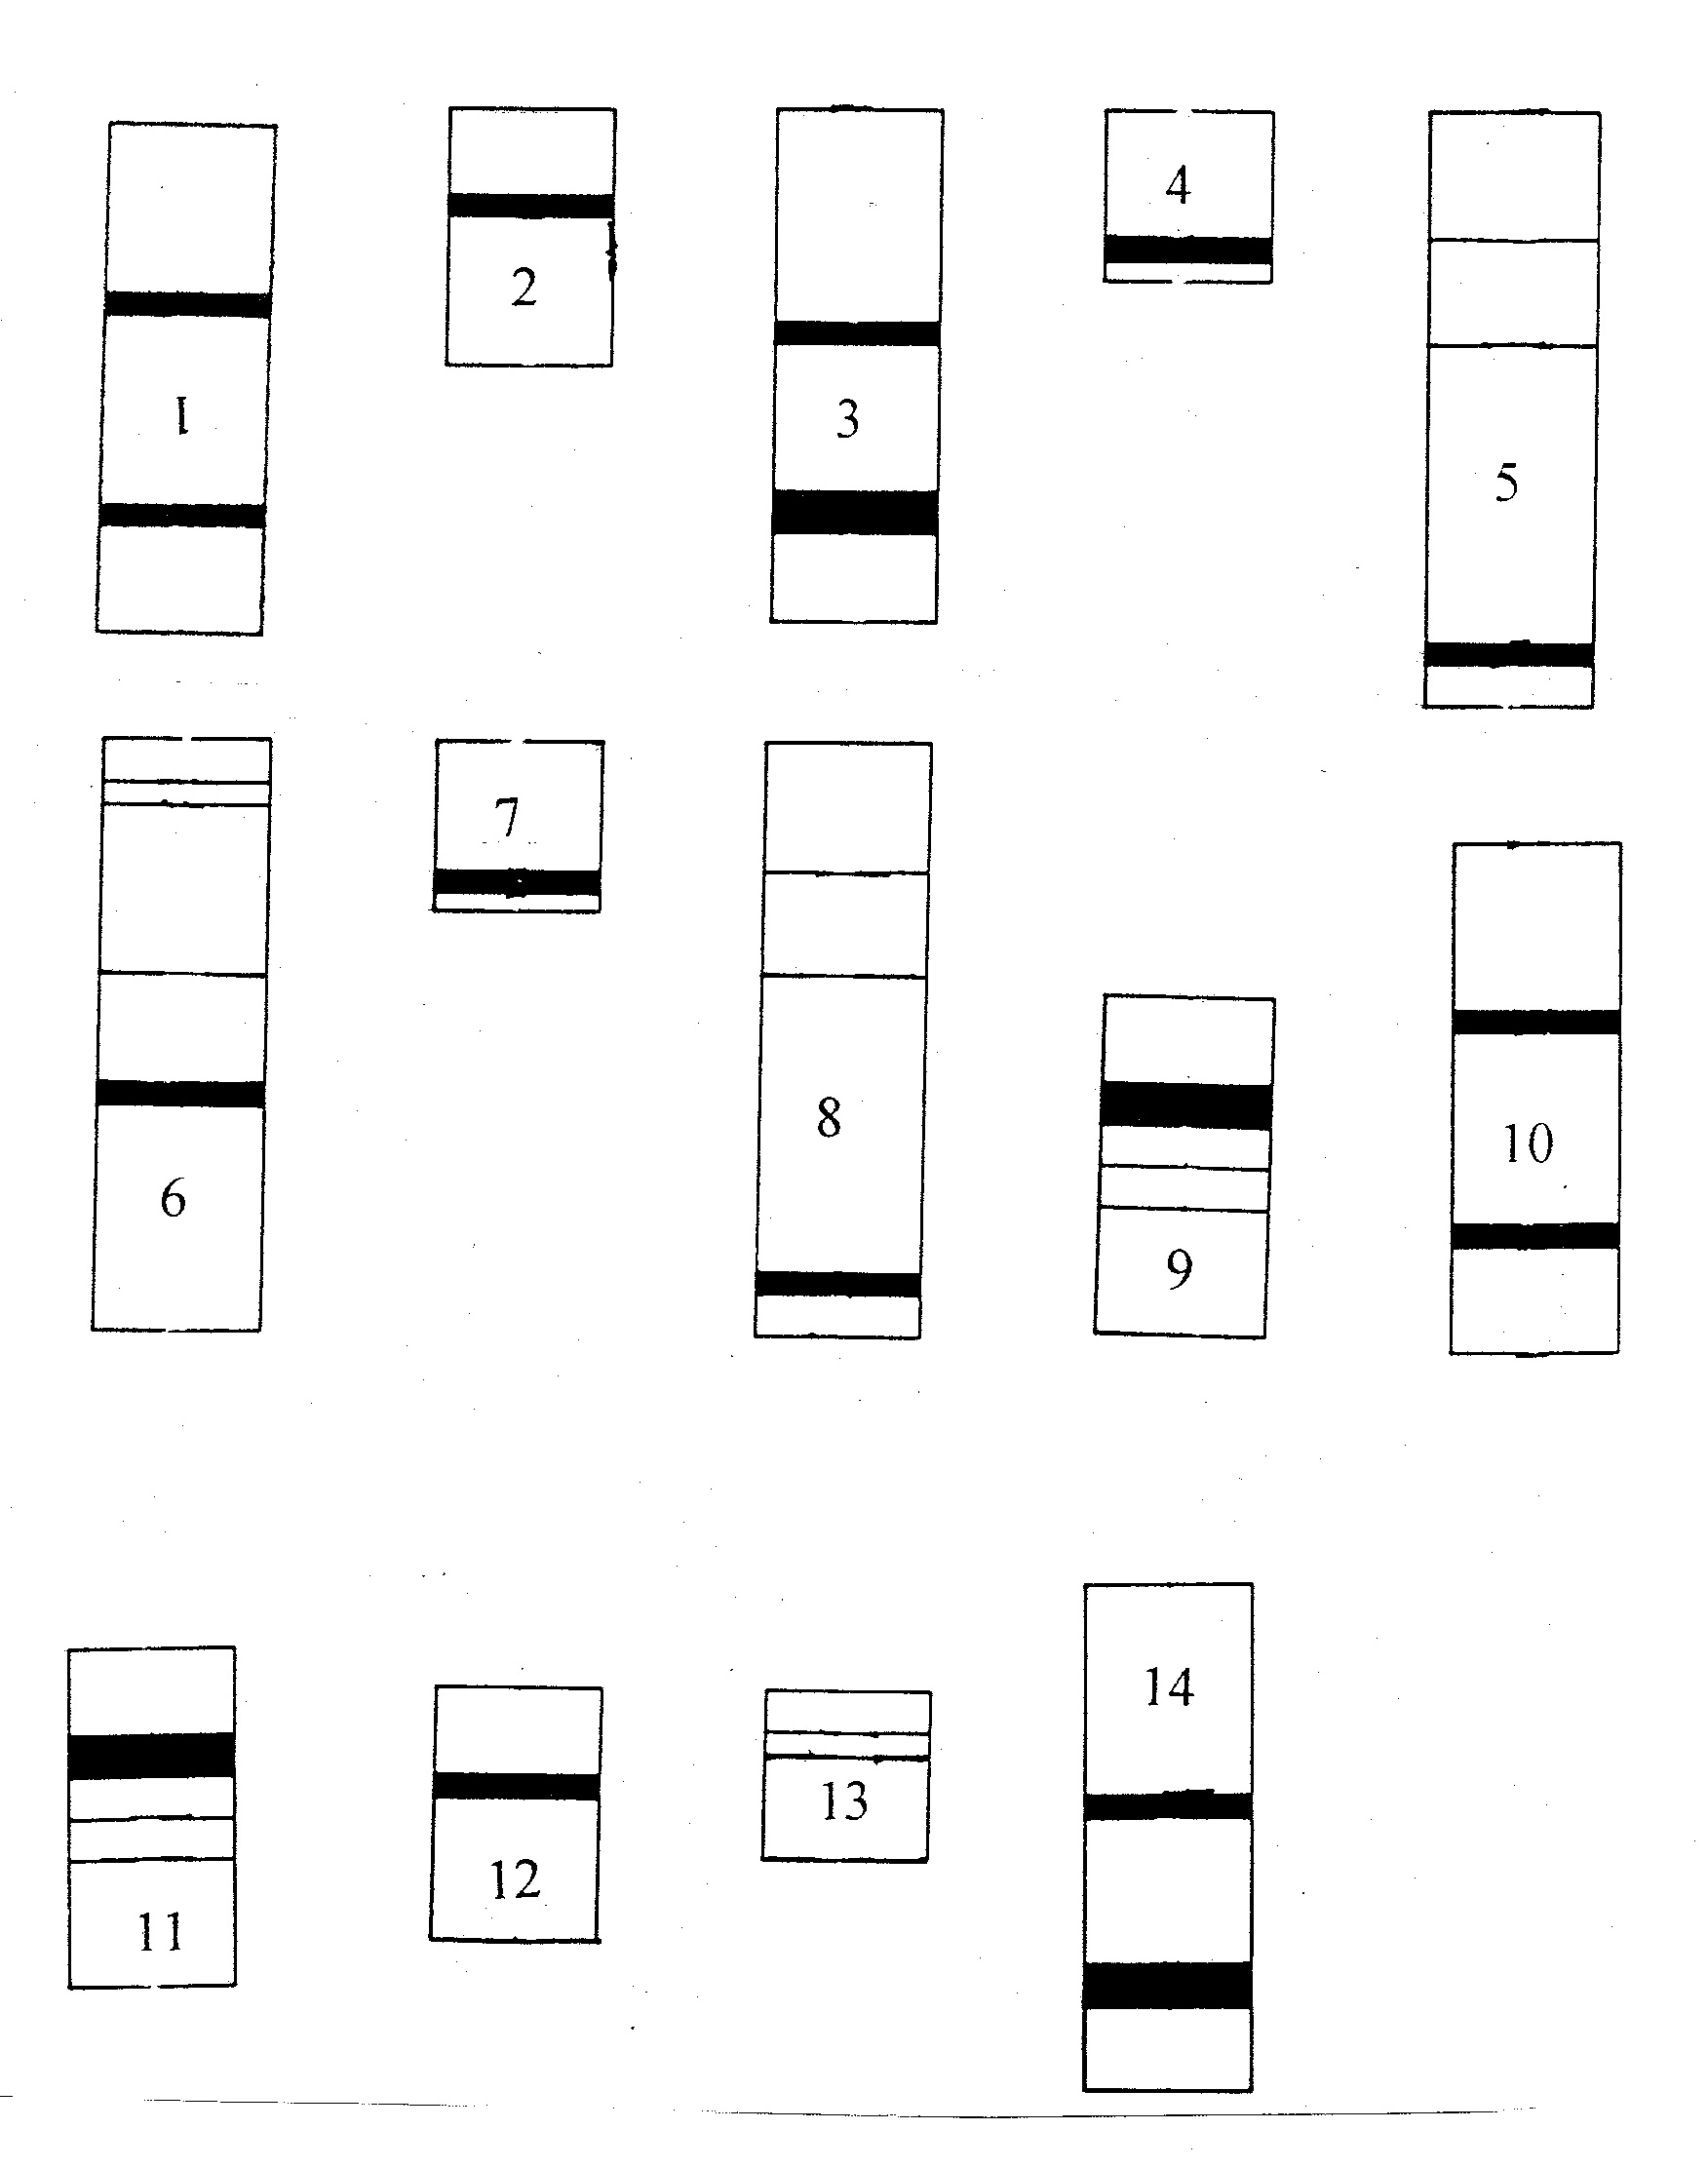

Watch the video Human Chromosomes found on www.missdoctorbailer.com

Questions:
1. Where in the cell is the video traveling? _______________________________________
2. How many chromosomes are in a crayfish? ______
3. How many chromosomes are in a dog? __________
4. How many chromosomes are in an ant? _______

Name ______________ period _____

EXIT TICKET
Learning About Genetics
1. The passing of genetic instructions from parent to
offspring is called –

A. genes
B. chromosome
C. heredity
D. DNA

2. What is the genetic material that controls an
organism’s inherited traits called?

A. chromosomes
B. traits
C. characteristics
D. heredity

3. Where are chromosomes found?

A. in the vacuole
B. in the nucleus
C. in the mitochondria
D. in the cell wall

4. How many chromosomes do humans have?

A. 2
B. 23
C. 36
D. 46

Name ______________ period _____

EXIT TICKET
Learning About Genetics
1. How many chromosomes do humans have?

A. 2
B. 23
C. 36
D. 46

2. What is the genetic material that controls an
organism’s inherited traits called?

A. chromosomes
B. traits
C. characteristics
D. heredity

3. Where are chromosomes found?

A. in the vacuole
B. in the nucleus
C. in the mitochondria
D. in the cell wall

4. The passing of genetic instructions from parent to
offspring is called –

A. genes
B. chromosome
C. heredity
D. DNA

