Dragon Genetics

Two useful terms that geneticists use to describe organisms are phenotype and genotype. An organism’s phenotype is its physical appearance or its observable traits. For example, people can have a widow’s peak or a straight hairline.
An organism’s genotype is its genetic makeup or gene combination. Geneticists (scientists who study genes) use letters to represent the genes found in an organism. They use capital letters to represent the dominant trait and lower case letters to represent the recessive trait.
Materials: Dragon parts paper, colored pencils, bags of chromosomes, scissors, glue, Dragon chart paper
What To Do:
1. In the chart below write your phenotype (physical appearance) in the phenotype column.
2. Determine your possible genotype and write it in the genotype column.
Traits | Dominant | Recessive | Your Phenotype | Your possible Genotype
Thumbs | Left / right  T | Right/left  t
Cheeks | Dimpled  C | No dimples  c
Hair color | Dark  D | Light  d
Tongue | Roller  R | Non-roller  r
Hairline | Widow’s Peak  W | Straight  w

Below you will find two sample chromosomes from a dragon, one from Dad and one from Mom. There are three traits and the genotypes for the traits on the chromosome.
Answer the questions at the bottom of the page.

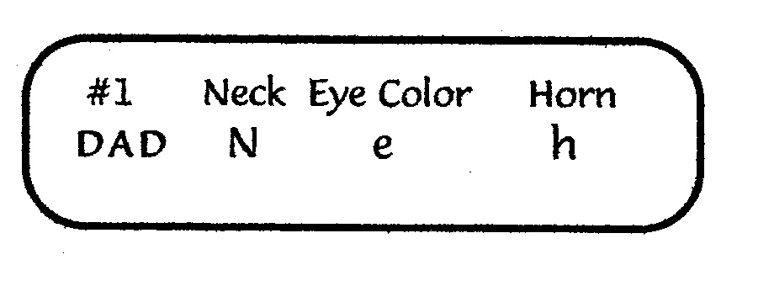
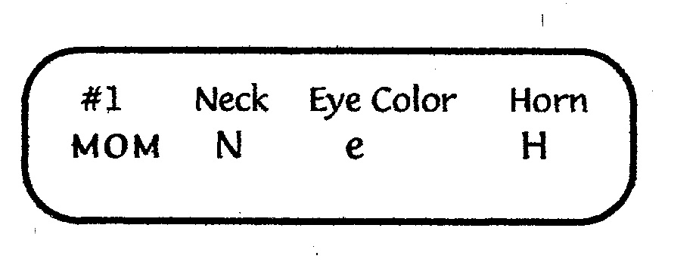

Questions:
1. What are the three traits listed on the chromosomes? ____________ _____________ _______________
2. What is the genotype for the neck? _____________
3. Will it be the dominant or recessive trait? ___________
4. How do you know? ____________________________
5. What is the genotype for the eye color? ____________
6. Will it be the dominant or recessive trait? ___________
7. How do you know? ____________________________
8. What is the genotype for the horn? ________________
9. Will it be the dominant or recessive trait? ___________
10. How do you know? ____________________________

What To Do:
1. Remove the chromosomes from the bag.
2. Match the chromosomes according to their numbers.
4. Make sure you have a Mom and a Dad for each of the
3 chromosomes.
5. Start with chromosome #1 and record the 3 traits and
the genotypes for each in the Dragon chart.
6. Determine if you will have a dominant or recessive trait.
7. Use the key below the chart to determine the phenotype
and record it.
8. Color your dragon, cut it out and glue it together on
page 51.

Questions:
1. How many dominant traits does your dragon have? ____________________
2. How many recessive traits does your dragon have? ____________________
3. How do scientists represent genes? __________
4. How many genes are in a genotype for each trait? _________
5. Where do you get your genes? _________________
6. How are dominant traits represented in the genotype? __________________
7. How are recessive traits represented in the genotype? __________________
8. What does the phenotype represent? ________________________________
9. What does the genotype represent? _________________________________

Dragon Genetics Chart
Chromosome  pair number | TRAIT | Genotype | Dominant or  Recessive | Phenotype
1
Chromosome  pair number | TRAIT | Genotype | Dominant or  Recessive | Phenotype
2
Chromosome  pair number | TRAIT | Genotype | Dominant or  Recessive | Phenotype
3

Key to  N = long neck  n = short neck  F = fire breathing  f = does not breath fire  S = spike at the end of tail  s = no spike at end of tail | Dragon Genes  E = red eyes  e = yellow eyes  B = green body  b = gray body  W = blue wings  w = purple wings | H = horn  h = no horn  T = long tail  t = short tail  C = three claws  c = four claws

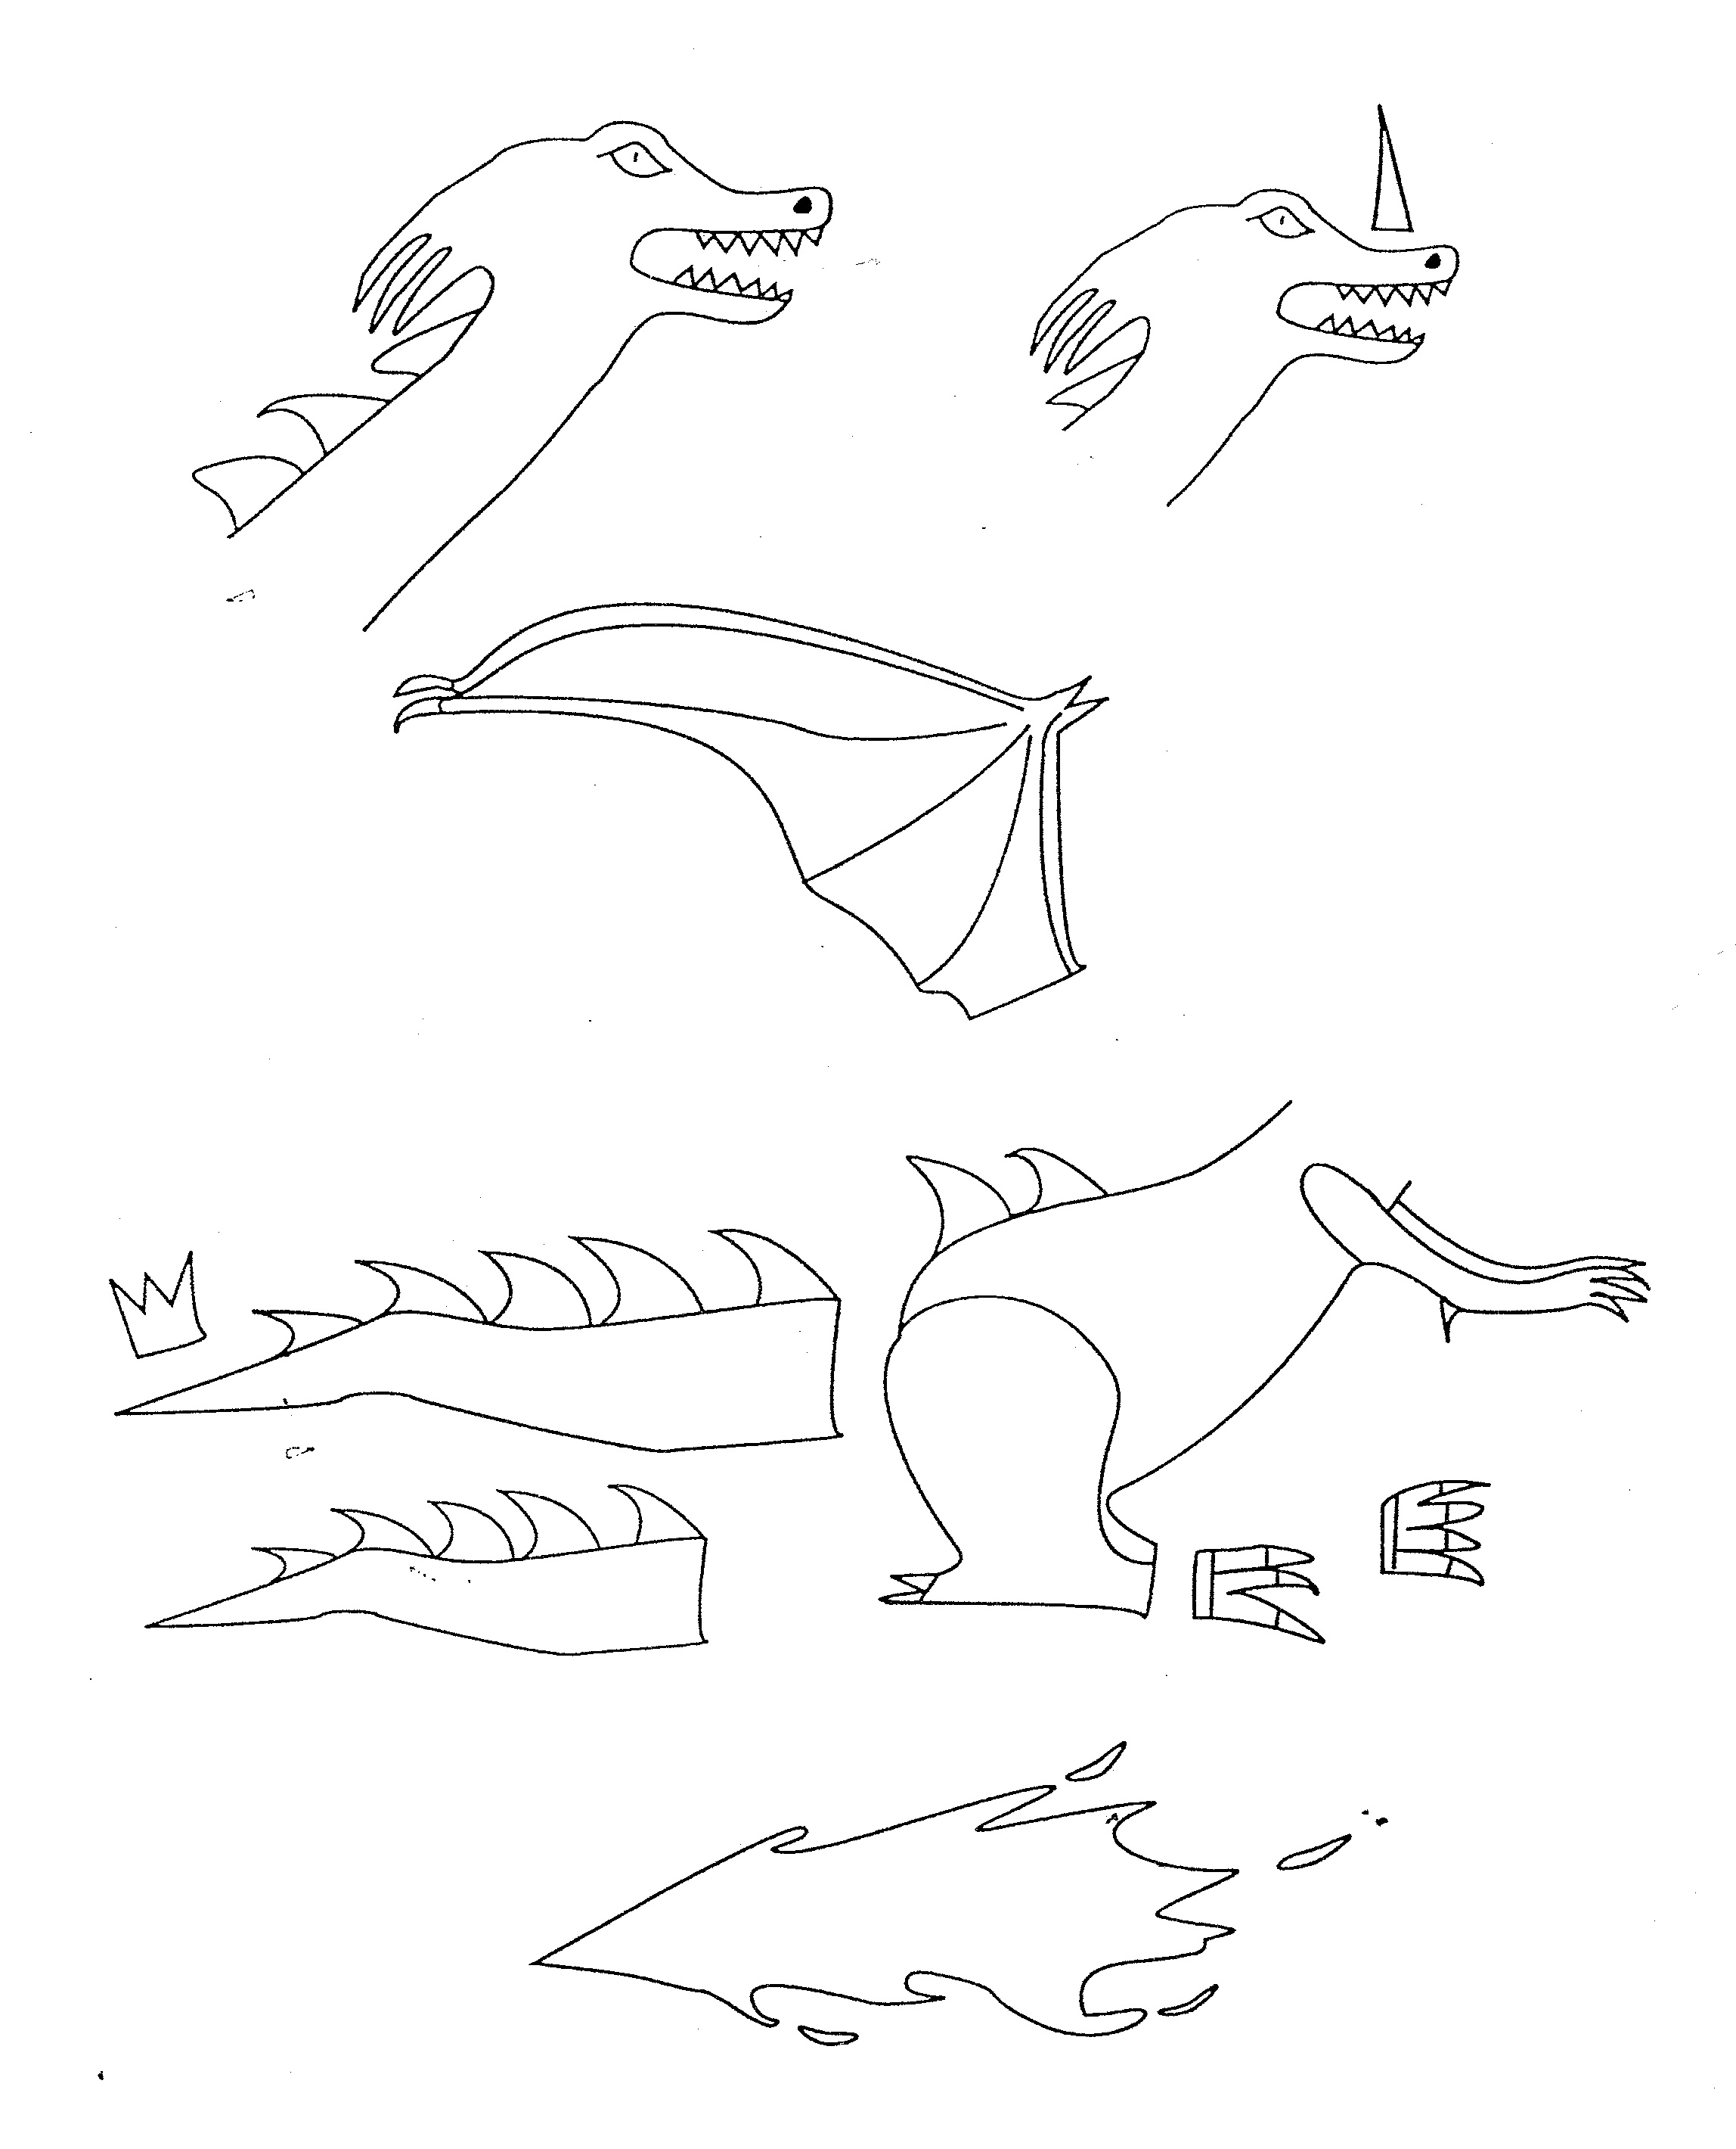

Name ________________ period _____
56

EXIT TICKET
1. What is an organism’s phenotype?
A. The physical appearance
B. The genetic make up
C. Dominant
D. Recessive

2. What is an organism’s genotype?
A. The physical appearance
B. The genetic make up
C. Dominant
D. Recessive

3. What is an example of a phenotype?
A. having dark hair
B. having dominant genes
C. having recessive genes
D. SS

4. What is an example of a genotype?
A. having dark hair
B. having dominant genes
C. having recessive genes
D. SS
5. Which of the genotypes below represent two
dominant genes?
A. SS
B. Ss
C. ss
D. sS

Name ________________ period _____
56

EXIT TICKET
1. What is an organism’s phenotype?
A. The physical appearance
B. The genetic make up
C. Dominant
D. Recessive

2. What is an organism’s genotype?
A. The physical appearance
B. The genetic make up
C. Dominant
D. Recessive

3. What is an example of a phenotype?
A. having dark hair
B. having dominant genes
C. having recessive genes
D. SS

4. What is an example of a genotype?
A. having dark hair
B. having dominant genes
C. having recessive genes
D. SS
5. Which of the genotypes below represent two
dominant genes?
A. SS
B. Ss
C. ss
D. sS

