Asexual Reproduction

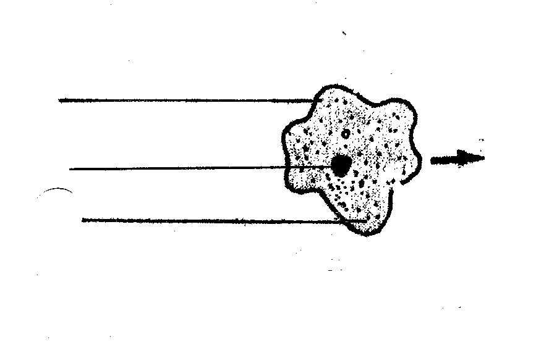
You have two parents – one male and one female. Most living things come from two parents. Reproduction from two parents is called sexual reproduction. Sexual reproduction results in offspring that are not exactly like either parent. Because the offspring from sexual reproducing organisms inherit genes from two parents, they are more diverse. We saw examples of this when we made our dragon. Only a few dragons were just alike. They were diverse offspring from many parents.
There is another kind of reproduction that comes from one parent. Reproduction from only one parent is called asexual reproduction. The offspring of asexually reproducing organisms inherit the genes from only one parent. Therefore, they are genetically identical to that parent. This results in more uniform offspring.
There are several kinds of asexual reproduction. The simplest kind is called binary fission. Bacterial and simple one-celled plants and animals reproduce by binary fission. Two other kinds are budding and regeneration.

Below is a bacterial cell. It has a cell membrane and cytoplasm just like other cells. It has nuclear material but no nuclear membrane so its nuclear material is spread out through the cytoplasm. Watch the bacteria video from website www.missdoctorbailer.com

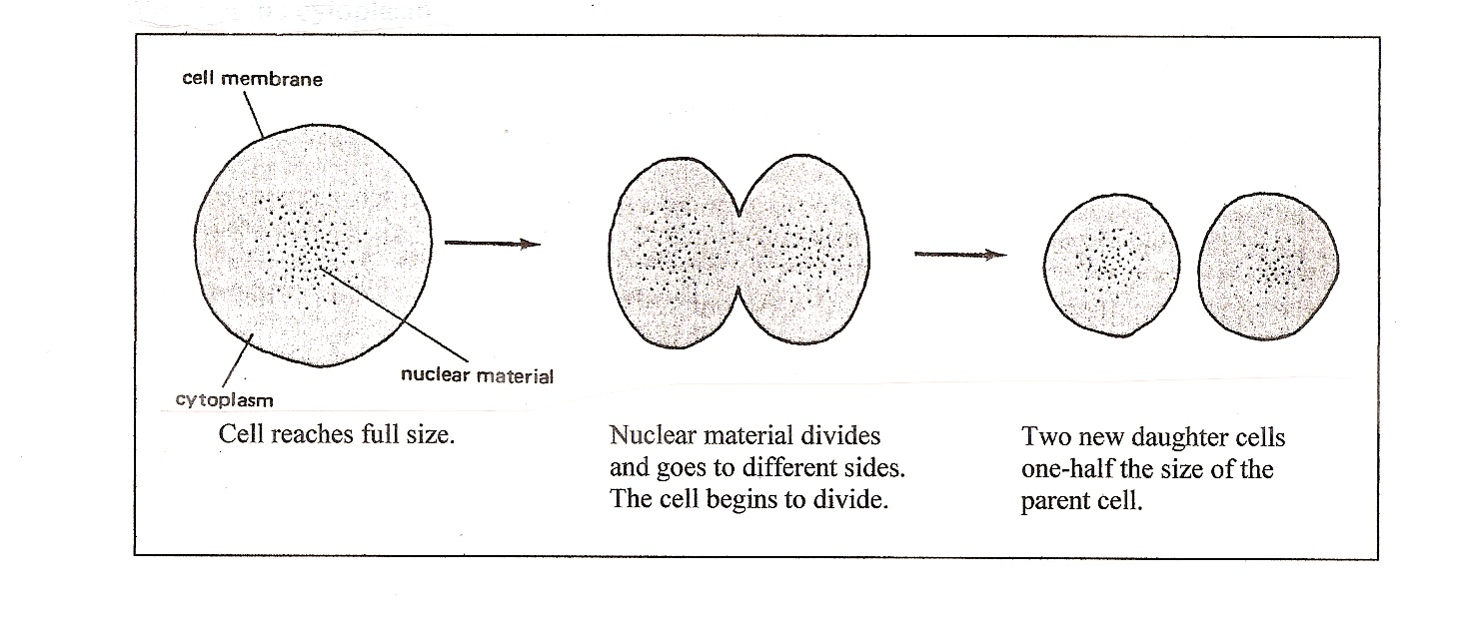

Below is an ameba parent cell. An ameba is a one-celled animal that lives in the water. It reproduces by binary fission.
Materials: scissors, glue, ameba pictures
What To Do:
1. Label the three main parts of the cell.
2. Cut out the other pictures of the ameba from the second sheet and with your teacher put them in order.
3. Glue them to the paper.

Questions:
1. What part of the cell divides first? __________________
2. After the nucleus divides what happens next?_________
3. Can you tell the two new cells from the parent cell? ____
4. Why not? _____________________________________
Below is a paramecium parent cell. A paramecium is a one-celled animal that lives in the water. It also reproduces by binary fission.
What To Do:
1. Label the three main parts of the cell.
2. Cut out the other pictures of the paramecium from the second sheet and put them in order. Glue them to the paper.
Watch the paramecium video from the website.
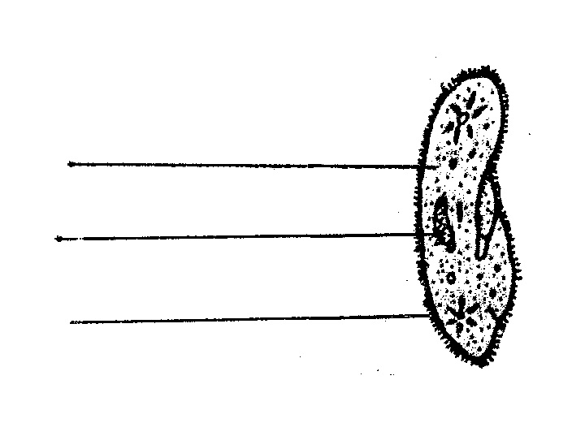

Questions:
1. What part of the cell divides first? _____________
2. After the nucleus divides what happens next? _________
3. Can you tell the two new cells from the parent cell? ____
4. Why not? ____________________________________
Another form of asexual reproduction is called budding. Yeast is the most common but other animals such as a hydra also reproduce by budding. Yeast is a fungus that is used in making bread. In budding, a tiny organism grows out from the parent cell. When it is large enough it breaks off from the parent cell. It grows until it is able to reproduce. Watch the video.

What To Do:
1. Look at the pictures below. You will see a budding
yeast cell.
2. Read the sentences below the picture and place the
number of the picture next to the sentences that
describe what is happening.
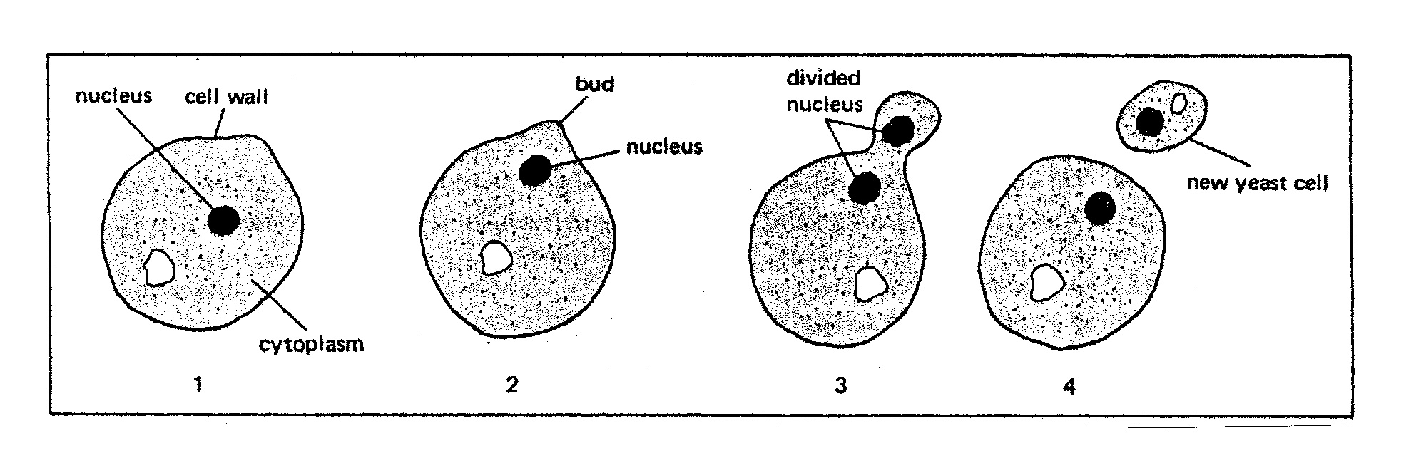

_____ The nucleus moves towards the bud.
_____ The bud breaks off from the parent cell.
_____ The bud grows larger and larger.
_____ Part of the cell membrane bulges to start the bud.

Questions:
1. What part of the cell divides first? _____________
2. After the nucleus divides what happens next? _________
3. Can you tell the two new cells from the parent cell? ____
4. Why not? ____________________________________
Asexual reproduction in plants
It is possible for plants to reproduce asexually (i.e. without flowers or fertilization). Three of the most important methods
of asexual reproduction are runners, bulbs and tubers.
Plants that are produced in these ways are genetically identical to each other and to the parent; a group like this is called a clone. A clone is a group of cells or organisms that are genetically identical to each other. Watch the video Artificial Reproduction in Plants and answer the following questions.

Questions:
1. What are some examples of tubers? __________________
2. What are some examples of bulbs? ___________________
3. What are some examples of runners? _________________
4. Planting small pieces of stems with some leaves attached is
called ____________________.
5. Attaching a cut stem with leaves and flowers with rootstock of another plant is called __________________________.
6. What are some benefits to artificial propagation?
___________________________________________________
___________________________________________________

Name ____________ period ______
EXIT TICKET
Asexual Reproduction

1. What type of reproduction results in many different
offspring?
A. Asexual reproduction
B. Sexual reproduction

2. What type of reproduction results in similar offspring?
A. Asexual reproduction
B. Sexual reproduction

3. Which is NOT a type of asexual reproduction?
A. Budding
B. Binary Fission
C. Grainary Fusion

4. Which type of reproduction has two parents?
A. Asexual reproduction
B. Sexual reproduction

5. Which type of reproduction has only one parent?
A. Asexual reproduction
B. Sexual reproduction

Name ____________ period ______
EXIT TICKET
Asexual Reproduction

1. Which type of reproduction has only one parent?
A. Asexual reproduction
B. Sexual reproduction

2. What type of reproduction results in similar offspring?
A. Asexual reproduction
B. Sexual reproduction

3. Which type of reproduction has two parents?
A. Asexual reproduction
B. Sexual reproductin

4. Which is NOT a type of asexual reproduction?
A. Budding
B. Binary Fission
C. Grainary Fusion

5. What type of reproduction results in many different
offspring?
A. Asexual reproduction
B. Sexual reproduction

