Diverse or Uniform?

Do you remember David and Leticia? David had dark hair just like his parents while Leticia had dark hair but her mother was blond and her father had dark hair. How can we predict what color of hair David and Leticia children will have? It’s easy! We can use a special chart called a Punnett square. A Punnett square is a chart used to show possible gene combinations. The steps below show you how to use a Punnett square.
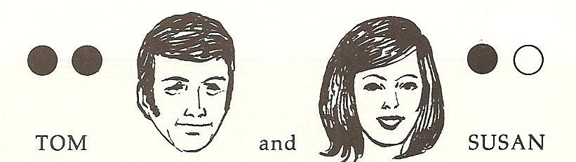
Leticia
David

1. First you need a box with four squares in it.
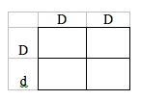
2. Write the genes from the father across the top of the chart. Remember a dominant gene is always written as a capital letter “D” stands for dark hair. Both of David’s genes for hair color are represented by D.

3. Write the genes from the mother down the side of the chart. A recessive gene is always marked with a lower case letter. Leticia has the dark gene from her father and the recessive gene from her mother. So one gene is D and the other one is d.
4. Now fill in each box with a gene from the father and another from the mother. Each box now shows the different combination of genes that can show up in the offspring.

The possible gene combinations for David and Leticia’s children are DD, or Dd. Each of these is a gene combination for dark hair. All of their children will have dark hair. Which gene combination will show up in a child? It’s a matter of chance!

Scientists at Bikini Bottoms have been investigating the genetic make up of the organisms in this community. Use the information provided and your knowledge of genetics to answer each question.
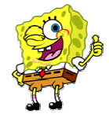
Determine the phenotype for each genotype using the information provided about SpongeBob.

Yellow body color (Y) is dominant to blue (y).

1. What color is YY ______ Yy_______ yy ______?

Square shape (S) is dominant to round shape (s).

2. What body shape is SS _____ Ss ______ ss______?
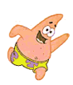
For each phenotype, give the genotypes that are possible for Patrick.

A tall head (T) is dominant to short(t).

3. Tall genotypes ________ or _______
4. Short genotype __________

Pink body color (P) is dominant to green (p)

5. Pink body genotypes ______ or _______
6. Green body genotype _______

SpongeBob SquarePants recently met SpongeSusie Roundpants at a dance. SpongeBob’s genotype for his shape is SS, but SpongeSusie is round. Create a Punnett square to show the possibilities that would result if SpongeBob and SpongeSusie had children.
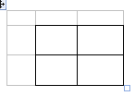

1. List the possible genotypes for their children ________
2. What are the chances of a child with a square shape?
_______ out of ______ or _____%
3. What are the chances of a child with a round shape?
_______ out of ______ or _____%

Patrick met Pattie at the dance. Both of them have pink bodies but both have the recessive gene for a green body.
Create a Punnett square to show the possibilities that would result if Patrick and Pattie had children.

1. List the possible phenotypes for their children ________
2. What are the chances of a child with a pink body?
_______ out of ______ or _____%
3. What are the chances of a child with a green body?
_______ out of ______ or _____%

Every one in Squidward’s family has light blue skin, which is the dominant trait for body color in his hometown of Squid Valley. His father brags they are a “purebred” line. He recently married a nice girl who has light green skin, which is a recessive trait. Create a Punnett square to show the possibilities that would result if Squidward and his new bride had children. Use B to represent the dominant gene and b to represent the recessive gene.
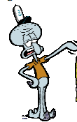

1. List the possible genotypes for their children
____________________________________
2. What are the chances of a child with light blue skin?
_______ out of ______ or _____%
3. What are the chances of a child with light green skin?
_______ out of ______ or _____%

Questions:
1. How many possible children are predicted in each
Punnett square? _________
2. How are dominant genes represented? ________
3. How are recessive genes represented? _________

As you may know sea stars, like Patrick, can reproduce asexually. If they lose an arm they can regrow it. This process is called regeneration. If they are cut in half both halves will regenerate and produce two brand new sea stars.
Typically scientists don’t create a Punnett square for this because they know the new organisms will be exact duplicates, or clones, of the first organism. But we can create one to compare to Patrick’s asexual and sexual reproduction.

In one of SpongeBob’s adventures Patrick was injured and he was cut in half. When the new sea star grows will he have a tall head or a short head? Patrick’s genotype for his head is TT. Create the Punnett Square for the two new Patricks.

1. List the possible phenotypes the new Patricks. ________
2. What are the chances of a Tall head?
_______ out of ______ or _____%
3. What are the chances of a short head?
_______ out of ______ or _____%

Compare this to the Punnett Square created by Patrick and Pattie.
1. Which square had the most diverse offspring? ________
2. Which square had the most uniform offspring? _______
3. Which type of reproduction has the most diverse offspring? ____________________________
4. Which type of reproduction has the most uniform offspring? ___________________________

Name ________________ period _____
69

EXIT TICKET
Divers or Uniform?
1. Create a Punnett square for the following organisms with these traits

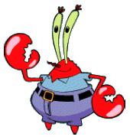
Mr. Krabby Tall Eyeballs Tt
Mrs. Krabby Tall Eyeballs Tt
2. List the possible phenotypes for their children
________ _______

3. What are the chances of a child with Tall Eyeballs?
_______ out of ______ or _____%

4. What are the chances of a child with Short Eyeballs?
_______ out of ______ or _____%

5. If Mr. Krabby were able to reproduce asexually, what would the difference in the offspring be?

A. They would be very diverse.
B. They would be somewhat diverse.
C. They would be somewhat uniform.
D. They would be very uniform.

