Systems and Functions

Think about the pen you may be holding. Does it have parts? Do they work together to do a job? Yes! A pen has the case, the tube that holds the ink, the ink, the ballpoint and it may even have an erasure if it contains erasable ink. If it clicks to open and close it will have a spring and a part to make the point go in and out. All of these parts work together so you can write with the pen. That makes it a system! So, a system is a group of parts that work together to perform a function. What is a function? The parts of a pen work together so you can write with it. That is its function. A function is the job a system does.

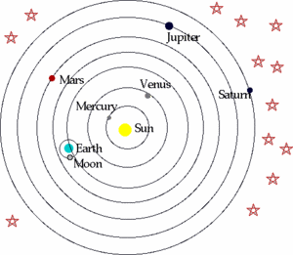

1. What is the name of this system? _____________

2. What are the parts of the system?
_____________________

3. What function do you think it performs?

___________________________________________

4. Predict what would happen if the Sun disappeared.
__________________________________________

1. What are this parts of the system?
_________________________________
2. What function do they perform?

_________________________________
3. Label the parts with their names.
4. Predict what would happen if the keyboard stopped working. _______________________________________

Your teacher will give you a flashlight. Carefully take it apart and find all the parts.

1. Draw all the parts by themselves in the space below. Label them with the following words:

Battery case, switch, batteries, bulb, reflector, lens, lens case, bulb holder

2. What function does a flashlight perform? _____________________________________________

3. Predict what would happen if the switch were broken. _____________________________________________

How is a book a system? Write three complete sentences to answer the question.

_______________________________________________________

_______________________________________________________

Watch the video “National Geographic - Human Body 101” from www.missdoctorbailer.com

Answer the following questions:

1. Living things are organized from smallest part to largest part. Order the following parts from smallest to largest.

________ Organ System

________ Cells

________ Organs

________ Tissues

________ Organism

2. Name the strongest muscle in the body. __________

3. What is the most complex object on Earth? ________

4. Name two systems of the human body - other than the ones on the next page.

______________________________________________

Below you will find some pictures of Human Body Systems. See if you can match the pictures to the names. Draw a line from the name to the picture.

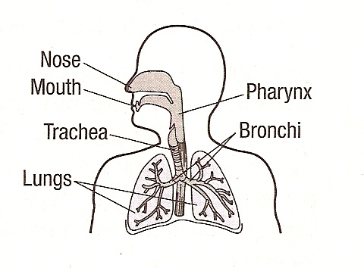 |  | Endocrine System
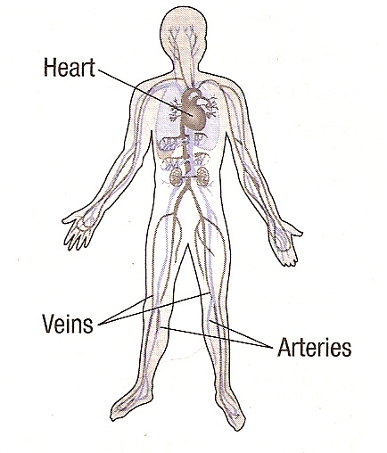 |  | Nervous System
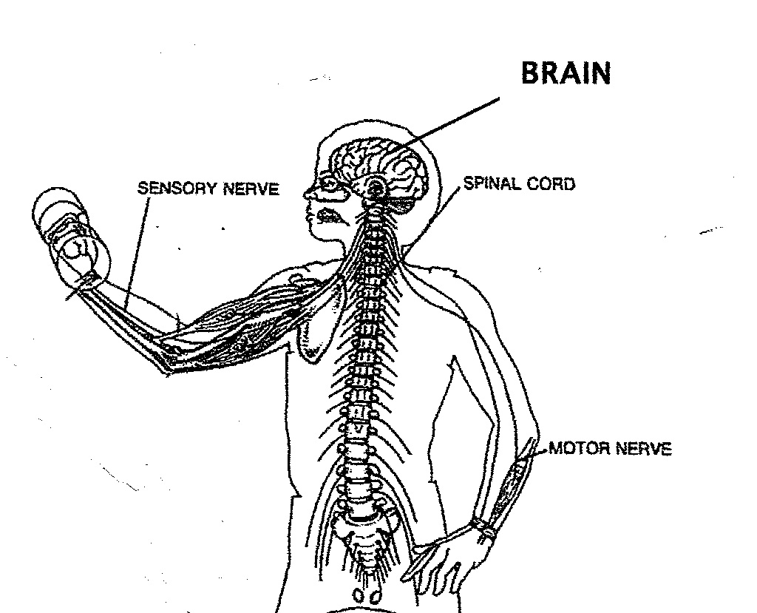 |  | Respiratory System
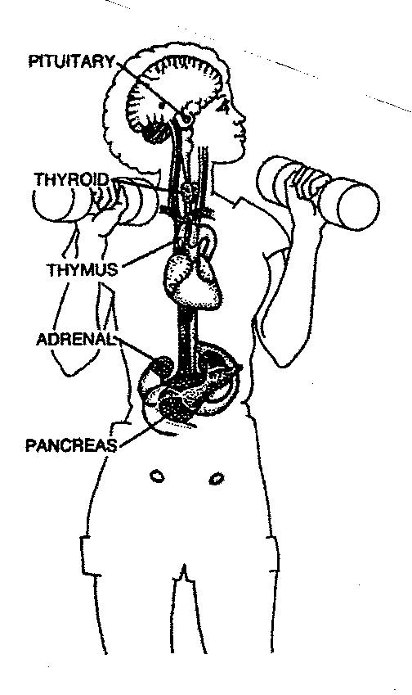 |  | Circulatory System

Name _________________ period _____
EXIT TICKET
Systems and Functions

1. What is a system?

A. The job something does
B. A group of parts working together
C. A function
D. A broken object

2. What is a function?

A. The job something does
B. A group of parts working together
C. A function
D. A broken object

3. Which of the following is NOT an example of a function?

A. the Solar System
B. Producing copies
C. Cooking breakfast
D. Making hamburgers

4. What is the function of a school?

____________________________________________

____________________________________________

Name _________________ period _____
EXIT TICKET
Systems and Functions

1. What is a function?

A. The job something does
B. A group of parts working together
C. A function
D. A broken object

2. Which of the following is NOT an example of a function?

A. the Solar System
B. Producing copies
C. Cooking breakfast
D. Making hamburgers

3. What is a system?

A. The job something does
B. A group of parts working together
C. A function
D. A broken object

4. What is the function of a school?

____________________________________________

____________________________________________

