Learning About the

Respiratory System
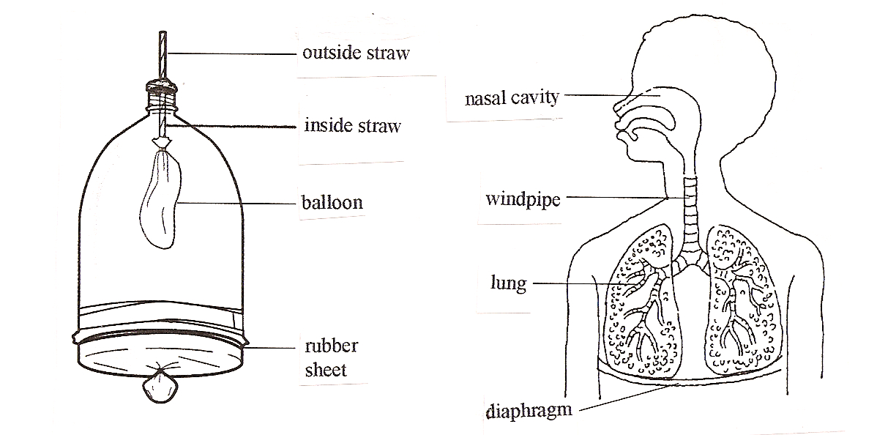
Almost every living thing must take in oxygen in order to live. Breathing is the process of bringing air into an organism. Breathing also gets rid of used air. Breathing is done by the means of the lungs and the diaphragm. The diaphragm is a muscle that contracts and expands to bring air into the lungs. The function of the respiratory system is to take oxygen into the lungs and to get rid of carbon dioxide and water. The mitochondria in the cells of the body use oxygen to make energy so we can live.
Air enters the body through the mouth and the nose. Then it moves into your throat and passes through the windpipe, or trachea. The windpipe branches into the lungs. The lungs are the main organs of the respiratory system. Each lung contains millions of tiny air sacs. Capillaries surround each air sac. In the air sacs the blood in the capillaries picks up oxygen and gives off carbon dioxide. This is one way the respiratory system works with the circulatory system.

What To Do:
1. Observe the balloon lung model.
2. Gently pull down on the rubber sheet at the bottom
of the bottle.
3. Observe what happens to the balloon inside as you
pull down and push up on the rubber sheet.
4. Draw what you observe in the spaces below.

Pulling Down Pushing Up

5. Compare the drawings of the model and the respiratory system below.
6. Color the model parts as follows:
a. outside straw - yellow c. balloon - blue
b. inside straw - green d. rubber sheet - red

7. Color the human parts the same color as its model parts.

Questions:

1. What part of the model represented the diaphragm? ___________________
2. What part of the model represented the lungs? _______________________
3. What part of the model represented the windpipe? ____________________

Changing The Rate of Breathing
Materials: clock or timer
What To Do:
1. As your teacher watches the clock, count the number
of inhales you make in 15 sec.
4. Place the number in the chart below and “DO THE MATH” for 60 seconds!
5. Stand up and sit down in your chair 25 times.
6. Count your inhales for 15 seconds and “DO THE MATH” for 60 seconds!

 | 15 seconds |  | 60 seconds
Number of breaths (At Rest) |  | X 4 =
Number of breaths  (After Exercise) |  | X 4 =

Questions:
1. What happens to your breathing rate after exercise?
______________________
2. Why do you think this happens? (Think about how
the mitochondria uses oxygen.) _________________________________________
3. Collect the data from all the people at your table and place it in the chart below.

Name of Student | Breathing Rate after exercise

Make a bar graph with the data from your table.

Name _______________________ period _____

EXIT TICKET
Learning About the Respiratory System

1. What is the major waste material our lungs exhale?

A. Oxygen
B. Nitrogen
C. Carbon Dioxide
D. Helium

2. What is the major component of air that our body needs?

A. Oxygen
B. Nitrogen
C. Carbon Dioxide
D. Helium

3. What are the main organs of the respiratory system?

A. Hearts
B. Kidneys
C. Lungs
D. Fingers

4. What is the major function of the respiratory system?

A. Take oxygen in and get rid of carbon dioxide.
B. Take carbon dioxide in and get rid of oxygen.
C. Make energy using carbon dioxide
D. Make energy using oxygen

Name _______________________ period _____

EXIT TICKET
Learning About the Respiratory System

1. What is the major function of the respiratory
system?

A. Take oxygen in and get rid of carbon dioxide.
B. Take carbon dioxide in and get rid of oxygen.
C. Make energy using carbon dioxide
D. Make energy using oxygen

2. What is the major waste material our lungs exhale?

A. Oxygen
B. Nitrogen
C. Carbon Dioxide
D. Helium

3. What is the major component of air that our body needs?

A. Oxygen
B. Nitrogen
C. Carbon Dioxide
D. Helium

4. What are the main organs of the respiratory system?

A. Hearts
B. Kidneys
C. Lungs
D. Fingers

