Learning About the Circulatory System

What’s In Your Blood?
If you drained out all your blood, you could fill a 5-liter bucket. Every cell in your body depends on blood to deliver food and oxygen and to carry away wastes. Blood is the key to keeping all the cells of your body alive. There are four components to the blood: plasma, red blood cells, white blood cells and platelets.
The plasma is mostly water and its function is to carry all the other components through the body. It is pale yellow and contains some sugar, protein, minerals and waste materials. You have about 15 trillion red blood cells. The function of the red blood cells is to transport the oxygen from the lungs to the cells. The function of the white blood cells is to attack germs and other invaders that get into the body. The platelet’s function is to keep you from bleeding to death by making a clot (we call it a scab) and keeping the blood from flowing out a cut.

Materials: colored pencils, model of the blood
What To Do:
1. Look at the diagram of the blood.
2. The red blood cells look like donuts. Color them red.
3. The white blood cells are larger than the red cells.
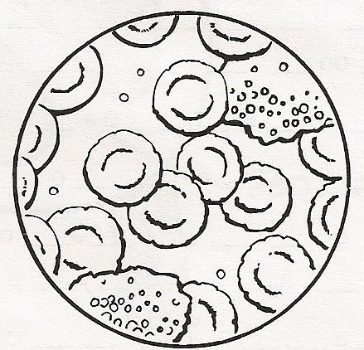
Don’t color them
4. The platelets are very small
and are clear in the blood.
Color them purple.
5. Color the plasma around the
blood cells yellow.
6. Observe the model of the
blood your teacher gives
you and identify each of the
components found in it.

Scientists use models and pictures to represent ideas and objects too big or too small to see with the unaided eye. The microscope aids our eyes in seeing very small things and the telescope aids our eyes to observe objects that are very far away. When we use models there are problems with size, scale, color and materials. These problems are called limitations.

Questions:
1. What is a limitation of the model of blood we used? _______________________________________________
2. What is a limitation of the picture we used?
_______________________________________________
Why does your blood look blue/green?
Some people think that the blood inside them is blue. That is not true. You have RED blood cells not blue. This is what happens. Your skin is thin and acts like a filter. Typical light has all the colors of the rainbow in it. When light goes through your skin and hits the blood vessels it bounces back out but the red is filtered by your skin leaving only the blue and yellow from the rainbow. This blue/green color is what we see.
Materials: ½ straw with red water, clay, petri dish, milk
What To Do:
1. Your teacher will show you ½ a straw that has been filled with red food coloring and plugged with clay.
2. Your teacher will place it in the petri dish and begin
covering it with milk.
3. Observe the color of the straw when covered with milk.
Questions:
1. What color do you observe the straw to have? _______
2. What made it change color? ______________________
3. What does the milk represent? ____________________
4. Why do you see a different color than red? __________

Parts of Your Circulatory System
Your heart is mostly muscle tissue. It has only one function. Day and night, twenty-four hours a day, your heart pumps blood to every part of your body. Every time your heart beats, the blood is being squeezed out of the heart, into an artery and out to the body. The arteries take the blood away from the heart where they connect with the smallest blood vessels called capillaries. The capillaries connect with the veins, which take the blood back to the heart.

Label the diagram with the following words.
1. Heart 3. Artery
2. Vein 4. Capillary
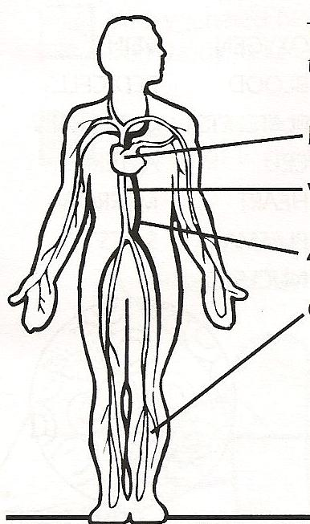

Listening to Our Hearts
Materials: stethoscope, alcohol, cotton balls
What To Do:
1. Clean the earpiece of the stethoscope with alcohol and a cotton ball.
2. Use the stethoscope to listen to your heart.
3. Listen for two different sounds.
4. Doctors call the sounds the “LUB” and “DUB.” See if you can hear them.
5. A LUB and a DUB make one heartbeat.
6. Listen to your partner’s heart while they listen to yours.

Questions:
1. What is the function of the heart? ________________
2. What sounds does the heart make? _______________

What the video, “The Circulatory Song” from www.misdoctorbailer.com

Fill in the blanks below.

Taking blood from the heart to the ________ and back
Dealing with all things vascular and _______________

Capillaries, arteries and ____________________
All I’m sa’in is ___________________ is the name of the game

Now lets start from the ____________ ‘cause that seems smart
It’s not hard to see that it's the most ______________part

The first step is to gather up ______________ sends blood
to the _____________, back to the _________ again.

Name _________________ period _____

EXIT TICKET
Learning about the Circulatory System

1. What color is your blood?

A. blue
B. yellow
C. green
D. red

2. What is the function of the circulatory system?

A. Deliver food to your cells
B. Take wastes away from your cells
C. Take oxygen to your cells
D. All of the above

3. What is a limitation of a model?

A. A grade
B. A problem in size or scale
C. The builder of the model
D. All the correct things found on the model

Conclusion: (blood, platelets, oxygen, white, plasma)
Red blood cells carry the _________ to all cells of the body. _______ blood cells attack invaders. ________ is the liquid that carries all the other _________. The component of the blood that causes it to clot is the ____________.
56

Name _________________ period _____

EXIT TICKET
Learning about the Circulatory System

1. What is the function of the circulatory system?

A. Deliver food to your cells
B. Take wastes away from your cells
C. Take oxygen to your cells
D. All of the above

2. What color is your blood?

A. blue
B. yellow
C. green
D. red

3. What is a limitation of a model?

A. A grade
B. A problem in size or scale
C. The builder of the model
D. All the correct things found on the model

Conclusion: (blood, platelets, oxygen, white, plasma)
Red blood cells carry the _________ to all cells of the body. _______ blood cells attack invaders. ________ is
56
the liquid that carries all the other _________. The component of the blood that causes it to clot is the ____________.

