Learning About the Nervous System

Together the brain, spinal cord and a network of nerves throughout your body make up the nervous system. The nervous system collects, processes and distributes all the information your body needs to work and keep you safe.
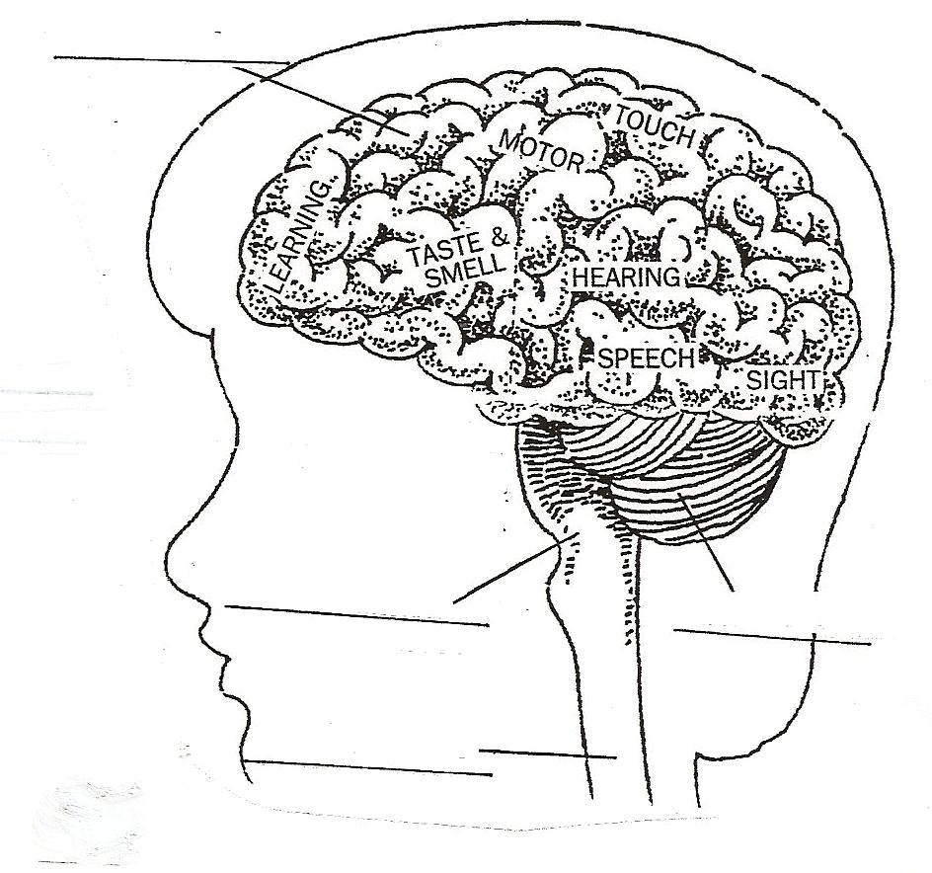
The brain is your body’s control center. It receives information about what goes on inside and outside the body. It sends messages to different parts of the body and tells them what to do. It does this by sending signals from the brain to the spinal cord. From the spinal cord the nerves take the messages to the muscles or skin.
The nervous system allows you to respond to different stimuli. If the teacher says to get a highlighter in your hand, you will use the muscles in your fingers and hand to pick it up. The message goes from your brain, down the spinal cord and to the muscles in your hand. Once you pick up the highlighter a message is sent from the nerves back to the spinal cord and then to the brain.
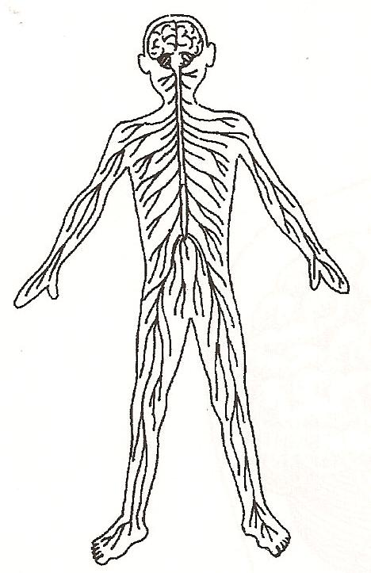
Label the brain, spinal cord and nerves.
Materials: red and yellow colored pencil
What To Do:
1. Use the red colored pencil to color the pathway the message would take to pick up your foot.
2. Use the yellow colored pencil to color the pathway that tells the brain you picked up your foot.

The brain has three parts, the cerebrum, cerebellum and the brain stem. The cerebrum makes up most of the brain. It receives messages from the sense organs and controls movement of the muscles. The cerebellum controls the body’s balance and movement. The brainstem controls our heartbeat, breathing and stomach muscles. The spinal cord connects the brain with the nerves that are throughout your body.

Label the parts of the brain below.

Use the information about the brain from the last page and the labels found in the brain to color the part of the brain that processes each of the following experiences.

Blue – listening to music
Green – smelling a rose
Orange – seeing your teacher’s face
Red – a hot match
Purple – studying for a test
Yellow – talking to a friend
Pink – walking down the hall
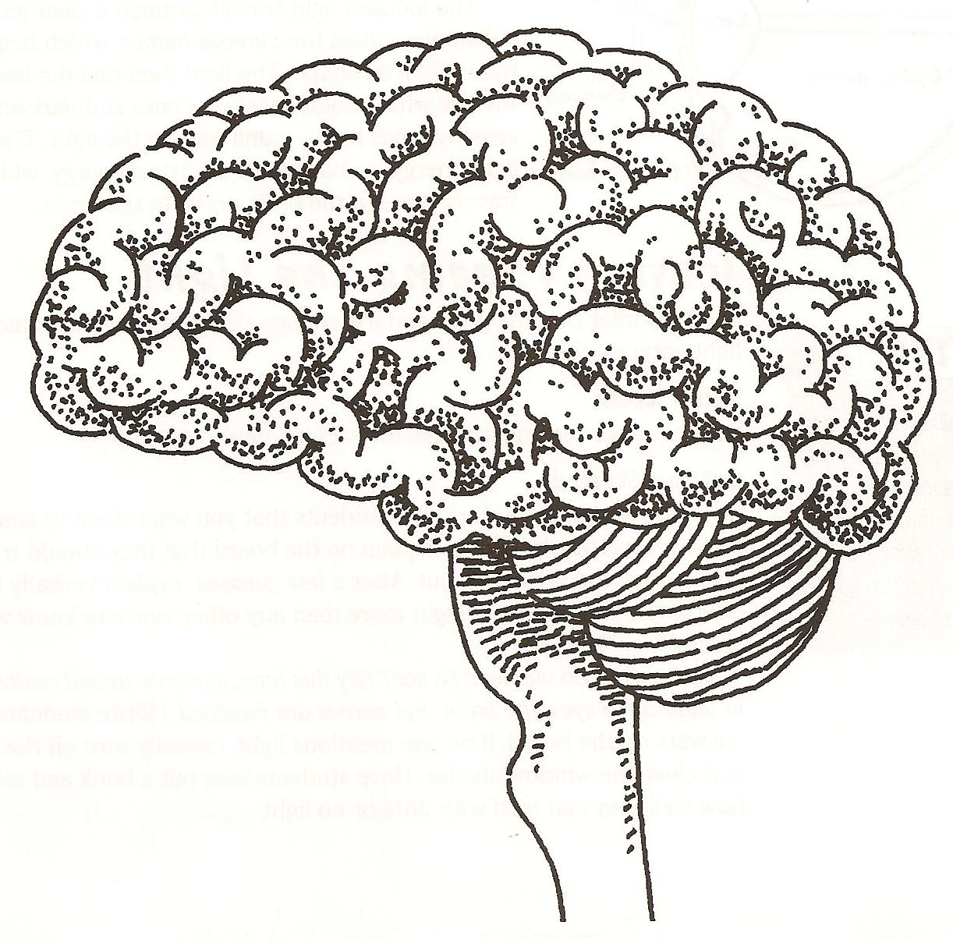

How fast can you respond?
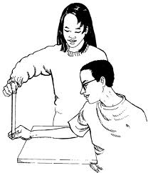
Materials: ruler
What to Do:
1. You must work with a partner in this activity.
2. Hold a ruler at the 30 cm end.
3. Place it over your partner’s hand.
4. Drop the ruler unexpectedly.
5. Your partner should try to catch the ruler as quickly as possible.
6. Record the position of the ruler where your partner catches the ruler in centimeters in the table below.
7. Repeat 3 times and find the average.
8. Change places and repeat.

Name | Trial 1 cm | Trial 2  cm | Trial 3  cm | Average

Questions:
1. In the activity above what was the stimulus? _______
2. What was the response? ________________________
3. Fill in the blanks to follow the pathway the signals followed.
_______ saw the ruler drop. Sent message through the ______ to the spinal ________. Spinal cord sent message to the ________. Brain sent message down the ________ cord to the __________ which told the muscles in your fingers to __________.

Name ________________ period _____
Exit Ticket
Nervous System
1. Someone drops a book on the floor and it makes a loud noise. At that time you turn and look at the person who dropped the book. The loud noise is an example of a –

A. Stimulus
B. Response
C. Tropism

2. In the scenario above turning and looking at the person
who dropped the book is an example of a –

A. Stimulus
B. Response
C. Tropism

3. Which of the following is the function of the nervous system?

A. bring oxygen into the body
B. pump oxygen to all parts of the body
C. collect, process and distribute information

4. Which of the following lists shows the important organs
of the nervous system

A. heart, veins, arteries
B. brain, spinal cord, nerves
C. brain, spinal cord, lungs

Name ________________ period _____
Exit Ticket
Nervous System
1. Someone drops a book on the floor and it makes a loud noise. At that time you turn and look at the person who dropped the book. The loud noise is an example of a –

A. Stimulus
B. Response
C. Tropism

2. In the scenario above turning and looking at the person
who dropped the book is an example of a –

A. Stimulus
B. Response
C. Tropism

3. Which of the following lists shows the important organs of the nervous system

A. heart, veins, arteries
B. brain, spinal cord, nerves
C. brain, spinal cord, lungs

4. Which of the following is the function of the nervous system?

A. bring oxygen into the body
B. pump oxygen to all parts of the body
C. collect, process and distribute information

