Learning About the Endocrine System
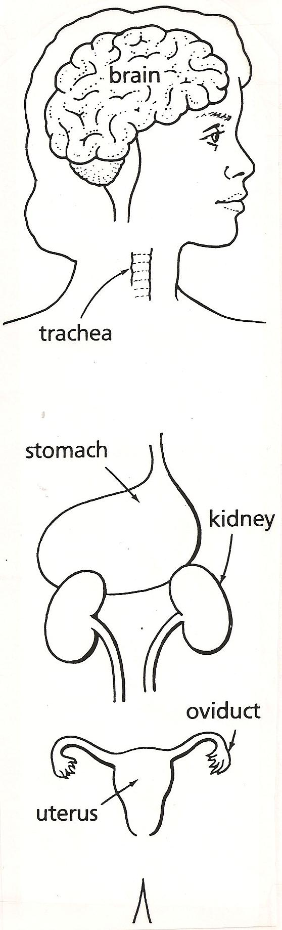
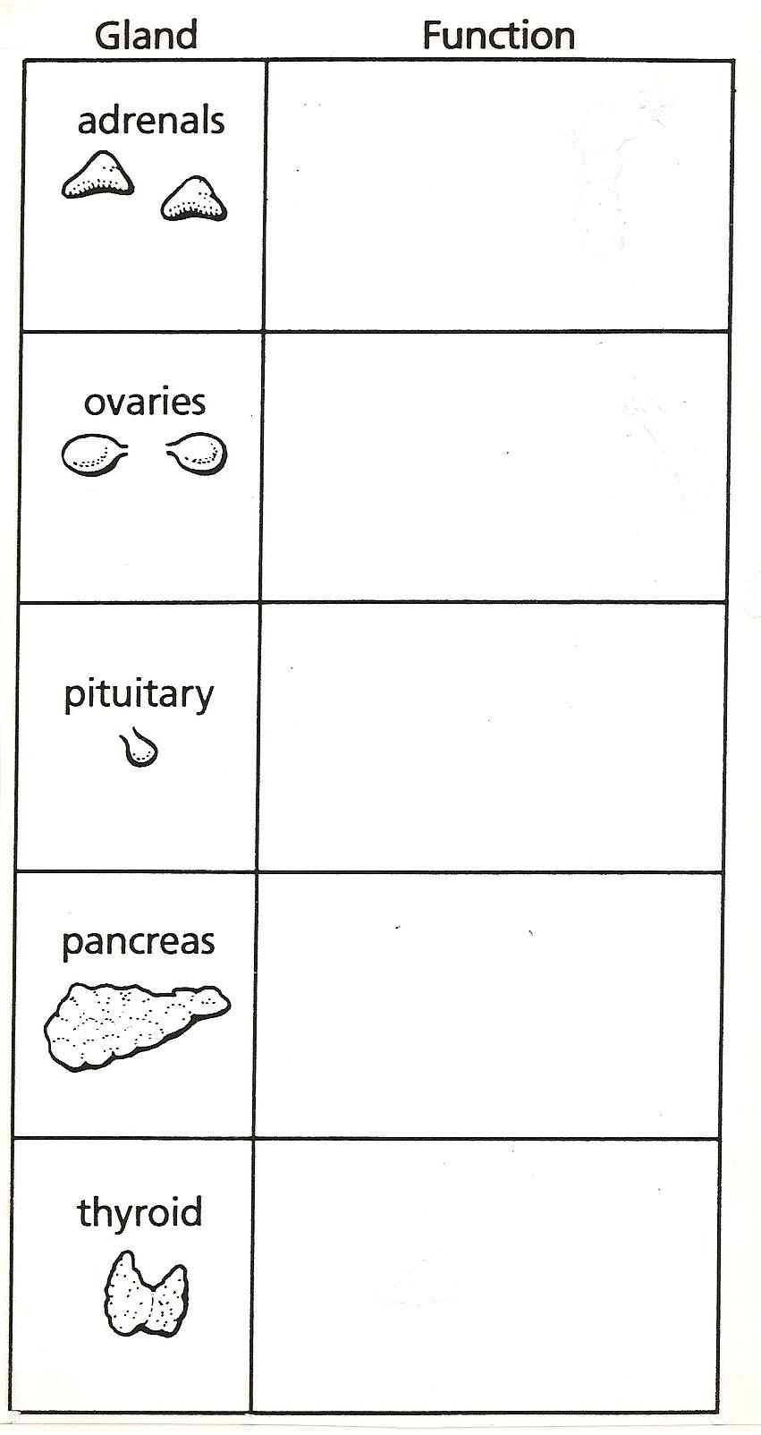
The endocrine system is a group of glands that secrete hormones to help regulate our body’s processes and keep the body in balance. These hormones are released in response to a stimulus just like what happens in your nervous system, only not as fast.
Think about the last time you were in trouble with your parents or a teacher. Your heart started beating faster; your breathing also began to get faster. Maybe your hands started to sweat. Why did these things start happening? Your body was getting you read to fight or run. This is called the “fight or flight” response. Let’s see how this works.
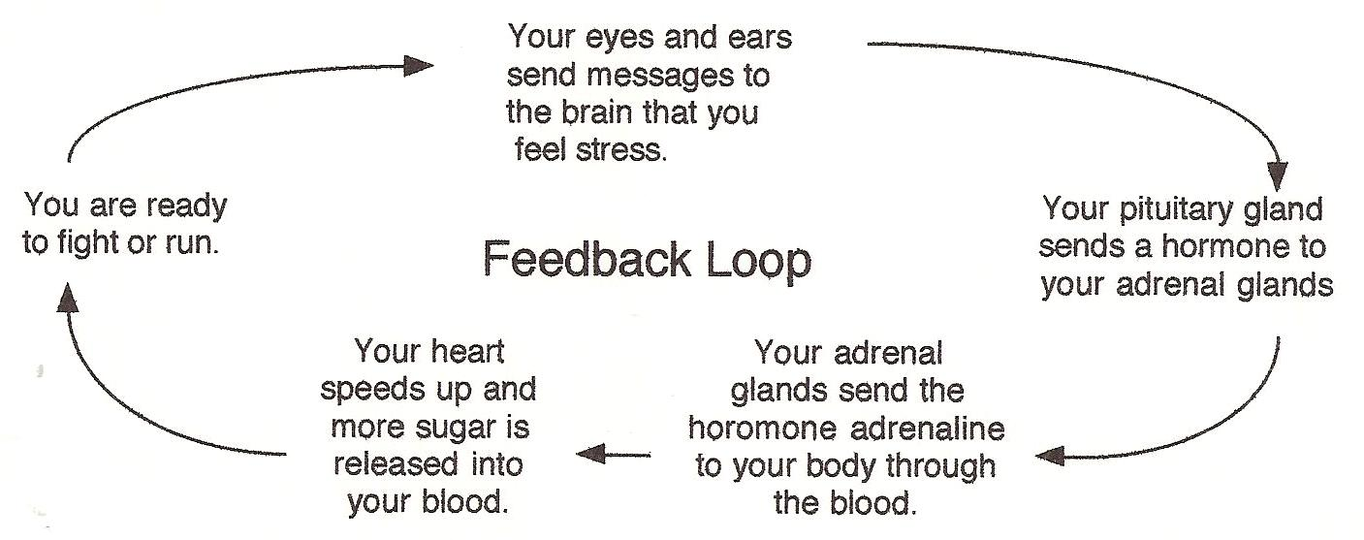
Watch the video Adrenaline: Fight or Flight Response from the website www.missdoctorbailer.com
Write down three things you learned from the video in the space below.

______________________________________________
______________________________________________
______________________________________________
______________________________________________

Use a ScienceSaurus (p. 097) or other resource to find the locations and function of each of the glands listed below. Write the function in the box. Then draw a line from the picture of the gland to where it is located inside the body.

Who Took the Insulin?
The food you eat supplies glucose (type of sugar) to the cells for energy. If you have the disease called diabetes then the glucose does not go into the cells because an organ called the pancreas is not producing insulin. The glucose stays in the blood where it is filtered by the kidneys and placed in the urine to be excreted. If the pancreas is not working correctly diabetics must take injections of insulin that they get from their doctor. Without insulin the body cannot maintain its balance.

Maintaining
Blood Glucose levels
You get ________ and eat _______.
Pancreas releases ______ to make cells use glucose.
Cells use glucose and oxygen to make __________
Blood glucose levels _____ _________.
Word Bank
insulinhungrygoes down
foodglucose
goes upenergy

Body turns food into _______ and blood glucose level ____ _____

Last night there was a robbery at the Springfield Drug Store. Ten bottles of insulin were taken. The Springfield Police Department has

eight likely suspects and they believe the perpetrator
is probably diabetic. All of the suspects have given
a urine sample.
A color change from yellow to blue/purple indicates there is sugar in the urine.

Materials: numbered urine samples in
test tubes for each table, universal indicator suspect sheet
What To Do:
1. Look at the suspect sheet and place the name of each suspect in the chart.
2. Place 5 drops of universal indicator in each test tube.
3. Swirl the test tube around so the liquids mix well.
4. Observe the color of the urine. Record.

Name of Suspect | Color of urine before testing | Color of urine after testing | Diabetic (yes/no)
1.
2.
3.
4.
5.
6.
7.
8.
Questions:
1. Who took the insulin? _______________________
2. How do you know? _________________________

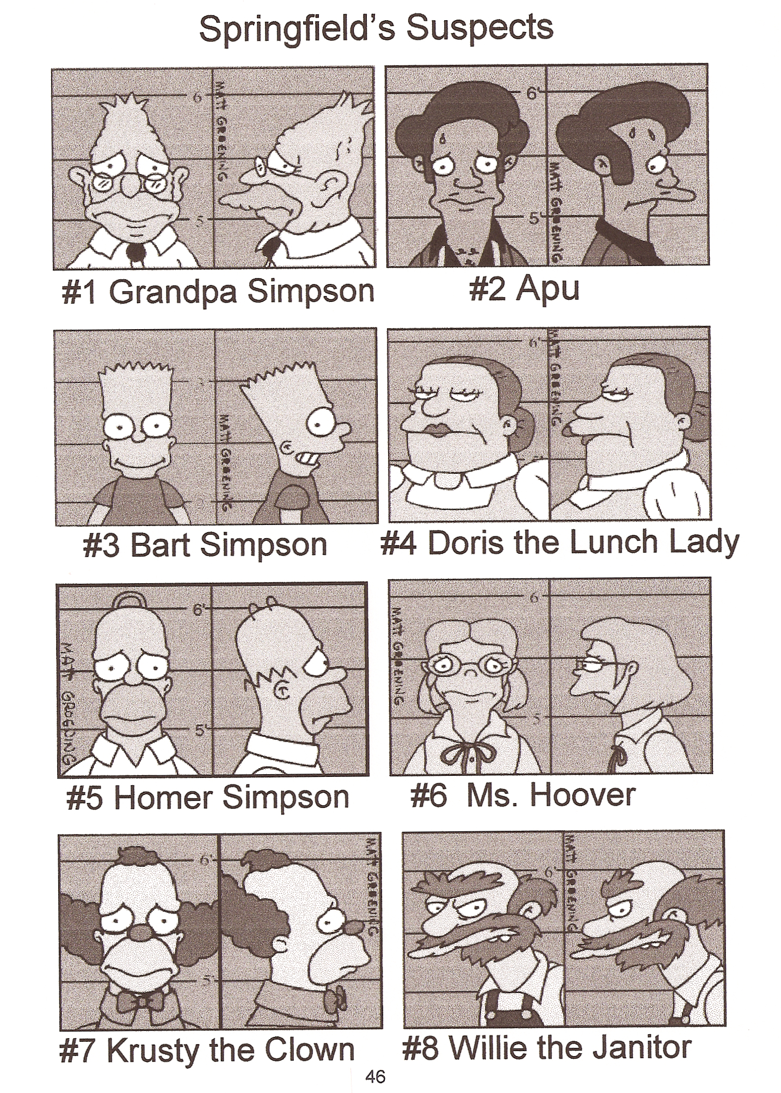

Name ________________ period _______
EXIT TICKET
Learning About the Endocrine System
1. Traveling fast on a roller coaster gives you an “adrenaline rush.” Which of the glands of the endocrine system produces adrenaline?

A. Thyroid
B. Pancreas
C. Ovaries
D. Adrenals

2. When something scary happens, your body gives you extra energy, your heart beats faster and your breathing speeds up. What is this response called?

A. Something Scary Response
B. Fight or Flight Response
C. Ready to Run Response
D. Ready to Fight Response

3. Which of the following is a hormone?

A. Hydrogen
B. Carbon Dioxide
C. Insulin
D. Pancreas

4. What is the disease called that happens when sugar can not be used by the cells of your body?

A. The common cold
B. Cancer
C. HIV
D. Diabetes

Name ________________ period _______
EXIT TICKET
Learning About the Endocrine System
1. Which of the following is a hormone?

A. Hydrogen
B. Carbon Dioxide
C. Insulin
D. Pancreas

2. What is the disease called that happens when sugar can not be used by the cells of your body?

A. The common cold
B. Cancer
C. HIV
D. Diabetes

3. When something scary happens, your body gives you extra energy, your heart beats faster and your breathing speeds up. What is this response called?

A. Something Scary Response
B. Fight or Flight Response
C. Ready to Run Response
D. Ready to Fight Response

4. Traveling fast on a roller coaster gives you an “adrenaline rush.” Which of the glands of the endocrine system produces adrenaline?

A. Thyroid
B. Pancreas
C. Ovaries
D. Adrenals

