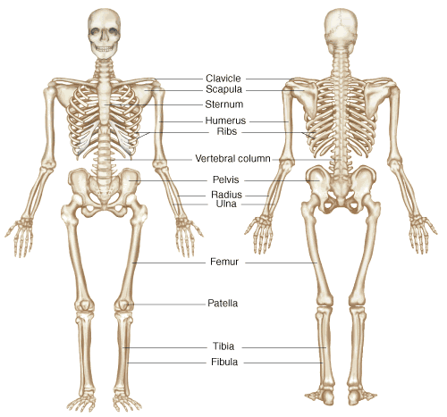
Learning About the Skeletal System
skull
phalanges
Just as a building could not stand without the steel beams that support it, you would collapse without your skeleton. Your skeleton has three major functions. It protects your internal organs, provides shape and supports your body. The skeletal system also enables you to move around, produce red blood cells and store certain materials, like calcium, until your body needs them.
One of the functions of the skeleton is to give shape to the body. Humans, fish, deer, frogs and giraffes all have different shapes because their skeletons have different structures. Bones also protect many of the organs in your body. For example, your skull protects your brain and your breastbone and ribs form a protective cage around your lungs and heart. Your skeleton provides support by allowing you to stand up.

Materials: a bag with various bones
What To Do:
1. Lay out all the bones in the bag on your table.
2. Determine the name of the bones by comparing them to the Human Skeleton diagram.
3. Write the scientific names of the bones in the chart below. Then determine the common name (what you call it).

Scientific Name | Common Name
1.
2.
3.
4.
5.
6.
7.

Questions:
1. How are the bones you observed similar? __________________________________
2. How are the bones you observed different? ____________________________________
3. Which of these bones might protect internal organs?
________________________________
4. Which of these bones might provide support for
the body? ________________________________

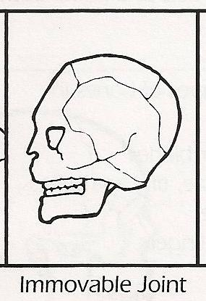

How Your Body Bends
Bones move and allow you to bend only at joints. There are three main kinds of joints in the body. They are fixed joints, partly moveable joints and moveable joints. Fixed joints do not allow any movement. The joints of your skull are not moveable after you are born. Partly moveable joints, like the ones in your ribs allow a little movement. Most of the joints of your body are moveable joints. There are four kinds of moveable joints. Look at the pictures below.
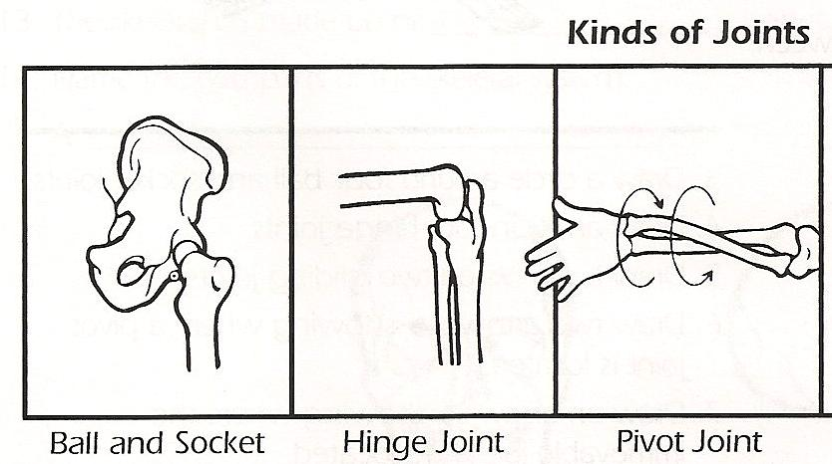
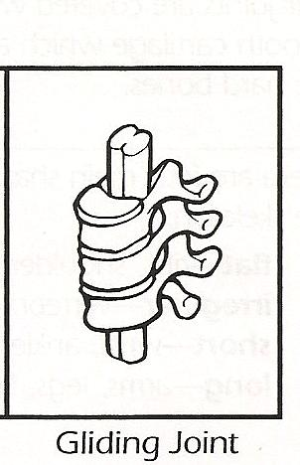

Watch the video segment The Skeleton Joints from www.missdoctorbailer.com and circle where each
kind of joint can be found.

Ball and socket | Hip | Finger | Shoulder
Hinge | Hip | Knee | Finger
Pivot | Arm | Neck | Hip
Gliding | Spine | Wrist | Toe

The Integumentary System
The integument is another name for skin. It is the body’s largest organ. The system includes the skin, hair, nails and some glands. There are several functions of the integumentary system. The first, and most important, is to act as a physical barrier to invaders such as bacteria and viruses. It also helps keep us cool by using the sweat glands and uses UV sunlight to make vitamin D. It also contains the nerves –called receptors - that allow us to feel pain, touch, hot and cold.

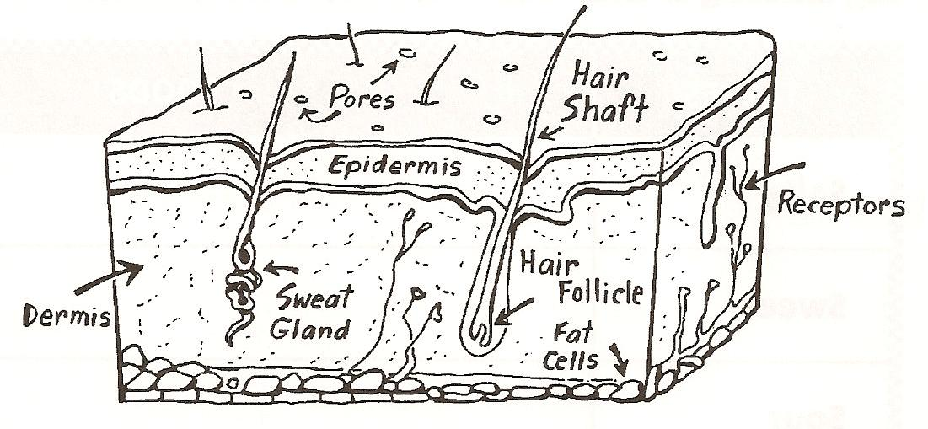

Color the section of skin above the following colors:
Pores – purple
Epidermis –pink
Dermis – yellow
Sweat gland – blue
Hair shaft – brown
Hair follicle –green
Receptors – red
Fat cells - orange

Name _______________ period _____
EXIT TICKET
Skeletal/Integumentary Systems
1. Which of the following is NOT a function of the
skeletal system?
A. Support your body
B. Give shape to your body
C. Bring oxygen to your body
D. Protect your body

2. Where are you able to bend your skeleton?

A. In the middle of the bones
B. At the joints
C. Anywhere you want

3. Where in your body would you find a ball and
socket joint?

A. Skull
B. Hip
C. Ribs
D. Fingers

4. Which of the following in NOT a part of the integumentary system:

A. heart
B. hair
C. nails
D. glands

5. Name an important function of the integumentary system.
__________________________________________

Name _______________ period _____
EXIT TICKET
Skeletal/Integumentary Systems
1. Which of the following in NOT a part of the integumentary system:

A. heart
B. hair
C. nails
D. glands

2. Name an important function of the integumentary system.
__________________________________________

3. Which of the following is NOT a function of the
skeletal system?
A. Support your body
B. Give shape to your body
C. Bring oxygen to your body
D. Protect your body

4. Where are you able to bend your skeleton?

A. In the middle of the bones
B. At the joints
C. Anywhere you want

5. Where in your body would you find a ball and
socket joint?

A. Skull
B. Hip
C. Ribs
D. Finger

