Learning About Muscles and Work
There are about 600 muscles in your body. Muscles have many functions. For example, they keep your heart beating, pull your mouth into a smile and move the bones of your skeleton. The heart and diaphragm are both muscles we have no control over. These types of muscles are called involuntary muscles. Muscles that we control are called voluntary muscles.
Your bones are moved by the muscular system. Muscles move only in one direction –they pull bones together. They cannot push bones apart. Muscles that move bones work in pairs. One muscle contracts and pulls the bones together. This causes the second muscle to relax. Then the other muscle contracts and pulls the same bones apart causing the first muscle to relax.
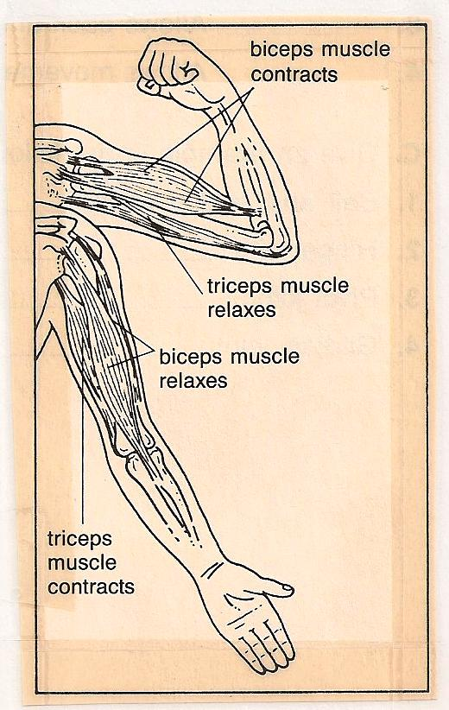
Observe the picture and answer the questions.
1. Name the two muscles in the picture. ________
____________________
2. Which muscle is contracting when you bend your arm? ____________
3. Which muscle is relaxing when you bend your arm? _________
4. Which muscle is contracting when you straighten your arm?
__________________
5. Which muscle is relaxing when you straighten your arm?
____________________________

Materials: student partner
What To Do:
1. Sit in your chair and place you hand on the top of your head.
2. Your lab partner will try to pull your hand off your head.
3. Your partner can only use one hand and must lift straight up.
Don’t pull to the side, and no jerking allowed!
4. You must try to keep your hand from leaving your head.
Questions:
1. Which muscle are you contracting?__________
2. Which muscle is relaxing? _________________
3. Which muscle is your lab partner contracting during this activity? ________________
4. Which muscle is your lab partner relaxing during this activity? _________________
5. Which muscle appears to be stronger?________

Materials: spring-type clothespin, timer
What To Do:
1. Grip the clothespin with the thumb and index
finger of your writing hand.
2. Squeeze the clothespin open and shut as quickly as possible for 2 minutes
3. Your partner will use the timer to time you.
4. Count how many times you can squeeze before your muscles tire.
5. Rest for 1 minute and repeat.
6. Record your information and repeat with your partner.
Names | Time 1 | Time 2

Questions:
1. Were you able to squeeze the clothespin as many times the second time you tried it? __________________
2. Why do you think this happened? ______________
3. You had to use force to open the clothespin. Where did the force come from? _________________________

Your muscles and Work
You and your friends use your muscles to try to push a car out of the ditch. After 10 minutes of pushing really hard, you’re muscles are very tired. The car is still stuck in the ditch. That sure was hard work, wasn’t it? You exerted a lot of force. But you might be surprised to discover that, in scientific terms, you didn’t do any work at all on the car!
In science you do work on an object when you exert a force on the object that sets the object into motion. So why didn’t you do work in trying to push the car out of the ditch? The car didn’t move. In order for you to do work on an object, the object must move some distance as a result of your force.
The amount of work you do on any object can be calculated. It depends on both the amount of force you exert (measured in Newtons) and the distance the object moves (measured in meters). So you can calculate the amount of work done on an object by multiplying force times distance. The (SI) unit for work is Nm and that has been name Joules (J) for James Prescott Joule.
Work = Force X Distance

If you exert a force of 20 N on a table to move it
10 m, how much work do you do?

_________ X __________ = __________
force distance work

DO NOT GLUE DO NOT GLUE
Glue Here | 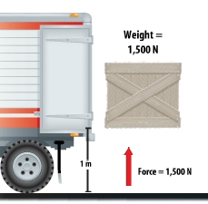
Glue Here | 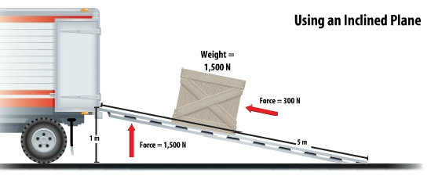
 | 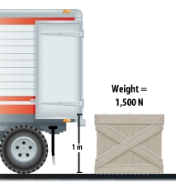

Teacher instructions previous page

Show students video clip at the following website

http://glencoe.mcgraw-hill.com/sites/0078778360/student_view0/chapter4/concept_animations.html#

Have students make the previous page a foldable. Cut on the dotted lines and fold on the solid line. Have them glue only the thin area between the dotted line and the solid line in their notebook.

Under each flap have the students copy and answer the following questions:

1. What is the force used on the box? ____________
2. What is the distance the box was moved? ________
3. Calculate the work done on the box. Show your work!

If time allows, watch the Muscles video from www.Brainpop.com

Name _______________ period _____
EXIT TICKET
Muscles and Work
1. What is the function of the muscular system?

A. To bring air into the body
B. To take blood around the body
C. To move your bones
D. To control your responses

2. What is an example of an involuntary muscle?

A. heart C. biceps
B. triceps D. brain

3. Muscles we have control over are called –

A. cardiac muscles
B. voluntary muscles
C. involuntary muscles
D. smooth muscles

4. A box weighted 3000N and you wanted to move it
10m but you could not get it to move. How much work did you do?

a. 3000 J
b. none
c. 30,000J
d. 300 J

5. What is the formula for calculating Work?

a. weight x distance
b. work x distance
c. force x distance
d. mass x distance

Name _______________ period _____
EXIT TICKET
Muscles and Work
1. A box weighted 3000N and you wanted to move it
10m but you could not get it to move. How much work did you do?

a. 3000 J
b. none
c. 30,000J
d. 300 J

2. What is the formula for calculating Work?

a. weight x distance
b. work x distance
c. force x distance
d. mass x distance

3. What is the function of the muscular system?

A. To bring air into the body
B. To take blood around the body
C. To move your bones
D. To control your responses

4. What is an example of an involuntary muscle?

A. heart C. biceps
B. triceps D. brain

5. Muscles we have control over are called –

A. cardiac muscles
B. voluntary muscles
C. involuntary muscles
D. smooth muscles

