Learning About the Digestive System
The word “digest” means to break down. So the major function of the digestive system is to break down food. Actually, the digestive system has three functions. The first function is to break down food into small pieces. The second function is to absorb the nutrients from the food into your blood so that it can to get into all of your cells. Your cells need the nutrients in food to give you energy. The third function is to absorb water from the food and liquids that you eat and drink.
There are a number of organs in your digestive system that have specific functions to perform. Digestion begins in your mouth. Your tongue and teeth mix your food with saliva so you can swallow it. After you swallow your food it is pushed into the stomach by a tube called the esophagus. Digestion continues in the stomach with hydrochloric acid to break down the food and continues in the small intestine with the help of chemicals from the liver. The lower part of the small intestine places the nutrients in your blood so it can be taken to all the cells of your body. Then water is placed into the blood by the large intestine. The anus eliminates any food that was not digested.

Organs of the Digestive System
Materials: colored pencils
What To Do:
1. Label the mouth and throat and color it red.
2. Label the esophagus and color it pink.
3. Label the stomach and color it yellow.
4. Label the small intestine and color blue.

5. Label the large intestine and color it orange.

6. Label the anus and color it brown.
7. Find the liver behind the stomach. Label it
and color it red/brown.
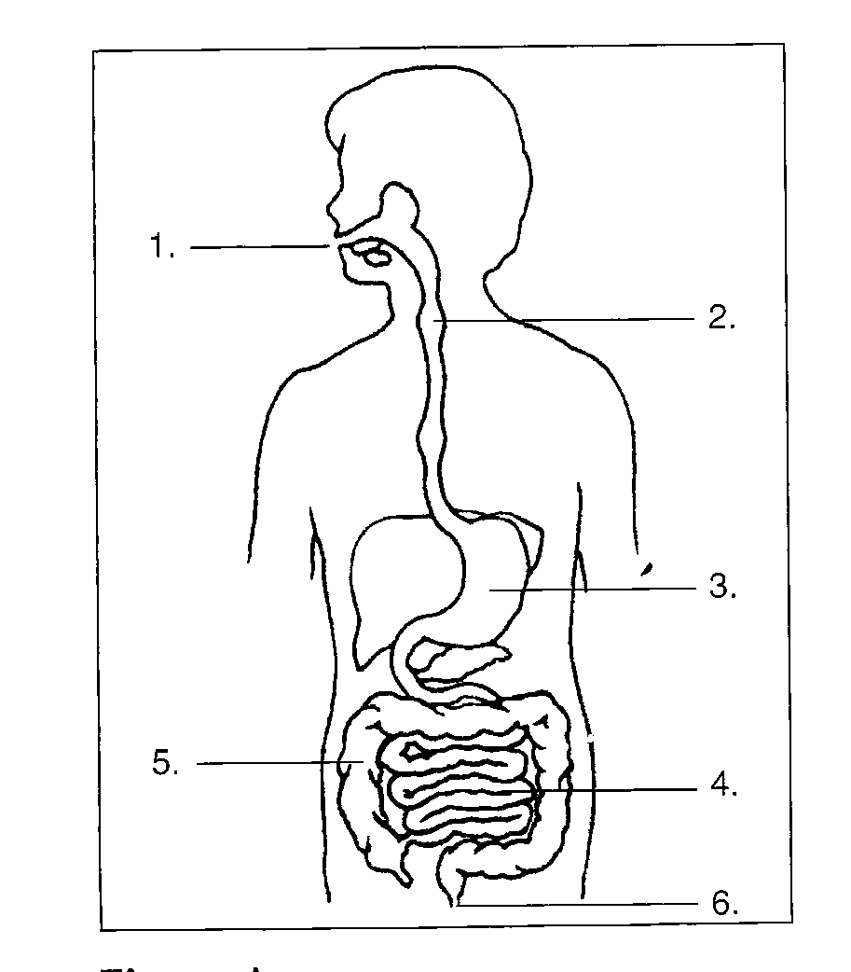
7.

Questions:
1. Where does digestion start? __________
2. Where is water absorbed? _____________
3. What is the name of the tube that connects the mouth
and the stomach? ___________
5. What does the word digest mean? _________________
6. How does the circulatory system help the digestive system? _____________________________________

Physical and Chemical Change in Digestive System
Digestion of food includes some physical and chemical changes. When you chew up some food two changes are occurring in your mouth at the same time. The first one involves your teeth. They break down the food into smaller pieces – this is a physical change. At the same time your salivary glands release saliva. The saliva has two functions – one to make the food moist enough to swallow-which is a physical change and the other is a chemical change. Saliva contains a chemical called amylase. The chemical causes any starch molecules to be broken down into sugar molecules.
Another chemical change happens in your stomach. When the hydrochloric acid mixes with proteins they are broken down into amino acids. A chemical supplied by the liver, called bile, breaks down fats and another from the pancreas breaks down sugars.

Place a check in the box to indicate which type of change is described.

Digestive Process | Physical Change | Chemical Change
Teeth breaking up food
Making food moist with saliva
Changing starch into sugar
Breaking down proteins into amino acids
Bile breaking down fats
Breaking down food into glucose

Materials: 1 cracker, 1 zip-lock baggie, 1 portion cup, whole milk, hydrochloric acid or vinegar, spoon
What To Do:
Part I
- Place 1 cracker on the paper towel and use your fingers to break it into 5-6 pieces.
- Place it in a baggie and add some hydrochloric acid or vinegar to it. Mix the cracker with the liquid.
3. Place a small amount of milk in the portion cup. Just enough milk to cover the bottom!
4. Place 25 drops of the hydrochloric acid or vinegar in the milk and stir with the spoon.

Questions:

1. What part of the digestive process did the breaking up of the crackers on the paper towel simulate? __________
2. Was this a physical or chemical change? ___________
3. What part of the digestive process did mixing the cracker and the hydrochloric acid or vinegar in the bag simulate? ____________________________________________
4. Was this a physical or chemical change? __________
5. What part of the digestive process did adding vinegar to milk in the condiment cup simulate? ____________________________________________
6. Was this a physical or chemical change? ___________
7. What does the mixture of milk and hydrochloric acid remind you of? (Think babies) ___________________

Name __________________ period _____
EXIT TICKET
Digestive System
1. Which of the following is NOT a function of the digestive system?
A. bring oxygen to the body
B. break down food into small pieces
C. absorb the nutrients from the food into your blood

2. Where does digestion begin?

A. stomach
B. mouth
C. liver

3. Which of the following is a type of physical change that happens during digestion.

A. amylase breaking down starches
B. hydrochloric acid breaking down proteins
C. teeth breaking up food into small pieces

4. Which of the following is a type of chemical change that happens during digestion?

A. amylase breaking down starches into sugars
B. teeth breaking up food into small pieces
C. wetting food so you can swallow it

Name __________________ period _____
EXIT TICKET
Digestive System
1. Which of the following is NOT a function of the
digestive system?
A. break down food into small pieces
B. bring oxygen to the body
C. absorb the nutrients from the food into your blood

2. Which of the following is a type of chemical change that happens during digestion?

A. wetting food so you can swallow it
B. teeth breaking up food into small pieces
C. amylase breaking down starches into sugars

3. Which of the following is a type of physical change
that happens during digestion.

A. teeth breaking up food into small pieces
B. hydrochloric acid breaking down proteins
C. amylase breaking down starches

4. Where does digestion begin?

A. stomach
B. liver
C. mouth

