Learning About the Excretory System
Removing waste products from the body is the major function of the excretory system. It works with both the respiratory and circulatory system to remove these wastes. There are four major organs in the excretory system. These organs are the lungs, liver, kidneys and skin.
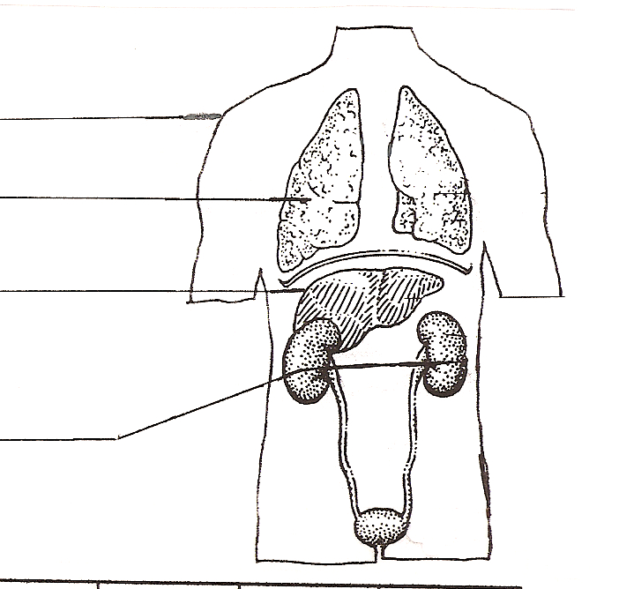
You have learned that the lungs excrete carbon dioxide waste. The lungs also excrete small amounts of heat and water. The skin excretes most of the body’s waste heat. In addition, the skin removes some water and salts. These wastes are excreted by the skin as sweat. This sweat helps your body cool off. The liver filters the blood and changes harmful materials, such as alcohol, to harmless materials. These harmless materials are placed in the blood so the kidneys can filter it out. The kidneys filter out excess water and excrete it in a liquid waste called urine.
1
2
3
4

Materials: colored pencils
What To Do:
1. Label 1 skin and outline it in brown.

2. Label 2 lungs and color them pink.

3. Label 3 liver and color it purple.

4. Label 4 kidneys and color them yellow.

As you breathe out, carbon dioxide is exhaled from your body. When carbon dioxide gas is combined with water it will make an acid called carbonic acid.

Cabbage juice can be used to determine the pH or the acidity of a substance. Very acidic solutions will turn a red color. Basic – the opposite of acidic solutions appear greenish-yellow. Neutral – neither acid nor basic - solutions result in a purplish color.

Materials: Straw, test tube, wash bottle of cabbage juice, paper towels

What To Do:
1. Place two fingers of cabbage juice in your test tube.
2. Place the straw in the test tube.
3. Wrap a paper towel around the top of the test tube so that it covers the opening and any splashes will be absorbed.
4. GENTLY blow into the straw so that bubbles appear.
5. Continue blowing until the cabbage juice changes color.

Questions:
1. What color was the cabbage juice before you started blowing into it? _______________________________
2. What color was the cabbage juice after you finished blowing into it? _______________________________
3. What gas do you breathe out? ___________________
4. What happens when this gas mixes with water?
______________________________________________
5. What does the color change in the cabbage juice tell you about the gas in your breath? ________________

Using information from the first page place a check mark in the boxes below that tell the function of each organ of the excretory system.
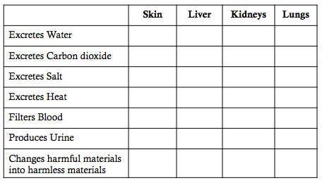

The kidneys keep our body in balance through a feedback loop with the nervous system and the endocrine system. It is important to maintain water balance in the body. If we have too much water, our cells fill up and our feet and hands can swell. If we have too little water in the blood, our liver and kidneys cannot do their job and we can become sick and die.

When we get thirsty we usually drink water. After the water has been put in the blood by the large intestine, the pituitary gland sends a message to the kidneys to filter water out of the blood. The kidneys filter out the water and that increases the amount of water in the urine. When we have gotten rid of the extra water, then we get thirsty again. Thus maintaining balance in our body.

Use the phrases below to fill in the feedback loop.

Maintaining water balance in the body

- Body gets rid of extra water
- Get thirsty and drink water
- Pituitary gland tells kidneys to filter out water
- Amount of water in urine increases
- Large intestine absorbs water

Name ______________ period _____

EXIT TICKET
Excretory System
1. Which of the following is NOT a waste from the human body?
A. Sweat C. Heat
B. Urine D. Sweet

2. Which of the following is part of the excretory system?

A. Stomach C. Heart
B. Kidneys D. Small Intestine

3. What acid is produced when carbon dioxide mixes with water?
A. Hydrochloric Acid C. Phosphoric Acid
B. Nitric Acid D. Carbonic Acid

4. Which of the following is the function of the excretory system?
A. Break down food. C. Remove wastes
B. Take oxygen to the body D. Protect the body

5. What is the signal from our body that tells us to drink water?
A. Thirst C. Hunger
B. Laughing D. Sleepiness

Name ______________ period _____

EXIT TICKET
Excretory System
1. What is the signal from our body that tells us to drink water?
A. Thirst C. Hunger
B. Laughing D. Sleepiness

2. Which of the following is the function of the excretory system?

A. Break down food. C. Remove wastes
B. Take oxygen to the body D. Protect the body

3. What acid is produced when carbon dioxide mixes with water?
A. Hydrochloric Acid C. Phosphoric Acid
B. Nitric Acid D. Carbonic Acid

4. Which of the following is NOT a waste from the human body?
A. Sweat C. Heat
B. Urine D. Sweet

5. Which of the following is part of the excretory system?

A. Stomach C. Heart
B. Kidneys D. Small Intestine

