Learning About the Reproductive Systems

The human reproductive systems are different in males and females. The function of the reproductive system is to produce cells that can unite and produce babies.

Male reproductive system
The testes are the organs that produce the sperm cells. Millions of sperm are produced every day. The sperm move from the testes to outside the body through tubes called the vas deferens. Then the sperm enter the urethra, the tube inside the penis, and leave the body. Glands in the man’s body produce chemicals that are added to the sperm as they pass through the tubes. These fluids, along with the sperm, make up semen. The male hormone, testosterone is produced in the testes and helps control the reproductive system.

Materials: Colored pencils
What To Do:
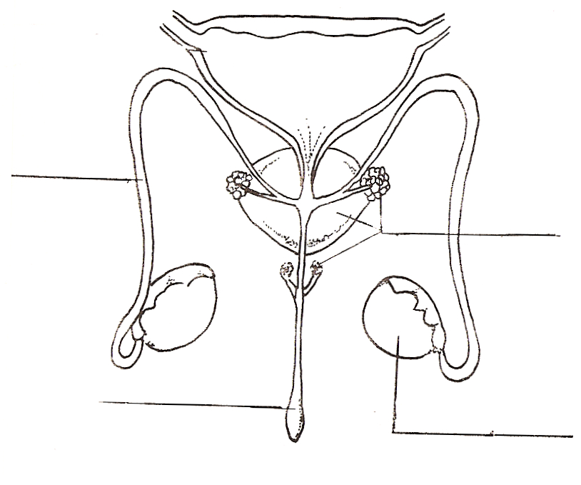
1. On the diagram color the
1
2
3
4
5
testes orange.
2. Color the
vas deferens brow
3. Color the glands
green
4. Color the urethra blue
5. Color the bladder
yellow.

Female reproductive system
Ovaries produce egg cells. The ovaries contain thousands of potential eggs but usually only one egg matures each month. When the egg is released from the ovary it travels down the Fallopian tubes to the uterus. It is within the uterus that the new baby develops. The uterus is connected to the outside by the vagina, a passageway that serves as a birth canal. Female hormones, such as estrogen and progesterone, are produced in the ovaries and the uterus and regulate the reproductive system.

1. On the female diagram color the ovaries orange.
2. Color the Fallopian tubes purple.
3. Color the uterus pink.
4. Color the vagina blue.
5. Find the eggs and color them red.
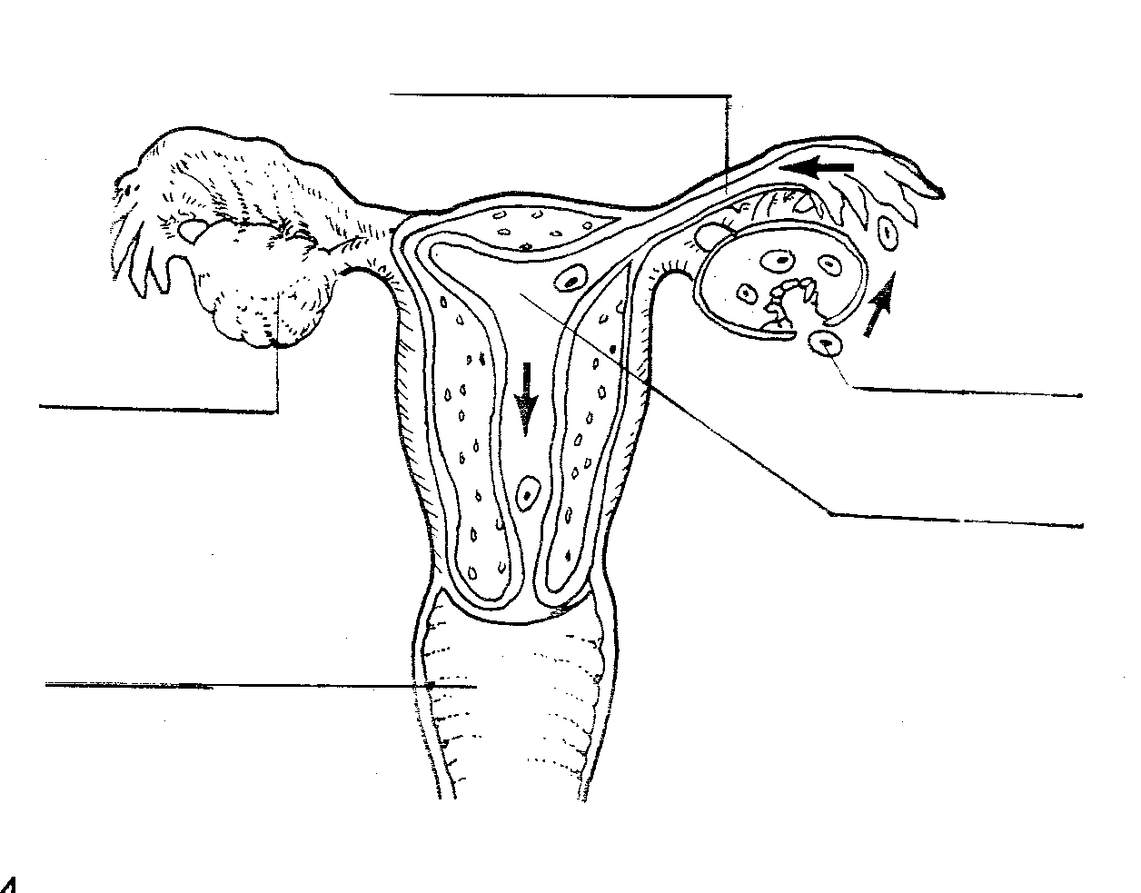
1
2
3
4
5

Questions:
1. What is the male hormone called? _____________
2. Where is it produced in the body? _____________
3. What are the female hormones called? __________
_______________________________________
4. Where are they produced in the body? ___________

How Fertilization Takes Place
What To Do:
1. Watch the videos Fertilization and From Cell to Embryo from www.missdoctorbailer.com
2. Decide what is happening in the diagrams below.
3. Place the number in the correct blank to order the steps.
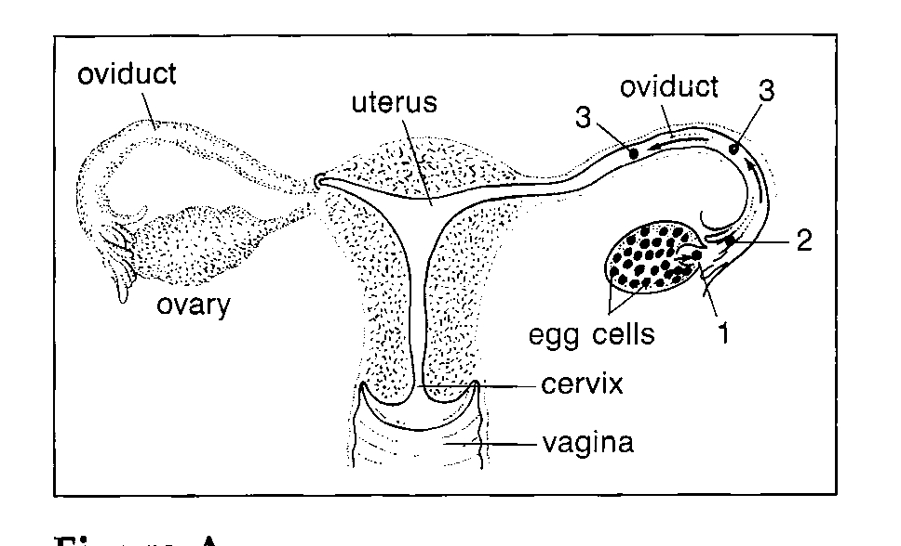
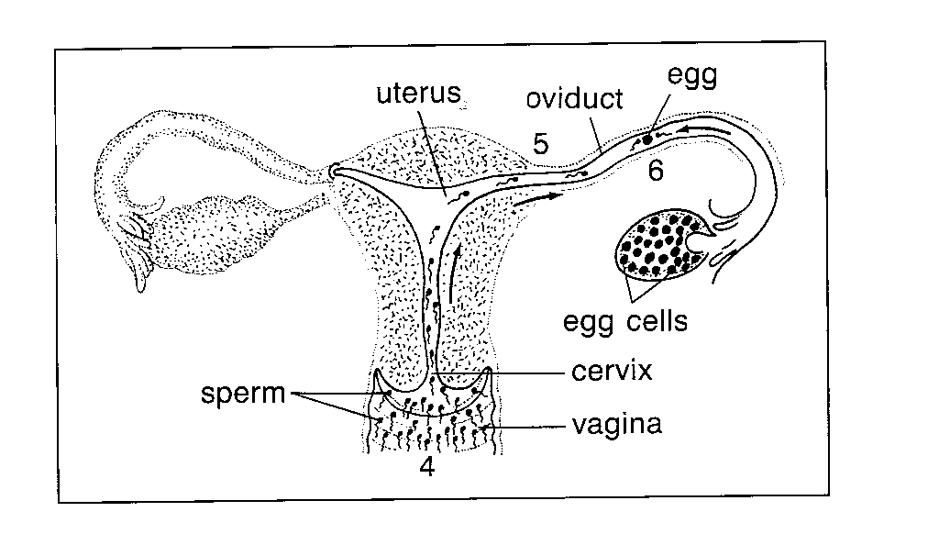
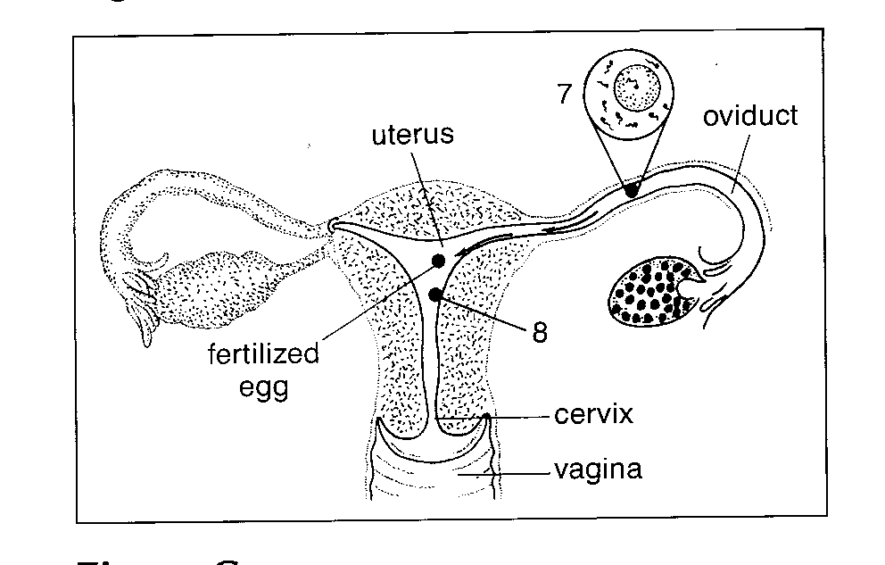
__The egg enters the
fallopian tube.

__The ovary releases
a mature egg.

__The egg moves along
the fallopian tube.
__ The fertilized egg
attaches itself to the
uterine wall.

___ One sperm penetrates
the egg and
fertilization takes place.

___ Only a few sperm
reach the egg.

___The sperm swim
toward the fallopian
tube and the egg.

__ Millions of sperm enter
the female reproductive
system through the
vagina.

Question:
1. How many sperm fertilize an egg? ______________

Your teacher will show you a power point on Multiple Births. Answer the following questions from the information in the slide show. There is also a video about conjoined twins.

1. What is the typical birth weight of a singleton baby? _____

2. How often are twins born? _________________

3. What are the two types of twins? ____________________

4. How many eggs and sperm are used to create identical twins? ________________________________

5. How many eggs and sperm are used to create fraternal twins? ________________________________

6. What is the birth weight of triplets? ________________

7. How many babies are quadruplets? ________________

8. How do fertility drugs work? _______________________

9. What is the scientific word for Siamese Twins?

___________________________________________

10. Why can some Conjoined twins be separated?

______________________________________________

11. Why can’t Brittany and Abby be separated?

_____________________________________________

Name ________________ period _____

EXIT TICKET
Reproductive System
1. Which of the following is the male hormone?

A. Progesterone C. Estrogen
B. Testosterone D. Insulin

2. Which of the following is one of the female hormones?

A. Insulin C. Estrogen
B. Testosterone D. Pectin

3. What is the process called when a sperm enters an egg?

A. Photosynthesis C. Fertilization
B. Glycolysis D. Gestation

4. What is the function of the reproductive system?

A. To produce digestive enzymes
B. To take food to all body cells
C. To make cells that can unite to make a baby
D. To protect internal organs

5. How many sperm fertilize an egg when identical twins are created?

A. one C. three
B. two D. four

Name ________________ period _____

EXIT TICKET
Reproductive System
1. Which of the following is one of the female hormones?

A. Insulin C. Estrogen
B. Testosterone D. Pectin

2. What is the process called when a sperm enters an egg?

A. Photosynthesis C. Fertilization
B. Glycolysis D. Gestation

3. What is the function of the reproductive system?

A. To produce digestive enzymes
B. To take food to all body cells
C. To make cells that can unite to make a baby
D. To protect internal organs

4. Which of the following is the male hormone?

A. Progesterone C. Estrogen
B. Testosterone D. Insulin

5. How many sperm fertilize an egg when identical twins are created?

A. one C. three
B. two D. four

