Frog Reverse Dissection

We have been learning about the human body systems. Vertebrates (animals with backbones) tend to have similar systems and since frogs and humans are both vertebrates we can relate the organs and systems we observe in the frog to what we would observe in humans.
The frog we dissect is a grass frog. They are grown in Mexico. They have muscular back legs for jumping and small front legs that help them land. They have eyes and nostrils (nose openings) on the top of their head. This allows them to sit under the water with just the eyes and nostril above the surface of the water. This position in the water allows them to catch insects easily.
Part 1
External Structures of the Frog

What To Do:
Label the following parts:
1. Eyes.
2. Jumping Legs
3. Nostrils
4. Ear Drum
5. Landing Legs
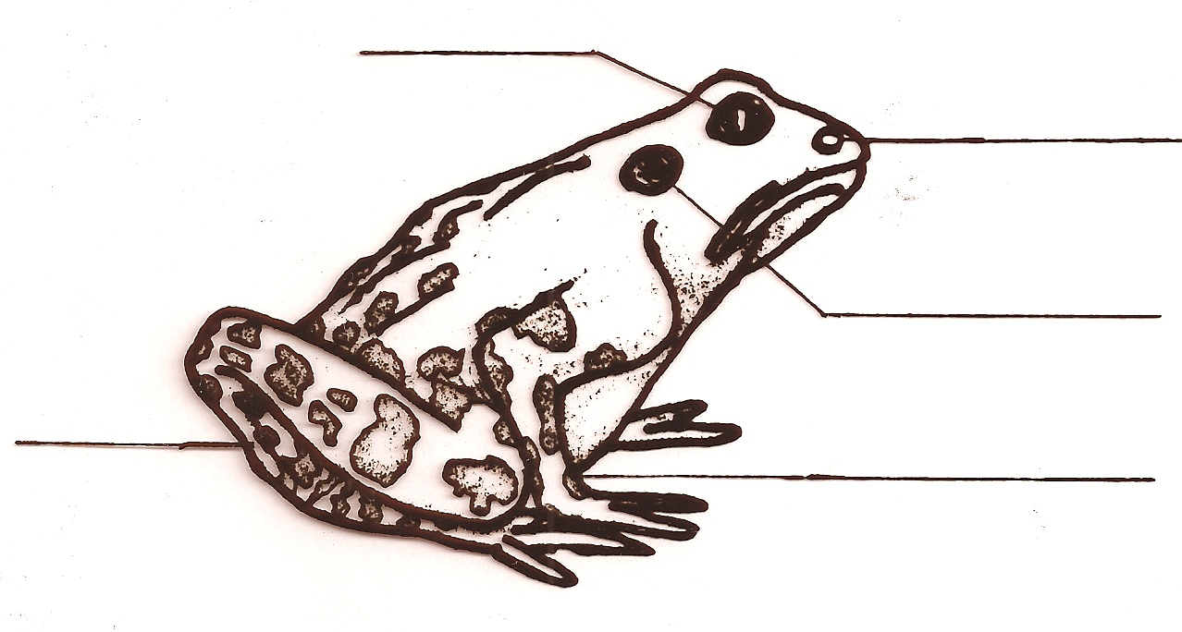
1
3

4
5

2

Internal Mouth Structures of the Frog

The frog has vomerine teeth in the roof of the mouth that allow the frog to hold on to the prey. The nostrils have openings in the roof of the mouth, too. The frog uses its tongue to draw in air when it is sitting in water. When the frog is on land it absorbs oxygen through its moist skin. If a frog’s skin dries out it will die because it can’t get enough oxygen.
In the bottom of the mouth the frog has the opening to the esophagus and the opening to the vocal sac. It draws air into the vocal sac (the balloon like organ under the chin) to make the croaking sound. It uses this sound to find a mate.
The tongue of the frog is not attached to the back of the throat like ours is. It is attached at the front behind the teeth. This is so the y-shaped tip can always have sticky salvia on it – the better to catch insects!
What To Do:
Label the following parts:
6. vomerine teeth 7. nostril openings
8. eye sockets 9. tongue
10. esophagus opening 11. vocal sac opening.

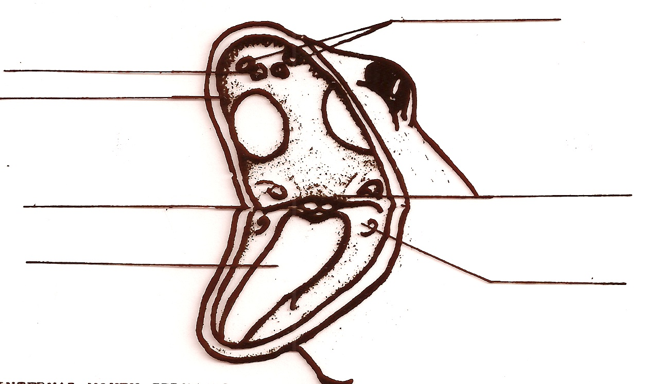
7
8

9
6
10
11

Materials: colored pencils, scissors, glue

What To Do:
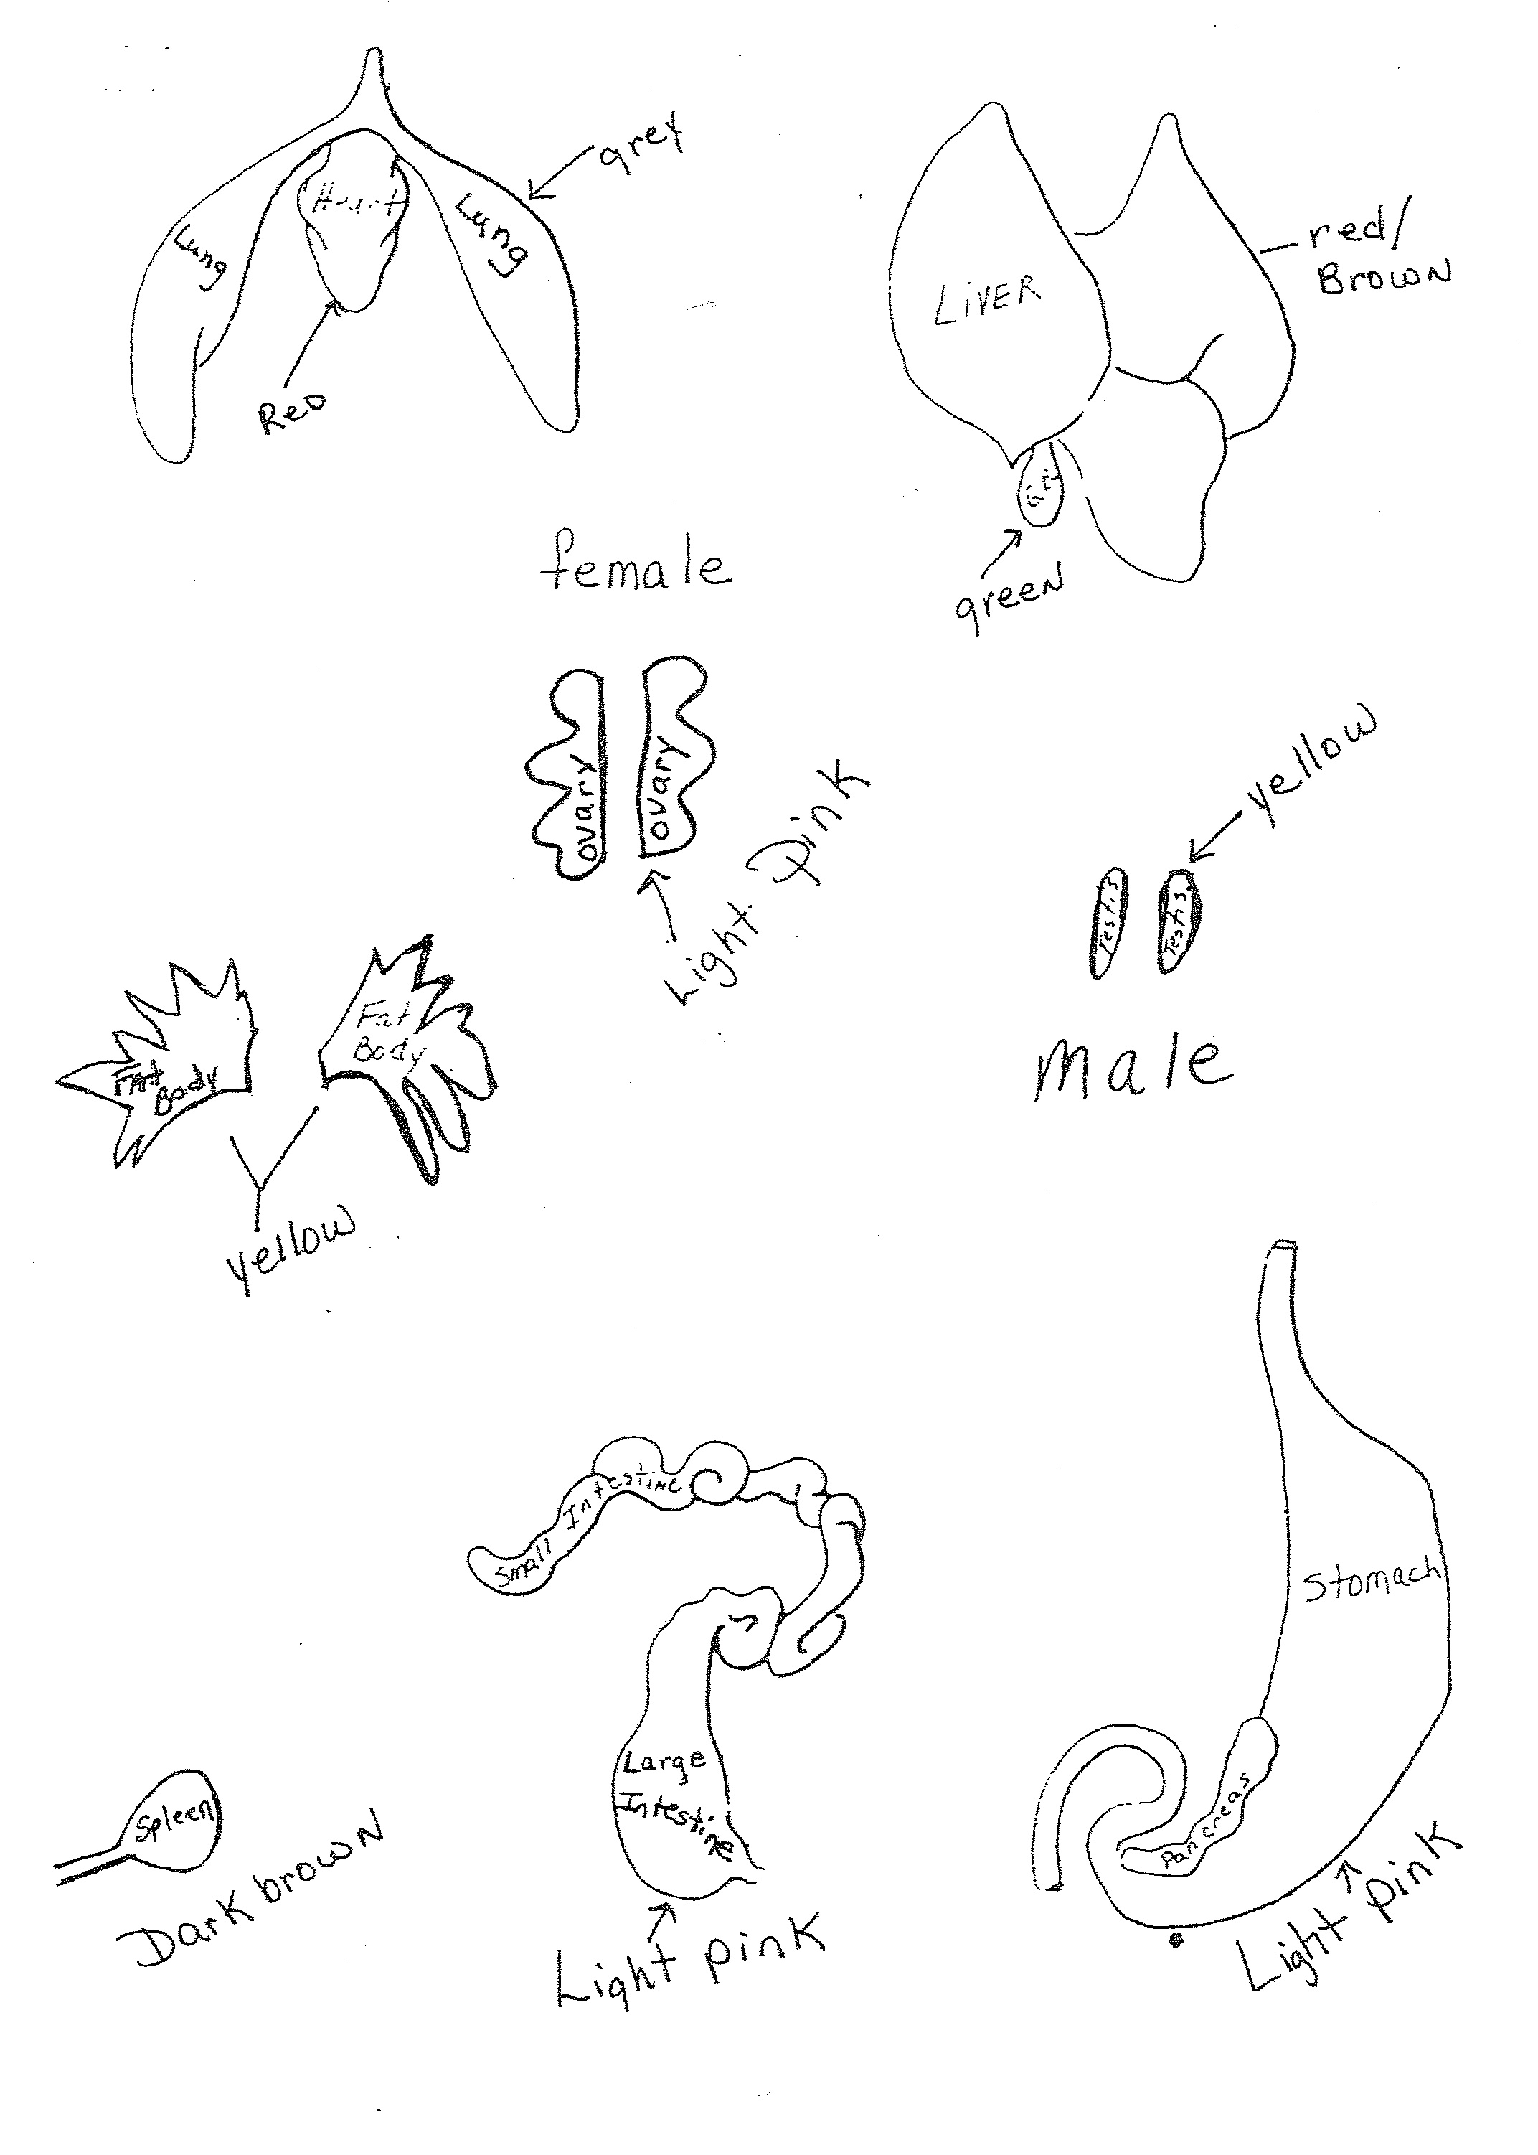
1. Color organs as indicated on the next page.
2. Cut them out and place them in the frog’s body as shown
by your teacher.
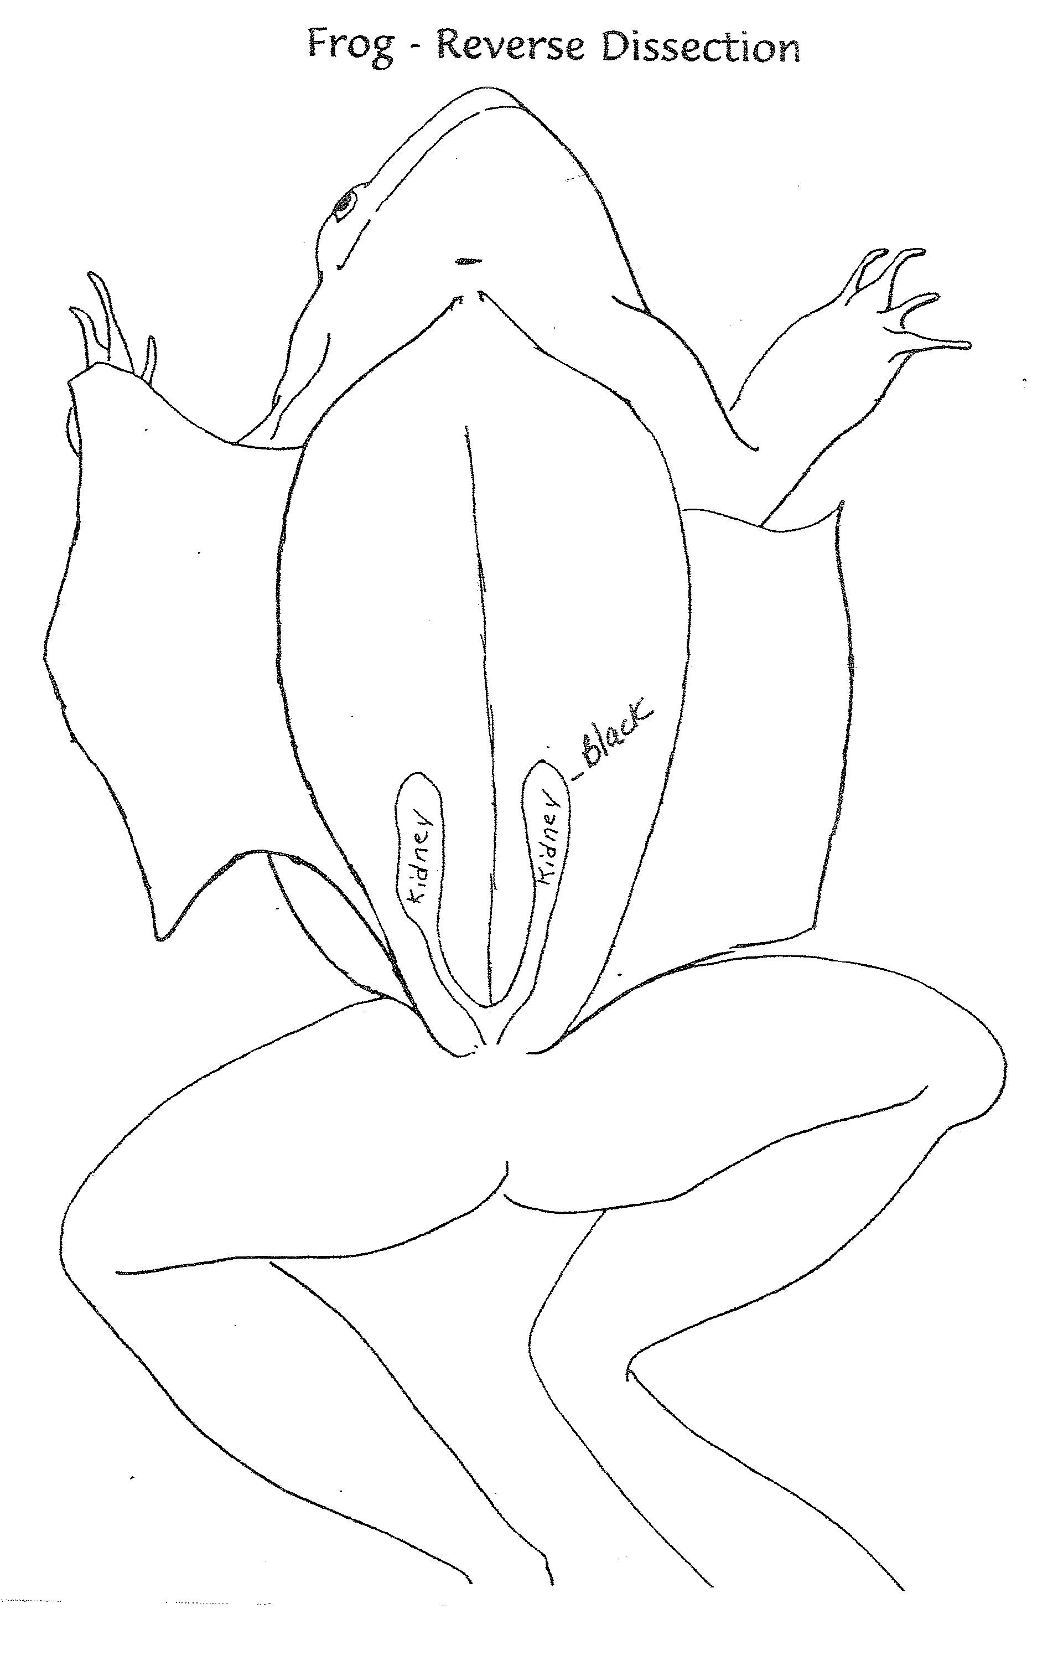
Do Not Color
this area

DO NOT GLUE! Color, cut out and glue organs into Frog body as shown by your teacher.
Name __________________ period _____

EXIT TICKET
Reverse Dissection
Directions: In the Venn Diagram below write 3 ways frogs are different than humans and 3 ways frogs are similar to humans.

Humans Frogs

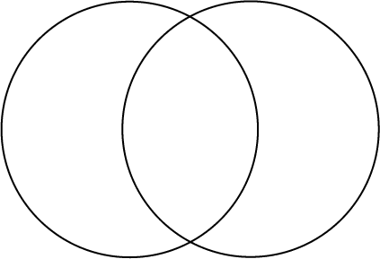

Name __________________ period _____

EXIT TICKET
Reverse Dissection
Directions: In the Venn Diagram below write 3 ways frogs are different than humans and 3 ways frogs are similar to humans.

Humans Frogs

