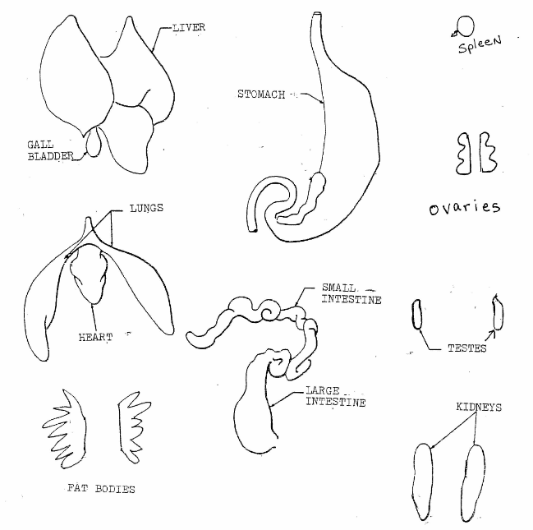Name ___________________________ Period _________

Name ____________________________

Frog Dissection Observation Sheet

1. Follow the directions on the Frog Dissection Sheet.

2. Place each organ you cut out of the frog on the correct drawing to the right.

3. After your teacher has graded your work, throw the **ORGANS** in the trash and place this sheet on the teacher’s desk. Each organ is worth 10 pts each.

4. Remember you will only find ovaries OR testes - not both!

5. If time allows find the green eyeballs and take them out of the frog.

6. Wash up the dissection tools and clean up your table.