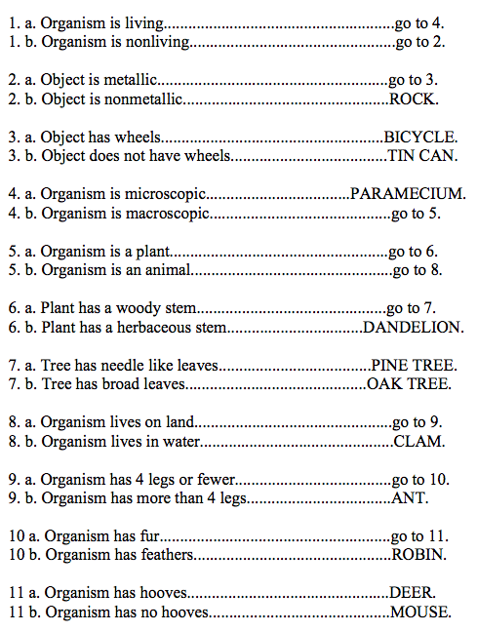
Using a Dichotomous Key

The word dichotomous comes from Greek and English roots: dicho is Greek for “in two,” and tom means, “to cut.” So dichotomous means “to cut in two” or “divide in two.” And that’s what you do at each stage of deciphering a dichotomous key – divide in two.
A dichotomous key is a grouping tool that scientists use to classify animals or plants based on observations. The key focuses on one feature of a living thing at a time. Usually the key will list the presence or absence of something or maybe highlight opposites. When using a dichotomous key, you will look at one characteristic at a time and divide your specimens into two groups until each living thing has been placed into a category all its own.
Here is a dichotomous key for various objects and organisms. Focus on one object at a time (see pictures). At each line, you look at the object and determine whether it possesses the characteristic listed. Then follow directions in the right side as to where to go next. You will always have two choices, a or b. When there are no further directions, and a type of object is listed, then you have completed the key for that object. Go to the next pictured object, and follow the key until all objects have been deciphered.

Materials: objects and organisms cards
What To Do:
1. Pick out one picture at a time.
2. Go to step #1 and determine if the picture is living or nonliving.
3. Follow the direction on the right.
4. Continue until all objects have been identified.
5. Place the letter of the picture next to the name of the object identified.

Questions:
1. Which object/organism was easiest to identify?
_________________________________________
2. Which object/organism was hardest to identify?
__________________________________________

Materials: Fish pictures
What To Do:
1. Use the dichotomous key below to identify the fish in the pictures above.
2. Write the name of the fish in each box.

Step 1
If fish shape is long and skinny then go to step 2.
If fish shape is not long and skinny, then go to step 3.

Step 2
If fish has pointed fins, then it is a trumpet fish.
If fish has smooth fins, it is a spotted moray eel

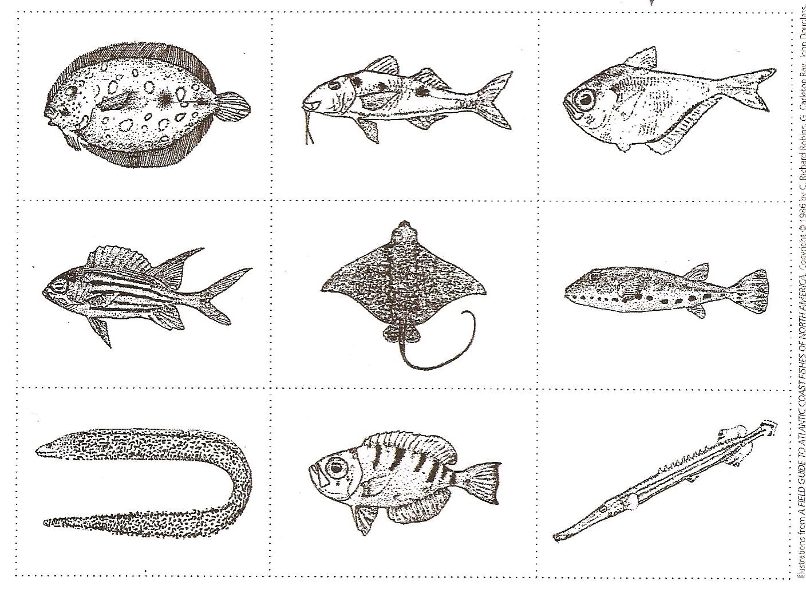
Step 3
If fish has both eyes on top of the head, then go to step 4.
If fish has one eye on each side of the head, go to step 5.

Step 4
If fish has long whip-like tail, it is a spotted eagle ray.
If fish has short, blunt tail, it is a peacock flounder

Step 5
If fish has spots, then go to step 6
If fish does not have spots, then go to step 7.

Step 6
If fish has chin “whiskers,” then it is a spotted goatfish.
If fish does not have chin “whiskers,” it is a band-tail puffer

Step 7
If fish has stripes, then go to step 8.
If fish does not have stripes, it is a glassy sweeper

Step 8
If fish has a v-shaped tail it is a squirrelfish
If fish has a blunt tail, it is a glass-eyed snapper.

Questions:
1. Did you get all of the fish named correctly? ______
2. Why or why not? ___________________________

Taxonomy
The process of assigning a scientific name to a plant or animal is called taxonomy. Taxonomy is a hierarchical system for classifying and identifying organisms that was originally developed by the Swedish scientist Carolus Linnaeus in the 18th century. Linnaeus's taxonomy system dictates the ordering of species into broad categories. There are seven major categories: Kingdom, Phylum, Class, Order, Family, Genus, and Species.
Humans belong to genus Homo and species sapiens and therefore the scientific name for humans is Homo sapiens. Note that the first part of a scientific name, genus, begins with a capital letter, while the second with a small letter.
Every plant and animal species is given a two part scientific name that allows people all over the world to communicate clearly about plant and animal names.
The great thing about scientific names is that every plant and animal has a unique name that means people all over the world can talk about the exact same species but a common name can be vague and confusing.

Materials: Animal Pictures, Dichotomous Key

What To Do:
1. Use the dichotomous key to find the scientific names of each of the animals found in the pictures.
2. Work with your partners and divide up the pictures so you won’t have to do all 21 animals.

Common Name | Scientific Name
1. Beaver
2. American Robin
3. Leopard Frog
4. Great Horned Owl
5. Moose
6. Raccoon
7. Mallard Duck
8. Bison
9. Lynx
10. Jack Rabbit
11. Grizzly Bear
12. Hummingbird
13. Sheet
14. Garter Snake
15. Little Brown Bat
16. Polar Bear
17. Harbor Seal
18. Giraffe
19. Zebra
20. Koala
21. Kangaroo

Name __________________ period _____

EXIT TICKET
Using a Dichotomous Key
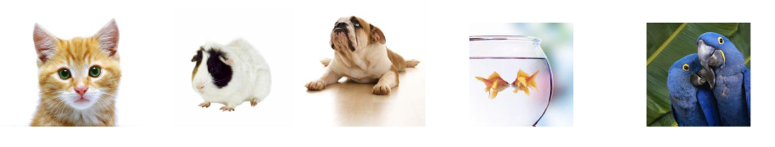

________ ________ ________ ________ ________
1. Use the dichotomous key below to find the names of each the animals pictured above. Write their name under the picture.

1. | a. Animal has fur  b. Animal does not have fur | Go to #2  Go to #4
2. | a. Animal is carnivorous (eats meat)  b. Animal is herbivorous (eats plants) | Go to #3  Starburst
3. | a. Animal has pointed ears that stand up  b. Animal has soft, floppy ears that hang down | Snickers  Milky Way
4. | a. Animal has feathers  b. Animal does not have feathers | Now/Later  Skittles

2. Which of the following scientific names is written correctly?

A. homo Sapien
B. Homo Sapien
C. homo sapien
D. Homo sapien

Name __________________ period _____

EXIT TICKET
Using a Dichotomous Key

1. Which of the following scientific names is written correctly?

A. homo Sapien
B. Homo Sapien
C. homo sapien
D. Homo sapien
_______ ________ ________ ________ _______

2. Use the dichotomous key below to find the names of each the animals pictured above. Write their name under the picture.

1. | a. Animal has fur  b. Animal does not have fur | Go to #2  Go to #4
2. | a. Animal is carnivorous (eats meat)  b. Animal is herbivorous (eats plants) | Go to #3  Starburst
3. | a. Animal has pointed ears that stand up  b. Animal has soft, floppy ears that hang down | Snickers  Milky Way
4. | a. Animal has feathers  b. Animal does not have feathers | Now/Later  Skittles

