Adaptations for Survival
Every species (kind of organism) lives in a specific kind of surroundings, or habitat. Organisms could not survive unless they were adapted to the conditions of their habitats. An adaptation is a trait that enables an organism to survive and reproduce in its environment. Many adaptations allow organisms to get food, water or nutrients.
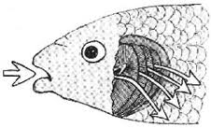
The different shaped beaks on the birds are an external adaptation. Those with larger beaks were able to eat a wider variety of food and so should have been able to survive. Animals also have internal adaptations. Fish have gills that allow them to get oxygen while under water is an example of an internal adaptation. The fish drinks in the water and uses specialize muscles to force the water across the gills where the dissolved oxygen in the water is absorbed. Carbon dioxide is released into the water. A fish’s gills work just like lungs in land animals.
You may not know that birds have hollow bones. For about 50 years scientist thought that the hollow bones made the birds lighter and would allow them to fly more easily. But in reality the skeleton of a two-ounce songbird weighs just as much as the skeleton of a two-ounce rodent. Bird bones are denser than bones in mammals, which make them heavier for their size, but it also makes them stiffer and stronger and more adapted for flying.

Materials: 1 flat toothpick and 1 round tooth pick per student. 1 sheet of paper and 3 inches of tape per table,
book for testing

What To Do:
1. Break the flat toothpick in half and break the round toothpick in half. Observe which was weaker and which was stronger.

2. Work with your partners to use the 1 sheet of paper and the tape to build a structure that will hold up the ScienceSaurus book. You will have about 7 minutes.

3. At the end of the time your teacher will test each table’s structure by placing the book on top.

Questions:
1. Which toothpick was the weakest? _____________
2. Which toothpick was the strongest? ____________
3. Which shape of structure was able to hold up the book the best? _______________________________
4. How does the structure of bird bones help the bird survive in its environment? _____________________
_________________________________________
Watch the video Gills from www.brainpop.com and answer the following questions.

1. Name 1 other animal that has gills. ____________
2. How can you observe diffusion? ______________
3. What gas do fish take in? ____________________
4. What gas do fish get rid of? __________________

What To Do:
Match the description of the adaptation to the picture.
Description | Picture
1. The golden eagle can soar for hours as it searches for prey. Its wings catch the wind to keep it flying. | 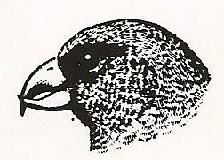
2. A duck’s foot with a tough membrane between the toes is a natural paddle, making swimming very easy. | 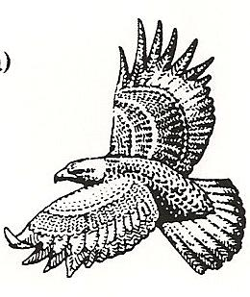
3. The crossbill uses its beak to separate the scales of pinecones and get at the seeds. | 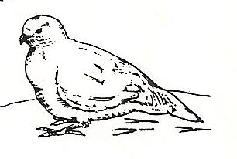
4. The ptarmigan is found in the Arctic that is snow-covered most of the year. | 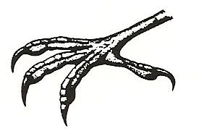
5. The foot of the evening grosbeak can curl tightly around a branch, allowing it to perch safely in trees. | 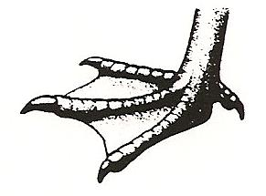

Look closely at your hand. You have five flexible fingers. The hand of a primate (humans and monkeys) can grasp an object because it has an opposable thumb. An opposable thumb stands out at an angle from the other fingers and can be bent toward them to grip an object. An opposable thumb is an adaptation that has helped humans to use tools to get food and build shelter.
23

Materials: masking tape, peanut in shell,

2 books per table
What To Do:
1. Have your partner use some masking tape to bind your thumbs to the palm of each hand. You should not be able to use your thumbs at all.
2. Open a peanut without using your thumb.
3. Pick up a pencil and write your name on this paper.
4. Pick up a book and try to turn the pages.
5. Take off the tape and help your partner bind their thumbs.

Questions:
1. What did you have to do to get the peanut open?
________________________________________

2. What did you have to do to write with the pencil?
________________________________________

3. What did you have to do to turn the pages of the book? _____________________________________

4. Name an animal that does not have an opposable thumb. ______________

5. How does this animal get its food? ________________________________________

6. How does your thumb help you survive?
________________________________________________________________________________

Name ____________________ period _____
EXIT TICKET
Adaptations for Survival

1. What is a species?

A. A kind of organism
B. Another way of saying special
C. A special kind of natural selection

2. What internal adaptation allows fish to survive in the water?

A. Lungs
B. Gills
C. Wings

3. What internal adaptation gives the bones of birds extra strength?

A. Being thick
B. Being made of calcium
C. Being hollow

4. A trait that allows an organism to survive in its environment is called an –

A. Evaporation
B. Operation
C. Adaptation

5. Another adaptation that a fish has is –

A. Fins to swim
B. Wings to fly
C. Thumbs to use tools

Name ____________________ period _____
EXIT TICKET
Adaptations for Survival

1. A trait that allows an organism to survive in its environment is called an –

A. Evaporation
B. Operation
C. Adaptation

2. Another adaptation that a fish has is –

A. Fins to swim
B. Wings to fly
C. Thumbs to use tools

3. What is a species?

A. A kind of organism
B. Another way of saying special
C. A special kind of natural selection

4. What internal adaptation allows fish to survive in the water?

A. Fins
B. Gills
C. Camouflage

5. What internal adaptation gives the bones of birds extra strength?

A. Being thick
B. Being made of calcium
C. Being hollow

