Natural Selection
Until the 19th century, most scientists believed that organisms lived as they had first appeared on the earth. However, by the late 1700’s, scientists had found and studied many fossils. Fossils are the remains or organisms that lived in the past.
Fossils show that organisms have changed. They show that the earliest living organisms were simple organisms. In the billions of years that passed, living things became more complex in response to changing environmental stimuli. Fossils show that many species, or kinds of organisms, have died out or become extinct because they could not respond to the stimuli fast enough to survive. Those that did survive were better suited to their environment.
Evidence shows that new species develop from old species as a result of gradual change. Natural selection is the process by which organisms change over time.
Over a hundred years ago an English naturalist named Charles Darwin suggested that organisms change over time through natural selection. Look at the pictures of how the giraffe got such a long neck.
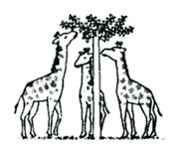 | 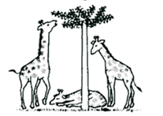 | 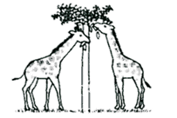
Originally the necks of giraffes were not long. Occasionally some giraffes were born with longer necks. | Those that had even a slightly longer neck had an advantage over the short-necked giraffes and survived to reproduce. | Generations and generations of the longer necked giraffes survived and reproduced. Now we have long neck giraffes.

Today you and your partners will act like a flock of Bobbing Birds. These birds will be looking for moths on trees. We will use black, white and newsprint dots for moths and a sheet of newspaper for the trees.

Materials: 1 sheet of b/w newspaper for each group, 100 white dots, 100 black dots, 100 b/w newsprint dots
What To Do:
1. Clear off your table and place the sheet of newspaper flat on the top of the table.
2. Spread out the dots so that none are on top of each other.
3. Stand up and push your chair in and stand behind it facing away from the table.
4. When the teacher says go, turn and look at the newspaper. Count – DON’T pick up as many black dots as you can in the 10 seconds allowed.
5. Turn away from the table and record the number of black dots in the column below.
6. Repeat for the white dots and then for the newsprint dots.
7. Return all the dots to the container then fold up the newspaper and return them to your teacher.
8. Place your group’s data in the table below.
9. Add them up and be ready to share with the class.
10. Make a bar graph of the class results.

Names | Black | White | Newsprint
Totals

 | Black | White | Newsprint
Class Totals

Questions:
1. Which color moth was eaten the most? ____________
2. Why do you think this happened? _______________
3. Which color moth was eaten the least? ____________
4. Why do you think this happened? _______________
5. If we had “eaten” the moths, which color had more moths left on the paper? _____________________
6. These moths will survive to reproduce. What advantage
do they have over the other moths? ___________________________________________
7. Why did more color of this moth survive while the other colors did not have as many survive? _____________________________________________
8. Eventually instead of 3 colors of moths there will be only one color of moth. What is the process by which organisms gradually change over time? _____________

How it all started
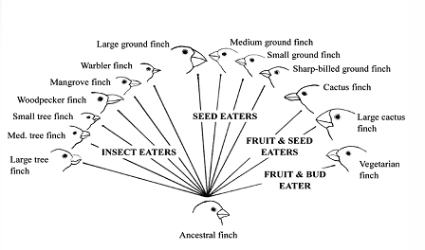
Charles Darwin developed the theory of natural selection in the 1800’s. He observed the Galapagos Islands plant and animal life including birds called finches. He noted that they were similar to a species of finch on the mainland of South America. However, the birds on each island had beaks with different shapes. Each island also had different foods available for the birds. Darwin concluded that the different beak shapes were adaptations for eating different kinds of food. He didn’t know about genetics at that time but we now know that species that survive pass on their genetic traits to their offspring allowing them to survive.
Watch the BrainPop video Charles Darwin.
1. What was the name of the ship? ______________
2. How long was the voyage? ___________
3. What was the variation in the two birds on the tree?___________________________
4. Did Darwin say people came from monkeys? _____
Watch the BrainPop video Natural Selection.
1. Did humans live at the time of the Dinosaurs? ____
2. What is a variation? ________________________
3. What is another name for natural selection?
____________________________________________
Name __________________ period _____

EXIT TICKET
Natural Selection
1. What is a species?

A. A kind of organism
B. Another way of saying special
C. A special kind of natural selection

2. At the beginning of the winter the squirrels in a neighborhood were counted. There were 100 thick furred squirrels and 98 thin furred squirrels. It was a very cold winter. In the spring there were 95 thick furred squirrels and only 50 thin furred squirrels. Why did more thickly furred squirrels survive the winter?

A. They are smarter.
B. They moved away for the winter
C. They are better suited to the winter environment

3. Natural Selection is –

A. The process where all living things survive
B. The process of gradual change over time
C. Why all living things die

4. What will happen to the different populations of moths?

A. Eventually the black and white will go extinct.
B. Eventually the birds will eat more newsprint moths
C. Eventually the newsprint ones will go extinct

5. What genetic trait did the successful finches pass on to their offspring?
A. bigger brains
B. smaller feet
C. different beak size
Name __________________ period _____

EXIT TICKET
Natural Selection
1. What genetic trait did the successful finches pass on to their offspring?
A. bigger brains
B. smaller feet
C. different beak size

2. What is a species?

A. A kind of organism
B. Another way of saying special
C. A special kind of natural selection

3. At the beginning of the winter the squirrels in a neighborhood were counted. There were 100 thick furred squirrels and 98 thin furred squirrels. It was a very cold winter. In the spring there were 95 thick furred squirrels and only 50 thin furred squirrels. Why did more thickly furred squirrels survive the winter?

A. They are smarter.
B. They moved away for the winter
C. They are better suited to the winter environment

4. Natural Selection is –
A. The process where all living things survive
B. The process of gradual change over time
C. Why all living things die

5. What will happen to the different populations of bugs?
A. Eventually the black and white will go extinct.
B. Eventually the birds will eat more newsprint moths
C. Eventually the newsprint ones will go extinct

