Learning about Selective Breeding

From cucumbers and carrots to white rice and wheat, we humans have altered the genes of almost every food we eat. For almost 10,000 years we've been engineering plants by keeping the seeds from the best crops and planting those the next season. Following this practice year after year has resulted in a slow but steady change -- and a substantial cumulative effect. We've been altering the genetic makeup of crops by cross-pollinating, too. About 8,000 years ago, for example, farmers in Central America crossed two mutant strains of a weedy-looking plant called Balsas teosinte and produced the first corn on the cob.
From: http://www.pbs.org/wgbh/harvest/engineer/

1. What two ways have we been engineering plants for the
last 10,000 years?

_____________________________________________

Watch the video from www.missdoctorbailer.com on corn.

Write down 3 things you learned in the space below.

Play the interactive game called Selective Breeding found on the website: http://www.pbs.org/wgbh/harvest/engineer/

1. Select an ear of corn to save for season 1. Your teacher or a student will go up to the Smart Board and select the ear that most students pick.
2. Select an ear of corn to save for season 2.
3. Select an ear of corn to save for season 3.
4. Select an ear of corn for the last season.

5. Repeat the experiment until your class is successful in choosing the right ears of corn to save for each year.

Questions:

1. What physical trait were you selecting each year?
________________________________________

2. How many times did it take you to be successful in selecting the right ear of corn? _______________

3. What problems did you encounter? _____________

Your objective for this activity was to save the largest ear of corn so the next year you could plant its seeds and get larger ears of corn. This is called selective breeding. You select the trait you want the parent corn plant to pass on to its offspring then you crossbreed it with another plant that has the same trait. Then you plant only the seeds with the trait you selected next year. After your corn gets big enough you may decide to change the trait you select.

Dog and cat breeders do the same thing. They select the trait or traits they want in their dogs or cats and only allow those animals to breed. Selective breeding is how new breeds of dogs and cats are created.
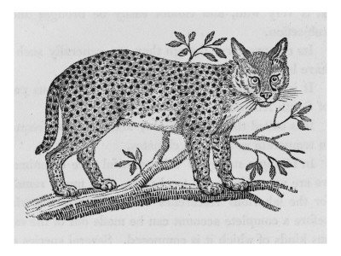
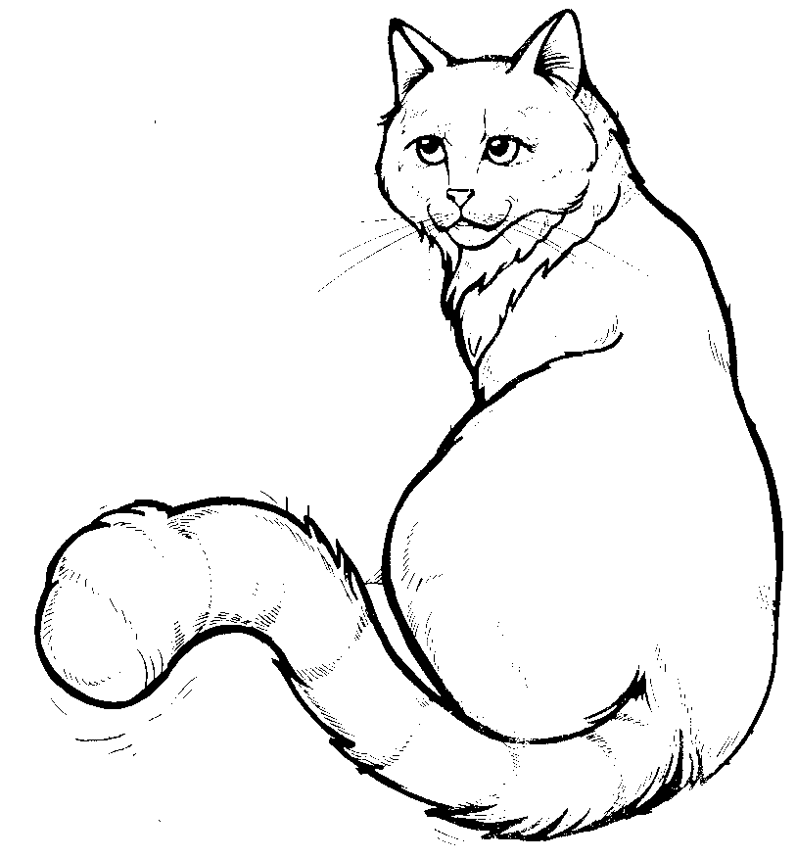
Felis lybicaFelis catus

Canis lupus Canis familiaris

The picture on the left (Felis lybica) has the common name of the African wild cat. The picture on the right is the domestic cat. Scientists believe that the domestic cat came from the African wild cat.

If you wanted to crossbreed some Felis lybica to selectively breed a domestic cat what traits would you have to change in the wild cat?
_______________________________________________

_______________________________________________

______________________________________________

Watch the Brainpop video on cats and write 2 things you learned on the lines below.
_______________________________________________
_____________________________________________

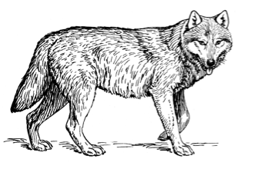
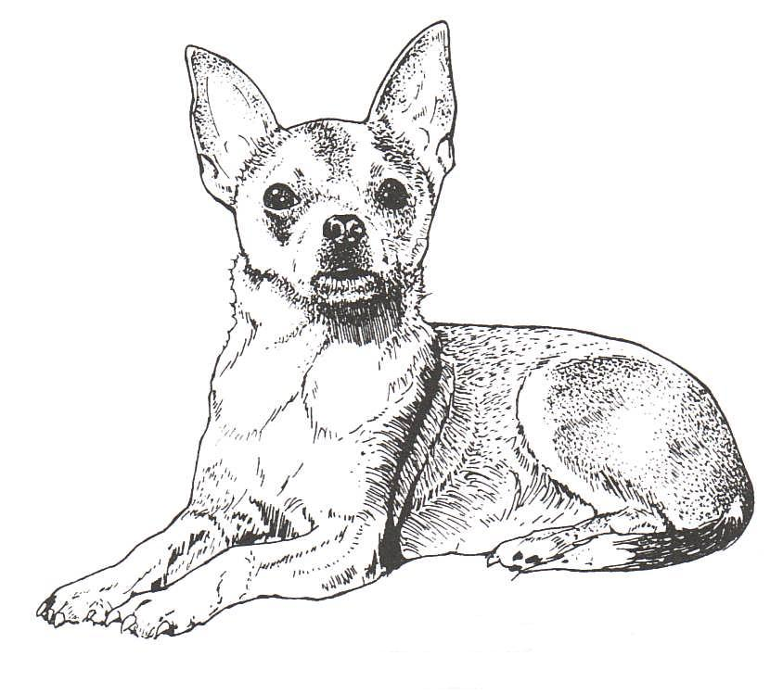

The picture on the left (Canis lupus) has the common name of the Grey Wolf. The picture on the right is the domestic dog – in this case a Chihuahua. Scientists believe that the domestic dog came from the Grey Wolf.

If you wanted to crossbreed some Canis lupus selectively breed a domestic dog such as a Chihuahua, what traits would you have to change in the wolf?

_____________________________________________

_____________________________________________

_____________________________________________

Watch the Brainpop video on dogs and write 2 things you learned on the lines below.

______________________________________________

______________________________________________

Name _______________ period _____

EXIT TICKET
Selective Breeding

1. When farmers selectively breed a crop they are –

A. Choosing the worst part of the crop to breed
B. Choosing any part of the crop to breed
C. Choosing the trait they want from the crop to breed

2. When dog breeders develop a new breed of dog they –

A. Pick the dogs with the traits they want to keep to
breed
B. Pick the dogs with the traits they don’t want to
Keep to breed
C. Don’t know what trait to breed.

3. Puppies look like their parents because –

A. They inherit the parent’s traits
B. All puppies are alike
C. The owner wants the puppy to look like the parents.

4. When a trait from an organism is picked to be passed on this is called –

A. Genetic mutation
B. Gene fixing
C. Selective breeding

5. Cats and dogs are examples of –

A. Domesticated animals
B. Wild animals
C. Breeding stock
Name _______________ period _____

EXIT TICKET
Selective Breeding
1. Puppies look like their parents because –

A. They inherit the parent’s traits
B. All puppies are alike
C. The owner wants the puppy to look like the parents.

2. When a trait from an organism is chosen to be passed
on this process is called –

A. Genetic mutation
B. Gene fixing
C. Selective breeding

3. Cats and dogs are examples of –

A. Domesticated animals
B. Wild animals
C. Breeding stock

4. When farmers selectively breed a crop they are –

A. Choosing the worst part of the crop to breed
B. Choosing any part of the crop to breed
C. Choosing the trait they want from the crop to breed

5. When dog breeders develop a new breed of dog they –

A. Pick the dogs with the traits they want to keep to
breed
B. Pick the dogs with the traits they don’t want to keep
to breed
C. Don’t know what trait to breed.

