Selectively Breeding Dogs

Selective breeding happens when people select individuals to mate that have features they hope the offspring will inherit. This is also called artificial selection. There are four things that are required: variation, inheritance, selection and time. You should remember that variations are differences that exist among individuals. Inheritance, of course is the genetic traits that are inherited from parents and passed to offspring. Selection happens when individuals with favorable traits are bred in the hopes that those traits will be pass on in the next generation. Getting the desirable traits does not usually happen in just one try. Often, you have to breed many generations to get a new breed established. This takes time.

A breed is a specific group of domestic animals or plants having similar appearance, similar behavior, and other characteristics that distinguish it from other animals or plants of the same species and that were arrived at through selective breeding. Dog belong to a single species, Canis familiaris, but that species is made up of about 400 different breeds. The breeds we have today are the result of people’s desire to have dogs with specific features that make them suitable for performing particular tasks.

Dog Breeding Example

You want a dog that can hear a polar bear approaching and scare the bear so it will turn back. Which of the following dogs would you selectively breed to produce offspring that would be most effective in scaring away a polar bear?

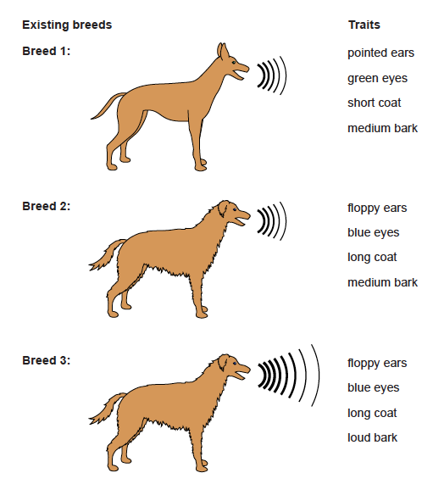

Questions:
1. Which trait would help the dog hear the polar bear? ____
2. Which trait would help the dog scare away the polar bear? __________________________
3. Which trait will help the dog stay warmer in the cold?
___________________________________________
4. Which breed would be best to cross? _____________
5. Explain your reasoning. __________________________
________________________________________________

Dog Traits
What To Do:
1. In the chart below brainstorm with your partners the importance of the physical and behavioral traits given.
2. Tell why you would want the trait in your dog.

Physical Trait | Function | Importance
1. Above average number of olfactory receptors | Smell
2. Above average number of eye cells called rods | Sight
3. Long pointed ears | Hearing
4. Long legs | Speed
5. Large heart | Endurance
6. Large muscles | Strength
7. Coat Color | Camouflage
8. Long/Short Hair | Temperature
Behavioral Traits
9. Trainability | High/Low
10. Disposition | Vicious/  Compatible
11. Bark | Loud/Quiet

Selectively Breeding Your Own Dog

You are a dog breeder. You have been contact by a scientist who wants dogs that could be used to see and retrieve waterfowl (ducks and geese) from lakes in the area so the birds can be tagged and re-released. The birds are very skittish (scare easily) and must be retrieved unharmed and with a minimum amount of stress.
What To Do:
1. For each trait below, shade in the box of the desired trait form you ideally want your dogs to have.
2. For traits that you do not think will affect your breed’s ability to perform the given task, shade in “any.”
Physical Traits
1. Smell | above average | average | below average | any
2. Sight | above average | average | below average | any
3. Hearing | above average | average | below average | any
4. Speed | above average | average | below average | any
5. Endurance | above average | average | below average | any
6. Strength | above average | average | below average | any
7. Coat color | very dark | average |  | any
8. Hair length |  | average |  | any
Behavioral Traits
9.Trainability | high | average |  | any
10. Disposition | vicious | compatible | meek | any
11. Bark | very loud | average | very quiet | any

3. Check the Dog Breeds paper your teacher gives you and fill in the sentences below.
1. The two dog breeds I have chosen to mate are:

____________________X ______________________

2. The reason I have chose these breeds is:

_____________________________________________

_____________________________________________

3. The two traits I think are the most important of the new breed to inherit are:

_______________________________________________

4. Which breed will be the mother? _________________
5. Which breed will be the father? __________________

Making Puppies
Each breeding pair will produce three puppies. Each puppy may inherit traits from the mother or the father.

Materials: penny
What To Do:
1. Flip a coin for the sense of smell. Use the following key to determine which trait will be chosen.

Heads = mother’s trait Tails = father’s trait

2. Use the Puppy Trait chart on the next page to keep track of each puppy’s traits.
3. Continue with each trait for 3 different puppies.

Puppy Traits

Physical Traits | Puppy #1 | Puppy #2 | Puppy #3
1. Smell
2. Sight
3. Hearing
4. Speed
5. Endurance
6. Strength
7. Coat color
8. Hair length
Behavioral Traits
9.Trainability
10. Disposition
11. Bark

Questions:
1. Which of your puppy’s do you think would be best for the assigned task? _________________________
2. Compare your puppies with the people at your table. Is there a single puppy that is perfect for the task?
_________________________________________
3. If you were to conduct the dog breeding for another generation, which pups would you select to be the parents? (Don’t select brothers and sisters!)
___________________________________________

4. What are the four things that are required for selective breeding? ___________________________________________

___________________________________________

Name _________________ period ______
EXIT TICKET
Selectively Breeding Dogs

1. What is another name for selective breeding?

A. variation
B. artificial selection
C. inheritance

2. What are variations?

A. Differences between individuals
B. The same trait in each person
C. Inheritance from your parents

3. What types of traits are bred in selective breeding?
A. unfavorable traits
B. favorable traits
C. undesirable traits

4. What traits determine a breed?

A. similar appearance
B. similar behavior
C. both of the above

5. How many tries does it take to get the traits you want?
A. only one
B. just two
C. many tries

Name _________________ period ______
EXIT TICKET
Selectively Breeding Dogs

1. What types of traits are bred in selective breeding?
A. unfavorable traits
B. favorable traits
C. undesirable traits

2. What is another name for selective breeding?

A. variation
B. artificial selection
C. inheritance

3. What are variations?

A. Differences between individuals
B. The same trait in each person
C. Inheritance from your parents

4. What is another name for selective breeding?

A. variation
B. artificial selection
C. inheritance

5. What are variations?

A. Differences between individuals
B. The same trait in each person
C. Inheritance from your parents

Make a class set and laminate for future use.

