Advantages in Nature
Humans have thousands of taste buds on their tongues. These taste buds are able to distinguish between four different tastes – salty, sweet, sour and bitter. Each taste bud is sensitive to one kind of taste. The taste buds are grouped together on different parts of the tongue.
Scientists think that taste buds gave primitive humans an advantage because most plants that are poisonous taste bitter. When primitive humans were learning what plants to eat to survive they would taste a small amount and spit out any that tasted bitter. This advantage allowed them to survive and reproduce.

Materials: colored pencils
What To Do:
1. The edges of the tongue have taste buds that are sensitive to sour tastes. Label the edges of the tongue sour and color them green.
2. The front of the tongue has taste buds that are sensitive to sweet and salty tastes. Label the front area sweet and salty and color them blue and orange.
3. The back of the tongue has taste buds that are sensitive to bitter tastes. Label the back of the tongue bitter and color it red.

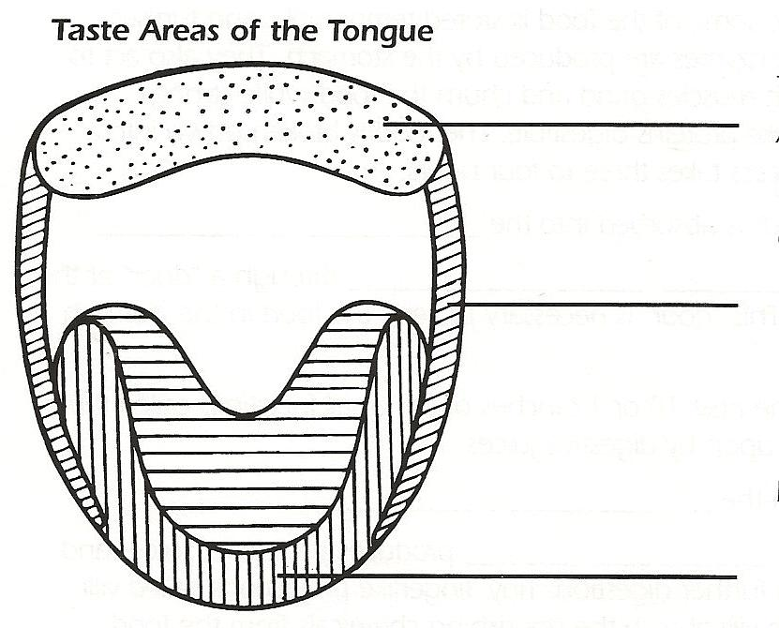

Materials: Milk chocolate Hershey Kiss, Dark chocolate Hershey Kiss per student, cup of water
What To Do:
1. Unwrap the sliver Hershey Kiss you have been given.
2. Place it in your mouth and chew it up. Don’t swallow yet!
3. Concentrate on the areas of your tongue and try to determine where you taste the candy the most.
4. Place X’s in pen/pencil where you tasted it the most.
5. Take a few sips of water to get rid of that taste.
6. Unwrap the purple Hershey Kiss you have been given.
7. Place it in your mouth and chew it up. Don’t swallow it yet!
8. Concentrate on the areas of you tongue and try to determine where you taste the candy the most.
9. Take a few sips of water to get rid of that taste.
10. Your teacher will count the number of students that liked each type of candy the best.

 | Silver | Purple
Number of students

Questions:
1. What was the main taste of the silver Kiss? _______
2. What was the main taste of the purple Kiss? ______
3. Which flavor did most students like? ____________
4. If your teacher put out a bowl of Kisses that had both silver and purple candy in it, which candy would be left in the bowl at the end of the period? ______________
6. Why? ____________________________________
7. Which flavor of candy would “survive to reproduce”? _____________________

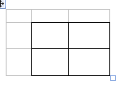
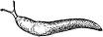
A gardener loved to grow beautiful flowers. He noticed that the slugs in the garden always seemed to eat and kill the plants with small leaves of his favorite flower but left the plants with large leaves alone. When he tasted the leaves he found that the small leaves were sweet and the large leaves were bitter. Now he wants to conduct a selective breeding experiment to see how many crosses (generations) it would take to make all the leaves large and bitter. Sweet is the dominant trait and has the genotype SS. Bitter is the recessive trait and has the genotype ss.

What To Do:
1. Below you will find several Punnett Squares.
2. Cross one sweet plant with a bitter plant for the first generation.
3. Calculate the percentages.
4. Then cross two of the plants in the Punnett Square for the second generation and calculate the percentages.
5. Remember we are trying to get all the plants to have the 100 % bitter genotype. Cross two of the plants from the second generation that will get us some bitter plants. Don’t forget to calculate the percentages.
6. Continue crossing plants until you get 100% bitter genotype.
________% Sweet

_________% Bitter

________% Sweet

_________% Bitter

________% Sweet

_________% Bitter

________% Sweet

_________% Bitter

Questions:
1. How many generations (crosses) did it take to
make all plants with bitter leaves? __________
2. What is the advantage that bitter leaves gives the plants? __________________________________

Name __________________ period _____

EXIT TICKET
Advantages in Nature
1. What are the four tastes our tongue is sensitive to?

A. Salty, sour, bitter, spicy
B. Spicy, salty, sour, sweet
C. Salty, sweet, bitter, sour

2. What is an advantage in nature?

A. Something that causes a living thing to die early
B. Something that allows a living thing to survive and reproduce.
C. Something that causes a living thing to keep from reproducing

3. Complete the Punnett Square below using the phenotypes father –hybrid Tall (Tt) with mother-hybrid Tall (Tt).
4. Calculate the percentages for the Punnett Square above.
__________% Tall __________% Short
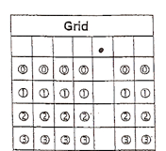
5. Grid in the % Tall:

Name __________________ period _____
97
EXIT TICKET
Advantages in Nature
1. Complete the Punnett Square below using the phenotypes father –hybrid Tall (Tt) with mother-hybrid Tall (Tt).

2. Calculate the percentages for the Punnett Square above.
__________% Tall __________% Short
3. Grid in the % Tall:

4. What are the four tastes our tongue is sensitive to?

A. Salty, sour, bitter, spicy
B. Spicy, salty, sour, sweet
C. Salty, sweet, bitter, sour

5. What is an advantage in nature?

A. Something that causes a living thing to die early
B. Something that allows a living thing to survive
and reproduce.
C. Something that causes a living thing to keep
from reproducing

