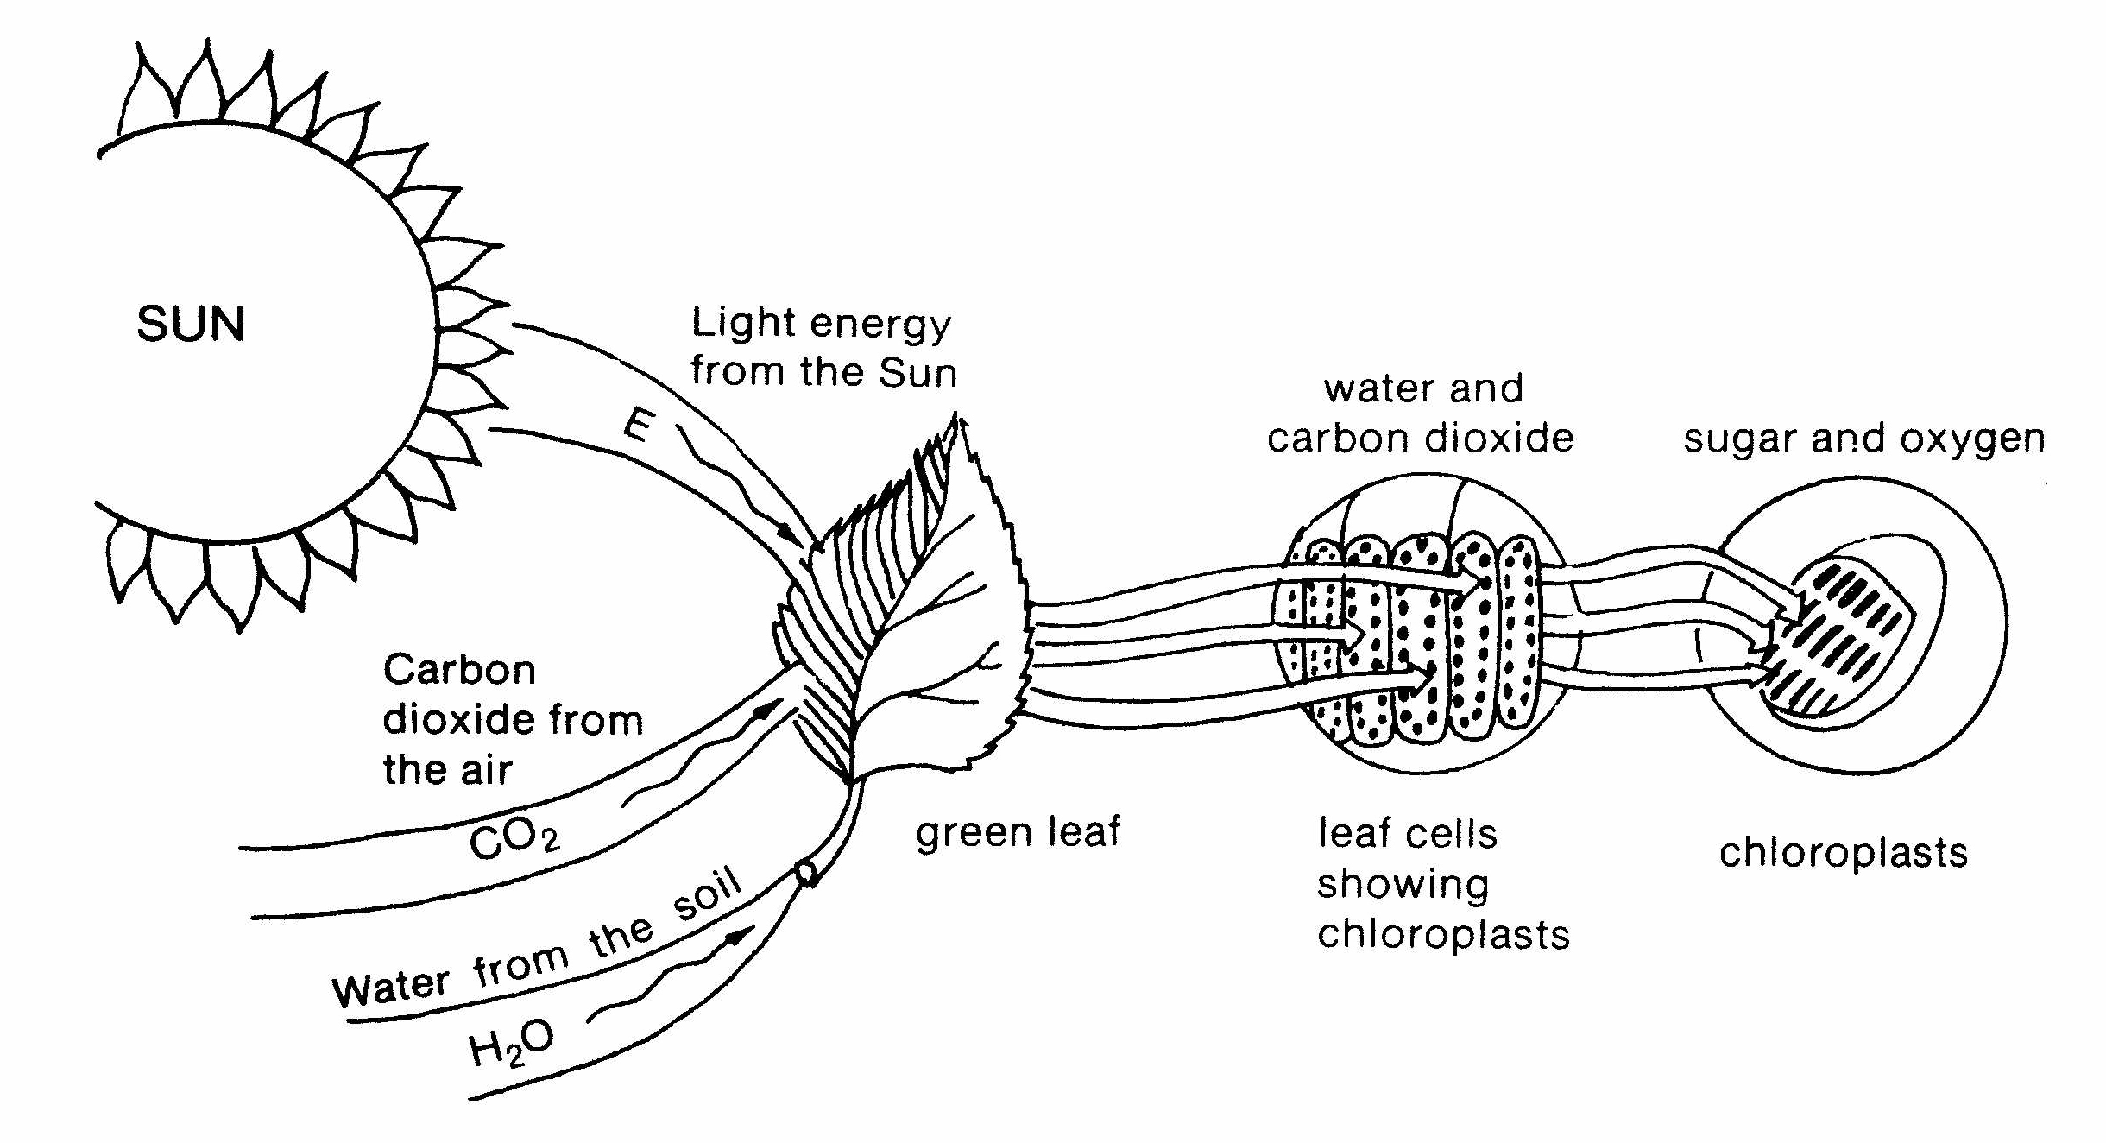
Photosynthesis – An Energy Transformation

In sixth grade you learned about energy transformations such as chemical energy to light energy in a flashlight. The process of photosynthesis is another type of energy transformation. Photosynthesis occurs in the green leaves of plants and is the process where light energy is used by plants to produce food. The light energy (sometimes called radiant energy) from the sun is changed to chemical energy in the process. The chemical energy is in the form of a simple sugar called glucose.
During photosynthesis inside the chloroplasts, where there is lots of chlorophyll, plants use carbon dioxide they take in through the leaves and water they have taken in through the roots in the presence of light to produce glucose and oxygen. The oxygen leaves the plant through the leaves and plants use the chemical energy in sugar for food and we use the plants for food. We also breathe the oxygen the plants make.

Watch the video Photosynthesis from www.missdoctorbailer.com. Answer the following about the investigation.

1. What was the manipulated or independent variable?
__________________________________________

2. What was the responding or dependent variable?
___________________________________________

3. What was the control? ______________________

Directions:
1. Color the light energy yellow.
2. Color the CO₂ purple
3. Color the H₂0 blue.
4. Color the leaf green.
5. Outline the leaf cells in green.
6. Color the chloroplast green outlined in black.
Questions:
1. Where does the carbon dioxide come from? _________
2. Where does the water come from? ________________
3. Where does the light come from? ________________
4. Where is the chlorophyll found in the plant? _________
5. What type of energy is sunlight? ________________
6. What type of energy is sugar? ___________________
7. What is photosynthesis? ________________________
______________________________________________8. Where does photosynthesis happen in the plant? _____
9. How do living things benefit from photosynthesis?
______________________________________________
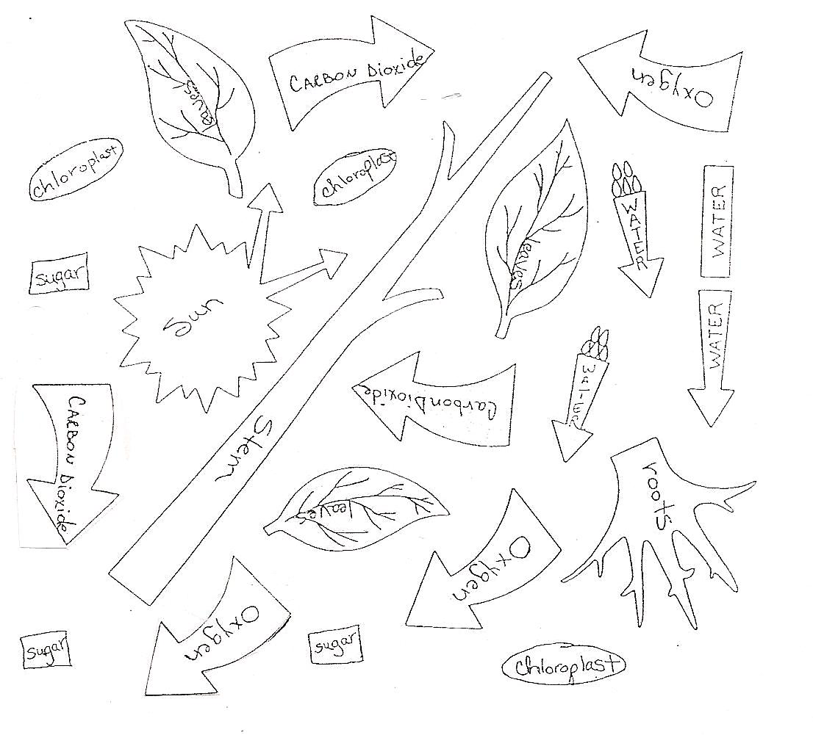

Materials: colored pencils
What To Do:
1. Color the parts and symbols below as indicated.
2. Cut out the parts and symbols to make a model of the process of photosynthesis.
3. Glue them into your notebook.
4. Answer the questions after you have assembled the model.
Colors:
Leaves, stem and chloroplasts = green Water = blue
Carbon Dioxide = purple Sun = yellow
Sugar = orange Roots = don’t color – leave white
Oxygen = pink

Questions:
1. What part of the plant takes in the carbon dioxide?
____________________________________
2. What part of the plant gives out the oxygen?
_____________________________________
3. How does water get into the plant?
_____________________________________
4. Where is the sugar made? _____________

Write the energy transformation for what happens
when we eat a plant. Use the following types of
energy: heat, radiant, chemical

DON’T GLUE IN YOUR NOTEBOOK!!!

Name ________________ period _____
EXIT TICKET
Photosynthesis
1. What type of energy is light from the Sun?

A. Mechanical
B. Radiant
C. Chemical

2. What type of energy is sugar produced by plants?

A. Mechanical
B. Radiant
C. Chemical

3. What gas is needed for photosynthesis?

A. Oxygen
B. Carbon Dioxide
C. Nitrogen

4. What gas is produced by photosynthesis?

A. Oxygen
B. Carbon Dioxide
C. Nitrogen

5. When an asteroid hit the Earth 65 million years ago, it threw a huge amount of dust into the atmosphere. This dust cloud stayed in the sky, blocking out the Sun for at least 10 years. Why did most of the animals on the Earth go extinct at this time?

A. The asteroid started fires that burned the Earth
B. The dust cloud prevented plants from making food
C. The Sun turned off

Name ________________ period _____
EXIT TICKET
Photosynthesis
1. What gas is needed for photosynthesis?

A. Oxygen
B. Carbon Dioxide
C. Nitrogen

2. What gas is produced by photosynthesis?

A. Oxygen
B. Carbon Dioxide
C. Nitrogen

3. When an asteroid hit the Earth 65 million years ago, it threw a huge amount of dust into the atmosphere. This dust cloud stayed in the sky, blocking out the Sun for at least 10 years. Why did most of the animals on the Earth go extinct at this time?

A. The asteroid started fires that burned the Earth
B. The dust cloud prevented plants from making food
C. The Sun turned off

4. What type of energy is light from the Sun?

A. Mechanical
B. Radiant
C. Chemical

5. What type of energy is sugar produced by plants?

A. Mechanical
B. Radiant
C. Chemical

