Plant Adaptations

Humans have veins and arteries to transport water, oxygen and nutrients throughout the body. Plants have a similar internal system, the primary components of which are the xylem and phloem. These two tissues transport fluid and nutrients from the roots up to the stems and leaves, and then back again. These two tissues are adaptations the plant has evolved so the plant can grow taller. If the leaves could not get water and nutrients the plant would not be able to carry out photosynthesis.

Materials: celery stalks, red food coloring, water, beaker, microscope, slides, and scalpel
What To Do:
1. Cut the end off a bunch of celery and place half of the stalks in the beaker with red food coloring.
2. Wait overnight.
4. Each table will have one stalk of celery that was in the red food coloring.
5. Observe the leaves. Draw what you observe in the box.
6. Use the scalpel and make a VERY THIN slice from the end of the celery without the leaves.
7. Place it on a microscope slide and observe under low power.
8. Draw and color what you see in the circle below.

Leaves _______

Questions:
1. What happened to the leaves? _______________
2. The areas of red in the leaves are called veins.
What is their function in the plant? ________________
3. The tubes that are red in the stalk of the celery are called xylem. What is their function in the plant?
__________________________________________
4. Next to the xylem are tubes called phloem. What do think their function in the plant might be?
___________________________________________
5. How does the adaptation of the xylem and phloem
help the plant survive? _______________________

Plants have many adaptations that allow them to survive. They have developed various systems just like animals.

Watch about 3 minutes of the video from www. missdoctorbailer.com about plant systems for absorption. Write 1 way plants absorb what they need to live.
___________________________________________
___________________________________________

Watch the video about plant systems for transport.
Write 1 way plants transport what they need to live.
___________________________________________
___________________________________________

Watch the video about plant systems for getting rid of wastes. Write 1 way plants get rid of their wastes.
____________________________________________
____________________________________________

Some plants have large underground storage structures. These structures are called bulbs. They are adaptations to allow the plant to survive cold, excessive heat, lack of light or drought by storing nutrients.
Bulbs or bulb-like plants have a period of growth and flowering. This is followed by a period of dormancy where they die back to ground level at the end of each growing season. Then in spring they start to grow and flower again.
We use many types of bulbs as food. True bulbs grow in layers, much like an onion. At the very center of the bulb is a miniature version of the flower itself. Helping the bulb to stay together is something called a basil plate, which is that round and flat hairy thing (those are the beginnings of roots) on the bottom of the bulb.
The easiest thing to think of when you’re trying to understand a tuber is the potato. The potato is a tuber that has leathery skin and lots of eyes – no basal plate. All of those eyes are the growing points where the plants will emerge.
Rhizomes are simply underground stems. They grow horizontally just below the soil’s surface. They will continue to grow and creep along under the surface with lots and lots of growing points. A rhizome we eat is called ginger.
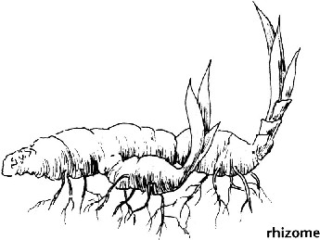
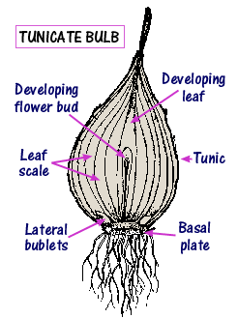
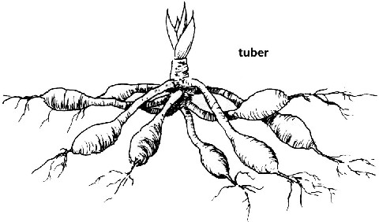

DO NOT GLUE UNTIL CUT OUT!

1. Place glue under the double lined rectangle.
2. Cut the double lines between each type of storage structure.
3. Glue the correct picture next to the name.
4. Under each flap define the type of storage structure
and give an example.
Structures | TRUE  BULB
Storage | TUBER
Plant | RHIZOME

Make one copy for each group of 4 students.

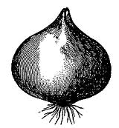

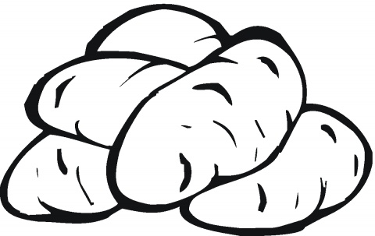

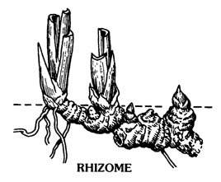

Name _____________ period ______
EXIT TICKET
Adaptations in Plants

1. What adaptation does a plant have that carries water from the roots to the leaves?

A. flowers
B. petals
C. xylem

2. Where is food for the plant stored?

A. leaves
B. roots
C. flowers

3. Some plants have underground storage structures. Which of the following is NOT one of these adaptations?

A. bulb
B. tuber
C. stem

4. What is an example of a true bulb?

A. potato
B. ginger root
C. onion

5. Some plants have adapted by developing bulbs. In what conditions do bulbs help plants survive?

A. Hurricanes
B. Droughts
C. Tornadoes

Name ________________ period ______
EXIT TICKET
Adaptations in Plants
1. Some plants have underground storage structures. Which of the following is NOT one of these adaptations?

A. bulb
B. tuber
C. stem

2. What is an example of a true bulb?

A. potato
B. ginger root
C. onion

3. Some plants have adapted by developing bulbs. In what conditions do bulbs help plants survive?

A. Hurricanes
B. Droughts
C. Tornadoes

4. What adaptation does a plant have that carries
water from the roots to the leaves?

A. flowers
B. petals
C. xylem

5. Where is food for the plant stored?

A. leaves
B. roots
C. flowers

