Learning About Food Chains

Organisms get the energy they need from food. A food chain traces the path of energy as it moves from organism to organism in an ecosystem. In most ecosystems, energy begins with the sun, so plants always form the base of a food chain.
Plants, because they can make food through the process of photosynthesis are called producers. The consumer (animal) that eats plants is called the primary consumer. The consumer (animal) that eats the primary consumer is called the secondary consumer. Decomposers are often left out of many food chain diagrams but they are extremely important because they break down dead organisms and release nutrients back into the soil. Examples of decomposers are fungi and bacteria and they should always be the final link in a food chain. Arrows always show the direction of energy movement in a food chain.
Label the decomposer, primary consumer, producer and secondary consumer in each food chain below.
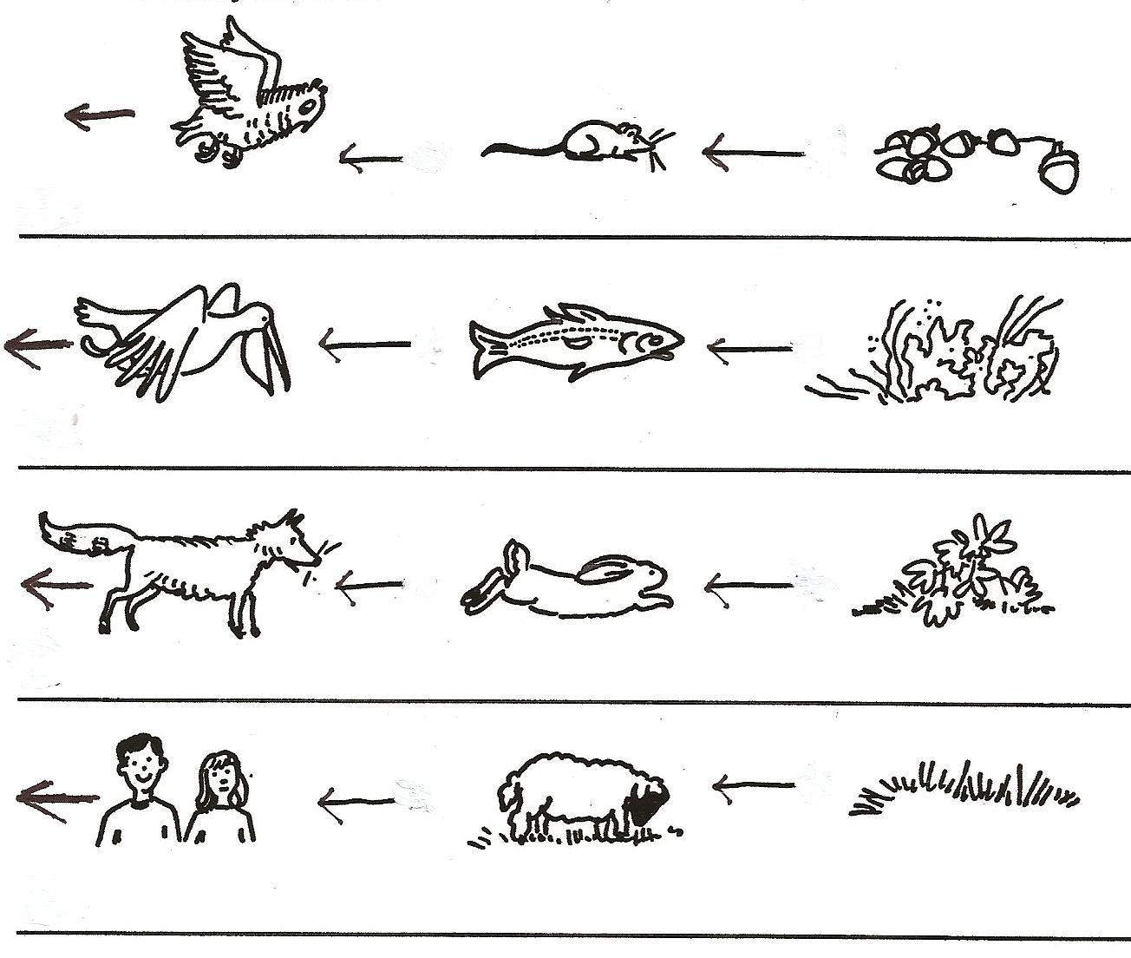
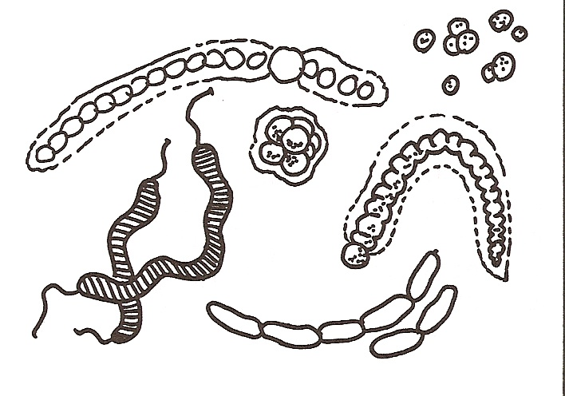
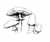

Watch the video “What is a Food Chain?” from www.missdoctorbailer.com

On the lines below write three different food chains shown in the video. Don’t forget your arrows!

Questions:
1. What type of organism is a producer? ________________
2. What type of organism is a consumer? _______________
3. What two organisms are decomposers? ______________

Rules for Food Chains
1. Start with the producer.
2. Determine where the energy from the producer is flowing.
3. Determine where the energy from each consumer is flowing.
4. Draw the arrows in the direction the energy is flowing.
5. End with a decomposer.

Materials: organisms sheet
What To Do:
1. Cut out the organisms. You should cut them closer than the rectangles so they can fit in the space below.
2. Separate the organisms into three piles – producer, consumer and decomposer.
3. Make 4 different food chains with the pictures. Remember the rules for food chains and start with a producer.
4. Glue them in the space below and on the next page.
5. Make sure the primary consumer eats the producer and the secondary consumer eats the primary consumer.
6. Label each organism as a producer, primary consumer, secondary consumer or decomposer.
7. Make sure you have the arrows going in the correct direction.
8. Draw in the sun for each food chain.

Questions:
1. Where does the energy to start a food chain come from? ____________________
2. What type of organism always starts a food chain?______
3. What type of organism ends a food chain? _____________
4. What does a primary consumer eat? ________________
5. What does a secondary consumer eat? ______________

Name ________________ period _____
EXIT TICKET
Learning About Food Chains

1. What energy form is a product of photosynthesis?

A. Radiant Energy
B. Mechanical Energy
C. Chemical Energy

2. How do decomposers help in a food chain?

A. They take in CO₂ and give off O₂
B. They release nutrients back to the soil
C. They use the Sun’s energy

3. Why are plants considered producers?

A. They make their own food
B. They eat consumers
C. They break down dead organisms

4. The type of consumer that eats plants is called a –

A. Tertiary Consumer
B. Secondary Consumer
C. Primary Consumer

5. In which direction does the arrow point in a food chain?

A. The direction the energy flows
B. Always toward the producer
C. Against the direction the energy flows.

Name ________________ period _____
EXIT TICKET
Learning About Food Chains

1. The type of consumer that eats plants is called a –

A. Tertiary Consumer
B. Secondary Consumer
C. Primary Consumer

2. In which direction does the arrow point in a food chain?

A. The direction the energy flows
B. Always toward the producer
C. Against the direction the energy flows.

3. What energy form is a product of photosynthesis?

A. Radiant Energy
B. Mechanical Energy
C. Chemical Energy

4. How do decomposers help in a food chain?

A. They take in CO₂ and give off O₂
B. They release nutrients back to the soil
C. They use the Sun’s energy

5. Why are plants considered producers?

A. They make their own food
B. They eat consumers
C. They break down dead organisms

