The Difference Between Food Chains and Food Webs

A food chain shows one energy path in an ecosystem. A simple food chain always contains a producer, a primary consumer and a secondary consumer and a decomposer. But most organisms are part of more than one food chain. Scientists often use a food web to show a more complete picture of the flow of energy in an ecosystem. A food web is a system of several overlapping food chains.

Directions: In the food chain below draw in the arrows and add a decomposer.

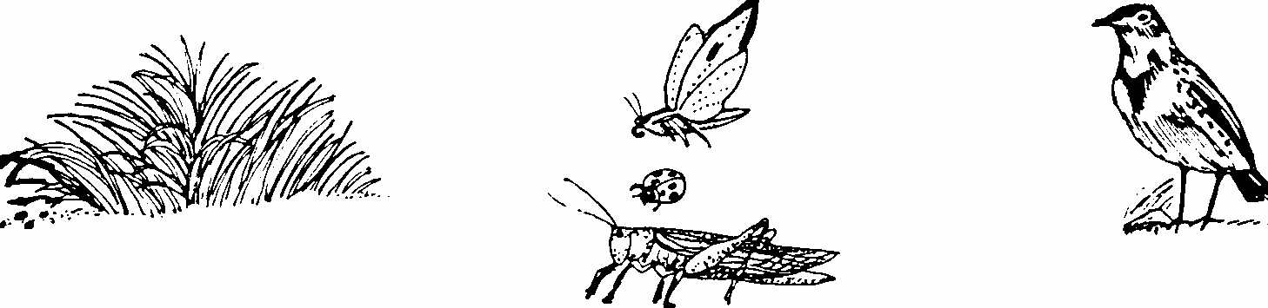

Consumers are classified by what they eat. Consumers that eat only plants are called herbivores. Deer, chipmunks and most insects are herbivores. Consumers that eat only animals are called carnivores. Badgers, cougars and wolves are carnivores. A consumer that eats both plant and animals are called omnivores. Birds, goats and monkeys are omnivores. An omnivore can play more than one role in an ecosystem. For example, a large fish in in a pond will eat both little fish and algae (microscopic plants). When it eats the algae it is a primary consumer. When it eats little fish it
is a secondary consumer.

Directions:

1. In the food web below use a different colored pencil to draw in each simple food chain.
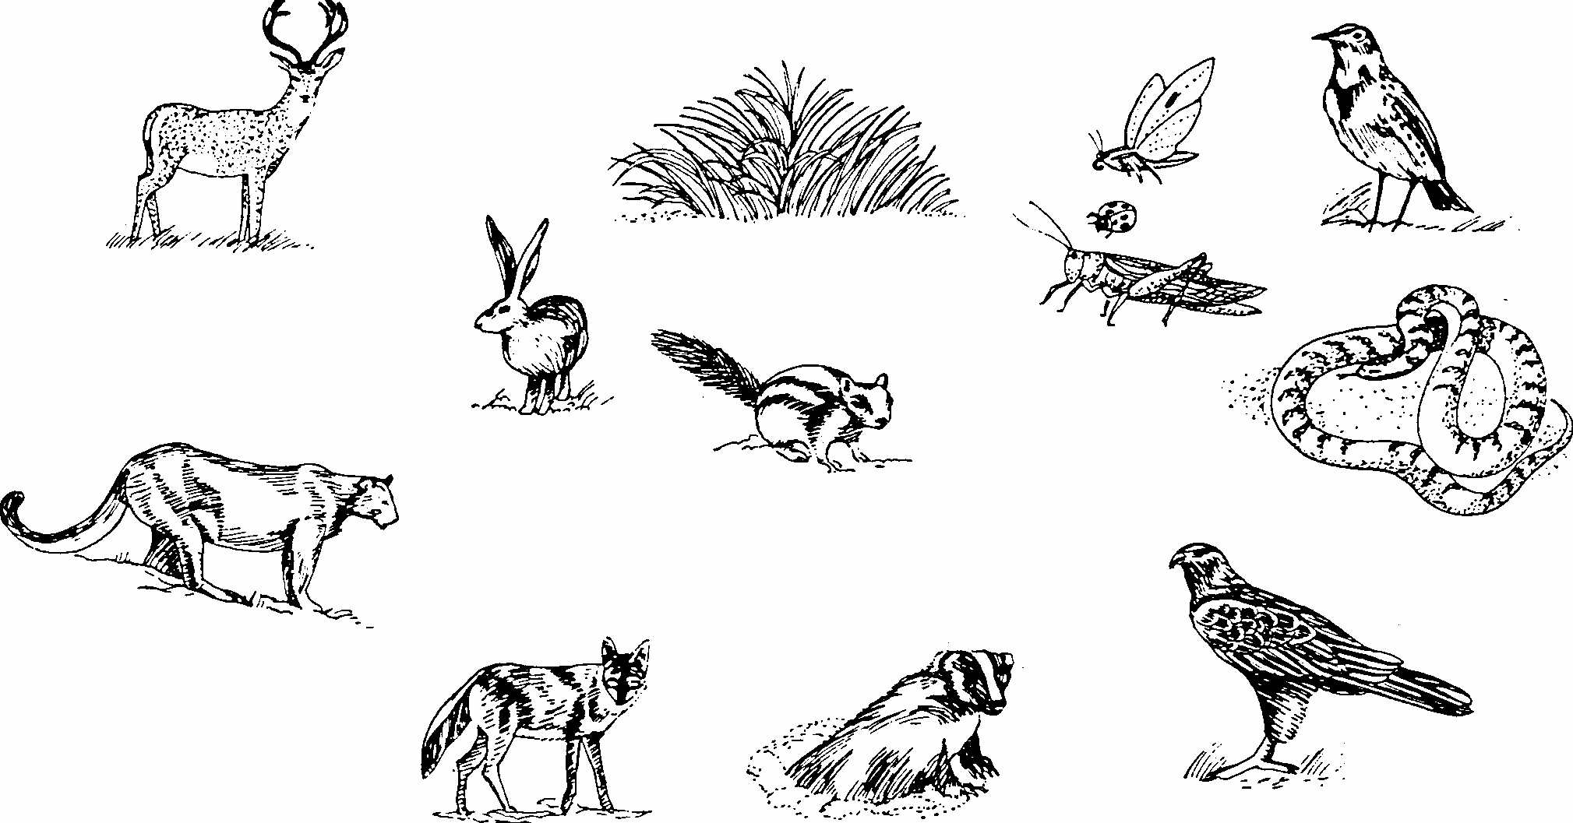

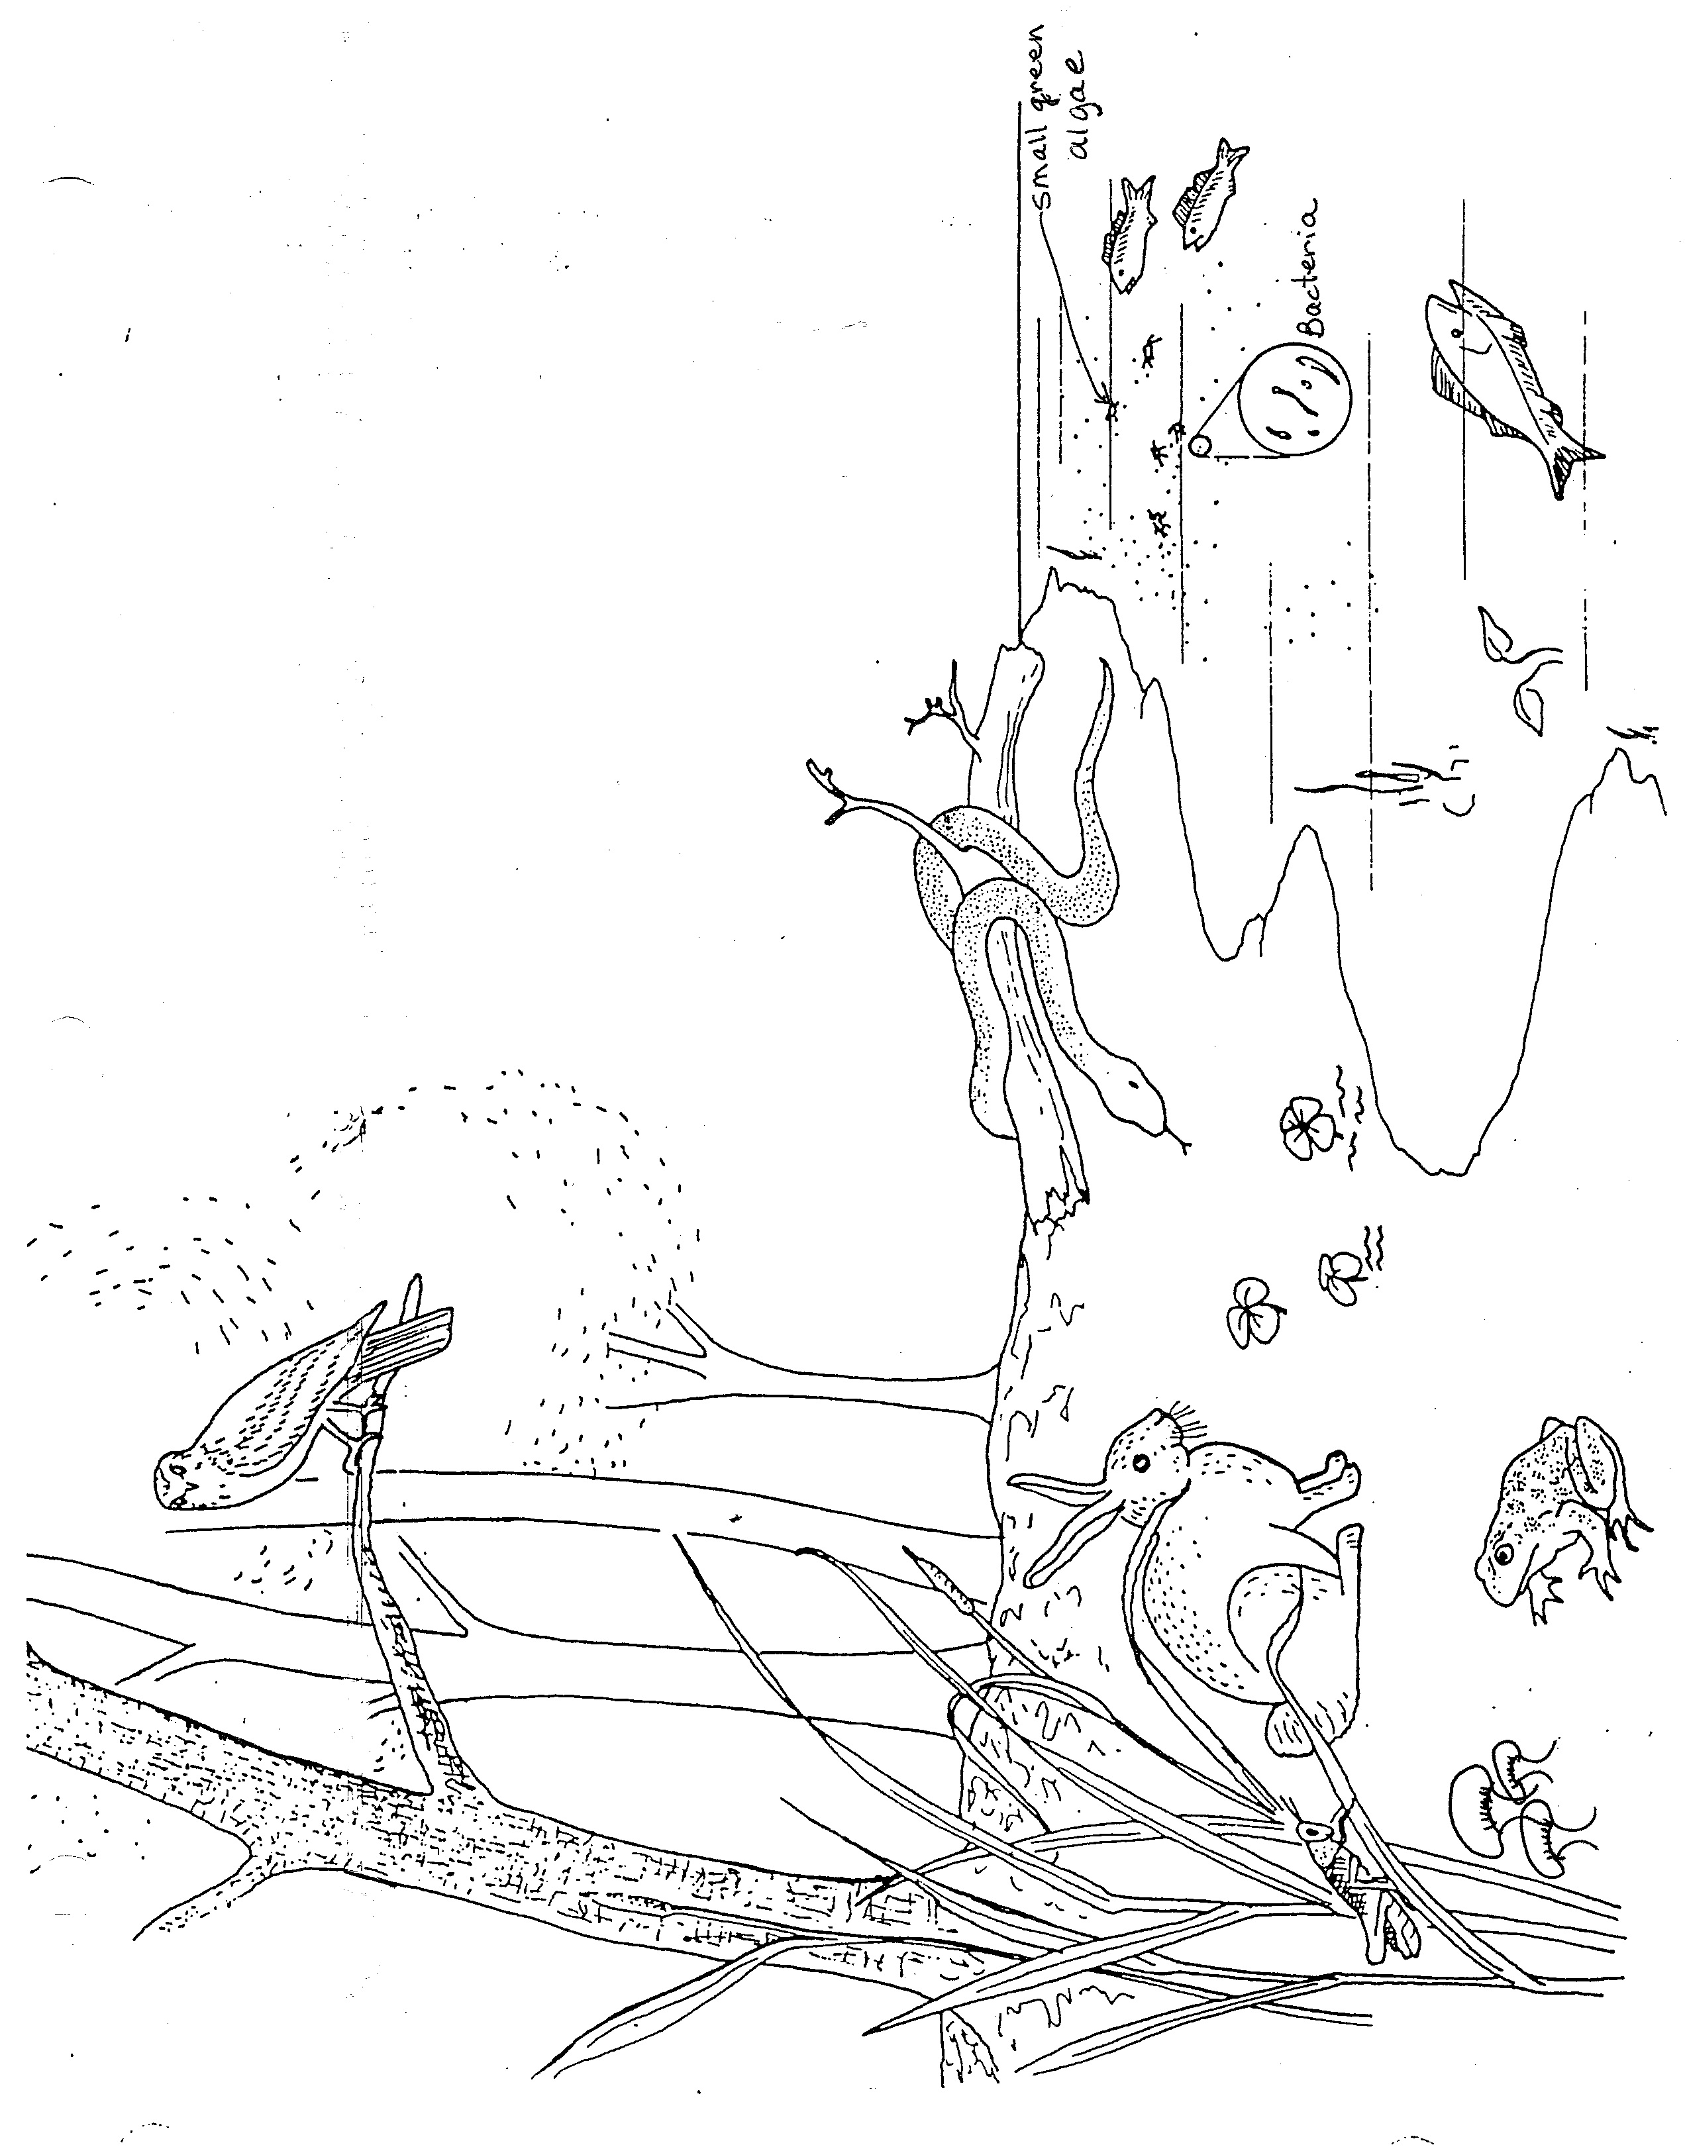
Materials:
Edge of A Pond Ecosystem
Edge of Pond Ecosystem paper, colored pencils
What To Do
1. Use different colored pencils to draw the arrows
for at least 3 different food chains.
2. Remember the arrows point in the direction the
energy flows.
3. Draw in the ecosystems energy source.
4. Color the picture.

Hints:
Small green algae are plants
Bacteria are found in dirt and soil. They can be
drawn into the picture.
Grasshoppers eat grass
Each food chain ends with a decomposer

Questions:
1. What does the snake eat? ___________
2. What does the owl eat? _____________
3. What would happen to the rabbit population
if all the snakes in this ecosystem were killed?
_______________________________________
4. What would happen to the owl population if there
were more rabbits? ______________________
5. What would happen to the grass around the pond
if there were more rabbits? _________________
6. If there were a great many rabbits and they ate all the
grass around the pond what would happen to the
grasshopper population? ___________________
7. What is the difference between a food chain and a
food web? ________________________________

If time allows watch the Food Web video on www.missdoctorbailer.com

Name _________________ period _____
EXIT TICKET
The Difference Between Food Chains and Webs

1. Which type of consumer eats both plants and animals?

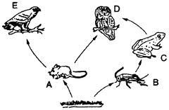
A. Herbivore
B. Omnivore
C. Carnivore

2. In the food web pictured to the right, which organisms are herbivores?

A. C and D
B. A and D
C. A and B

3. In the food web pictured which organisms are carnivores?

A. D and E
B. A and D
C. B and C

4. In the food web pictured what is missing?

A. Producers and Consumers
B. Producers and Decomposers
C. The Sun and the Decomposers

5. What would happen to this ecosystem if all the frogs
were killed?
A. The number of producers would greatly increase
B. The number of grasshoppers would greatly increase
C. The number of owls would greatly increase
Name _________________ period _____

EXIT TICKET
The Difference Between Food Chains and Webs
1. In the food web pictured to the right, which organisms are herbivores?

A. C and D
B. A and D
C. A and B

2. In the food web pictured which organisms are carnivores?

A. D and E
B. A and D
C. B and C

3. In the food web pictured what is missing?

A. Producers and Consumers
B. Producers and Decomposers
C. The Sun and the Decomposers

4. Which type of consumer eats both plants and animals?

A. Herbivore
B. Omnivore
C. Carnivore

5. What would happen to this ecosystem pictured above if all
the frogs were killed?

A. The number of producers would greatly increase
B. The number of grasshoppers would greatly increase
C. The number of owls would greatly increase

