Learning About Energy Pyramids
When an organism in an ecosystem eats food, it obtains energy. The organism uses some of this energy from food to move, grow, reproduce and carry out other life activities. This means that only some of the energy will be available to the next organism in the food web.
A diagram called an energy pyramid shows the transfer of energy through a food chain. The most energy is available at the producer level. At each level in the pyramid, there is less available energy than at the level below.
In general, only about 10 percent of the energy contained in one level of a food web is transferred to the next, higher, level. The other 90 percent of the energy is used in life processes. Because of this most food webs only have three or four feeding levels.
Each level of the pyramid is called a trophic level. Trophic means nutrition or feeding. Producers are called autotrophs – auto meaning self. So they are “self feeding”.
Consumers are called heterotrophs – hetero meaning other. So consumers feed on other organisms or “other feeding”.
The first level of an energy pyramid is the producer or autotroph. If we have a fantasy ecosystem and say that the producers have 1000 units of energy (kilocalories – kcal) what amount of energy could be transferred to all the other consumers (heterotrophs)?

Producer’s Energy |  | Energy transferred to the Primary Consumer
 | X .10

Primary Consumer’s Energy |  | Energy transferred to the Secondary Consumer
 | X .10

Secondary Consumer’s Energy |  | Energy transferred to the Tertiary Consumer
 | X .10

Materials: Energy Pyramid to cut out, colored pencils
What To Do:
1. DO NOT cut out the pyramid until you are finished with these instructions.
2. There are four sides on your pyramid. Each side will have different information placed on it.
3. Label each level of the first pyramid side with the following terms as you move up the pyramid: producer, primary consumer, secondary consumer, tertiary consumer.
4. Place the amount of energy available for each level from your previous calculations.
5. Label each level of the second pyramid side with the following terms as you move up the pyramid: plants, herbivores, carnivores, top carnivores.
6. Label each level of the third pyramid side with the following terms as you move up the pyramid: autotroph, 1st order heterotroph, 2nd order heterotroph, 3rd order heterotroph.
7. Draw a picture of what might belong in each level:
1st: flowers, trees, grass algae
2nd: caterpillars, cows, grasshoppers, beetles
3rd: humans, birds, frogs
4th lions, dogs, snakes
8. Shade the first level (bottom) of each side green.
9. Shade the second level of each side yellow.
10. Shade the third level of each side blue.
11. Shade the fourth (top) level of each side red.
12. Cut out the pyramid and fold on the lines radiating from the center and stand it up.
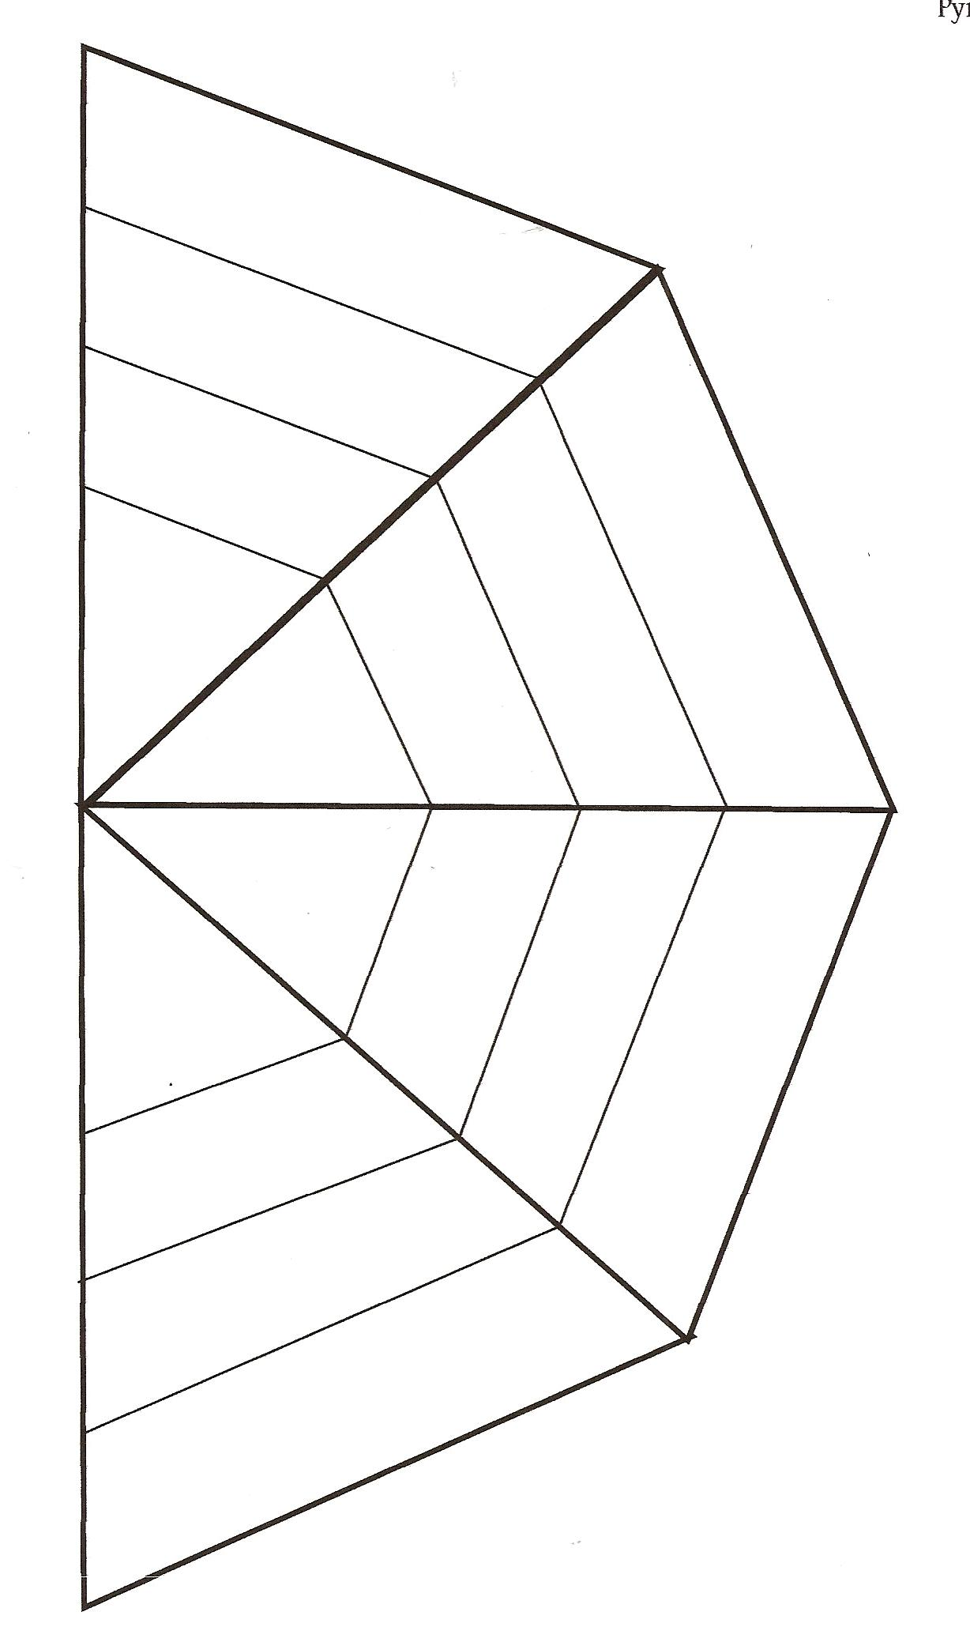

13. Answer the questions below and then glue the flat pyramid to the next page.

Questions:
1. What are three terms used to describe organisms such as trees? ______________________________________
2. What are three terms used to describe organisms such as cows? _____________________________________
3. What are three terms used to describe organisms such as humans? ___________________________________
4. What are three terms used to describe organisms such as lions? ______________________________________
5. What do autotrophs eat? _______________________
6. What do heterotrophs eat? _____________________
7. What happens to the amount of energy in the pyramid as it moves through the different levels? _____________
8. Do organisms always stay in the same level? _______
Explain your answer. __________________________
_____________________________________________
Watch the two short videos about Tropic Levels and Energy Pyramids from www.missdoctorbailer.com

Write down something you learned.
______________________________________________
______________________________________________

Name ________________ period _____
EXIT TICKET
Learning About Energy Pyramids
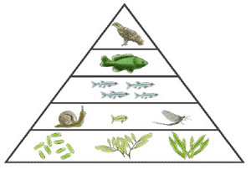
Level 5
Level 4
Level 3
Level 2
Level 1
Level 5
Level 4
Level 3
Level 2
Level 1

1. On which level of the energy pyramid above will you
find autotrophs?

A. Level 5 C. Level 2
B. Level 3 D. Level 1

2. On which level will you find the top carnivores?

A. Level 5 C. Level 2
B. Level 3 D. Level 1

3. What happens to the amount of energy in the pyramid as it moves up through the different levels?

A. It increases C. It stays the same
B. It decreases D. It decreases/then increases

Name ________________ period _____
EXIT TICKET
Learning About Energy Pyramids

1. On which level of the energy pyramid above will
you find the top carnivores?

A. Level 5 C. Level 2
B. Level 3 D. Level 1

2. On which level will you find autotrophs?

A. Level 5 C. Level 2
B. Level 3 D. Level 1

3. What happens to the amount of energy in the
pyramid as it moves up through the different levels?

A. It increases C. It stays the same
B. It decreases D. It decreases/then increases

