Ecological Succession

A community is all the different organisms that live together in an area. A community in an ecosystem is in equilibrium, or state of balance, when the number and species of organisms in it do not change suddenly. Events such as fires, floods, volcanoes and hurricanes disrupt the equilibrium of a community by changing it drastically in a short period of time. After a fire, flood, volcanic explosion, succession enables an ecosystem to recover.
But even without a disaster, communities sometimes change. Ecological succession is the series of predictable changes that occur in a community over time.

Ponds are areas of standing water that are smaller than a lake. Ponds do not have streams or rivers associated with them. They may have small fish living in them. Ponds begin to get smaller as they fill in due to erosion of the soil around it and the dead plant material that has fallen to the bottom of the pond. After a number of years a bog forms. A bog is a wetland that has shallow water because of all the deposits of dead plants. Over the years a bog continues to fill in and eventually turns into a marsh. Marshes are even shallower than a bog and have grasses growing in them and trees growing around them. In Texas we call a marsh a swamp. After a number of years the marsh fills in and becomes a meadow. A meadow is a vegetated field with grasses, flowers and trees. After the meadow is formed eventually taller trees will grow and the area will be come a forest.

What To Do:
1. Observe the pictures on the next page. Determine the name of the stage of pond succession and read the paragraph to determine what is happening in that stage. Write the important information about each stage.

Pond Succession

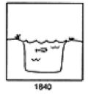 | What is this stage called?  _____________________  What is happening? ______  _______________________
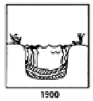 | What is this stage called?  _____________________  What is happening? ______  _______________________
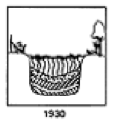 | What is this stage called?  _____________________  What is happening? ______  _______________________
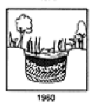 | What is this stage called?  _____________________  What is happening? ______  _______________________
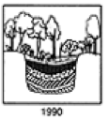 | What is this stage called?  _____________________  What is happening? ______  _______________________
Primary succession is the series of changes that occur in an area where no ecosystem previously existed. Such an area might be a new island caused by the eruption of an undersea volcano or an area of rock uncovered by a melting glacier.

Watch the video “Stages of Primary Succession” from www.missdoctorbailer.com. Read the paragraph below and answer the questions about the graphic.
Primary succession begins on bare rock. The first organisms to inhabit the area are called pioneer species. These are typically lichens and mosses. These organisms break down the rock and begin the process of making soil. Over time flowers, grasses and shrubs (bushes) begin to grow. As they die other larger plants such as trees take their place. Eventually, a forest community will develop. This last community is called a climax community.
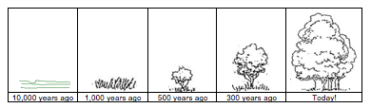
A
B
C
D
E
Questions:

1. What has happened in box A? ___________________
2. What are the first organisms to inhabit box B called?
______________________________________________
3. What organisms will be found in box B?
______________________________________________
4. What do the organisms in box B do? ______________
5. What organisms will be found in box C? ___________
6. What organisms will be found in box D? __________
7. What organisms will be found in box E? __________
8. What is the community in boxy E called? ___________
Secondary succession is the series of changes that occur after a disturbance in an existing ecosystem. Natural disturbances that have this effect include fires, hurricanes and tornadoes. Human activities, such as farming, logging, or mining can also disturb an ecosystem. Secondary succession is different from primary success because is starts in an area that already has soil. Annual plants such as wildflowers appear first then grasses and perennials appear and then the steps are the same as primary succession.

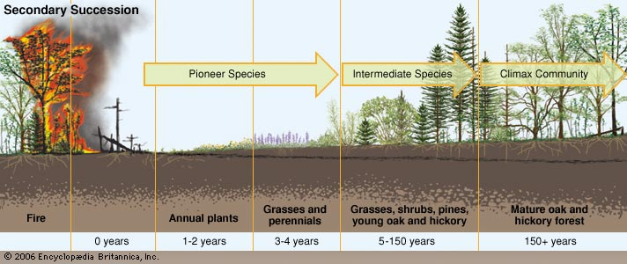

Questions:
1. Why type of disturbance to the ecosystem happened in the picture above? ____________________________________
2. What annual plants will appear after 1-2 years? ________
3. What plants appear in years 3-4? ___________________
4. What different plants appear during years 5- 150?
__________________________________________________
5. What plants appear after 150 years? __________________
6. What are the pioneer species in secondary succession?
__________________________________________________
7. What is the climax community? _____________________
8. How is primary succession different from secondary succession? _______________________________________
_______________________________________________

Name _________________ period _____

EXIT TICKET
Ecological Succession
1. Over the course of about 100 years a pond can fill in with soil and dead plant material. What is this process called?

A. Ecological devastation
B. Ecological succession
C. Ecological equilibrium

2. If farming has disturbed an ecosystem and then the farmers move away the area will return to its natural state. What is this process called?

A. Primary succession
B. Secondary succession
C. Ecological equilibrium

3. If a glacier retreats leaving behind a mixture of rock and soil what type of organism will begin to colonize the area?

A. grasses
B. lichens
C. flowers

4. What sequence below characterizes primary succession?

A. rocks, flower, trees, grasses
B. rocks, lichens, grasses, bushes
C. soil, flowers, grasses, trees

5. What sequence below characterizes secondary succession?

A. rocks, flower, trees, grasses
B. rocks, lichens, grasses, bushes
C. soil, flowers, grasses, trees

Name __________________ period _____

EXIT TICKET
Ecological Succession
1. If a glacier retreats leaving behind a mixture of rock and soil what type of organism will begin to colonize the area?

A. grasses
B. lichens
C. flowers

2. What sequence below characterizes primary succession?

A. rocks, flower, trees, grasses
B. rocks, lichens, grasses, bushes
C. soil, flowers, grasses, trees

3. What sequence below characterizes secondary succession?

A. rocks, flower, trees, grasses
B. rocks, lichens, grasses, bushes
C. soil, flowers, grasses, trees
4. Over the course of about 100 years a pond can fill in with soil and dead plant material. What is this process called?

A. Ecological devastation
B. Ecological succession
C. Ecological equilibrium

5. If farming has disturbed an ecosystem and then the farmers move away the area will return to its natural state. What is this process called?

A. Primary succession
B. Secondary succession
C. Ecological equilibrium

