Learning About Biodiversity
Millions of different kinds of things inhabit the Earth. Some live on land while other live in the water. Other organisms spend their time under the soil. No matter where they live, they depend on one another to stay healthy, even to stay alive. The disappearance or extinction of even one kind of living thing may affect the health or survival of other living things.
The variety of organisms in a place, whether it is small or large is called biodiversity. Biodiversity is a contraction of the phrase “biological diversity”. Bio means life and diverse means different. You can think of biodiversity as meaning different kinds of life - both in the variety of species and in the variety of genetic material. The more links in a food web, the more stable it is. If there are only a few links in a food web, the extinction of one organism can cause the entire ecosystem to die.
Sustainability of an ecosystem is the ability of that ecosystem to maintain itself in the face of external stress such as disease, tornados, floods or pollution. The greater the biodiversity in an area, the healthier and more sustainable the area will be. Biodiversity keeps life in balance and healthy on Earth, or in any ecosystem.
Directions: Observe the pictures below and answer the questions.
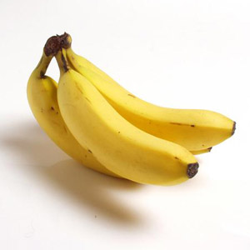
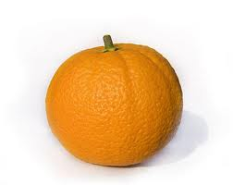


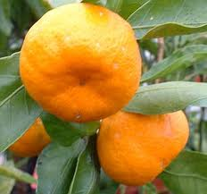
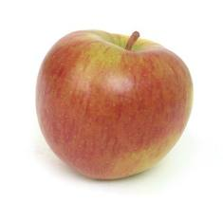
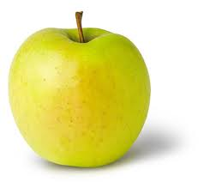

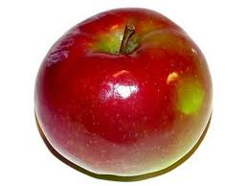

Questions:
1. How many different kinds of apples do you see? ___
2. How many different kinds of bananas? __________
3. How many different kinds of oranges? __________
4. If all the Golden Delicious (yellow) apple trees became diseased and died out would you still be able to bake an apple pie? ________________
5. If all the Satsuma Orange trees became diseased and died out would we still be able to have orange juice with our breakfast? ______________
6. If the Cavendish banana trees became diseased and died out would we still be able to have banana on our cereal? ______________

There are over 400 different varieties of bananas grown in the world but the one we like to eat the most cannot make seeds that have embryos inside. This makes farmers have to clone their old banana trees to get new ones. These cloned banana trees are genetically identical. This means that a disease could spread very quickly and wipe out all of our favorite bananas because none of them would have any resistance to the sickness. Without genetic biodiversity our favorite banana trees could become extinct. So, yes you could still have a banana on your cereal, but it would have to be a different type of banana than you are used to.

Materials: 2 Index Cards for each student
Part 1
What To Do:
1. Your teacher will give every student an index card.
2. Place a large D on one side.
3. When your teacher tells you to, walk around the room and have 3 students who are not sitting at your table write their first name on the back of the card.

4. When you have gotten each name have a seat and follow your teacher’s directions.
5. Answer the following questions.

Questions:
1. How many trees were left standing? ________
2. Why were so many trees wiped out? _________
_________________________________________
3. How did the lack of biodiversity in this ecosystem contribute to its sustainability? _________________
___________________________________________
1. Your teacher will give you another index card with different letters on it.
2. When your teacher tells you to, walk around the room and have 3 students who are not sitting at your table write their first name on the back of the card.
3. When you have gotten each name have a seat and follow your teacher’s directions.
4. Answer the following questions.

Questions:
1. How many trees were left standing? __________
2. Why were so many trees left standing? __________
____________________________________________
3. How did the biodiversity of this ecosystem contribute to its sustainability? _____________________________
4. Why is biodiversity important? ________________
____________________________________________

Scientists can determine how healthy and stable a habitat is by calculating the biodiversity index. The closer to 1 the biodiversity index is, the more diverse and healthy the habitat is.
You can calculate the biodiversity index by dividing the number of species by the total organisms.

BI = Number of species______
Total number of organisms

Materials: Habitat Cards
What To Do:
1. You group will be given 4 habitat cards that represent
the animals in 1 square meter of 4 different habitats.
2. List the species that you see in your microhabitat in
the chart below.
3. Count how many of each species are in the microhabitat and record below.
4. Count the total number of organisms in your microhabitat.
5. Calculate the biodiversity index.
Species found | Number
Questions:
1. What was your biodiversity index? ___________
2. Which habitat had the highest BI? ___________
3. Which habitat is the most healthy and stable? _____
4. Why? _____________________________________
Exploring Biodiversity Game Teacher Directions
Part 1
Give every student and index card and have them write the letter D on one side. Have students walk around the room and have 3 people they are not sitting with write their names on the back of the card.

Explain to the students that they are a forest of trees called Douglas Firs (the D on the card). Have the students stand up. They will remain standing until their name is called.

Tell students when you are a disease and will walk around the room and tap someone on the arm.

At that time that person will sit down and read off the names from their card. If their name is called, they caught the disease and died.

Everyone whose name is called should sit down.

Anyone who is sitting that has a card should call the names on their cards. When all those names are called look around at the number of people left standing.

Have students answer the questions to part I.

Part 2
Pass out the next set of cards. As you hand out the cards give students one of the following letters to write on their card.
D - Douglas fir W – White Fir
WD – Western Dogwood L – Lodge Pole pine
C - Western Red Cedar WP – Western pine
M – Vine Maples B – Big Leaf Maple
H – Western Hemlock N – Nobel Fir

Explain to students that they are a forest of lots of different trees. Have students walk around the room and have 3 people they are not sitting with write their names on the back of the card.

Have the students stand up again. They will remain standing until their name is called.

Tell the students you are a disease and will walk around the room and tap someone on the arm.

At that time that person will sit down and read off the names from their card.

IMPORTANT IMPORTANT IMPORTANT

This time ONLY the student’s whose name is called AND has a D on their card will sit down. The sitting students will call the names on their cards and again
ONLY the student’s whose name is called AND has a
D on their card will sit down.

If a student’s name is called but they have another letter on their card they do not sit down.

Continue until all sitting students have called the names on their cards.

Have students look around and observe the number of people left standing.

Show the names of all the trees to the students.

Name _______________ period _____
EXIT TICKET
Biodiversity
1. Tropical Rainforests tend to have the most biodiversity because of the many types of plants and animals that live there. Which of the following habitats would have the least biodiversity?

A. A forest with 12 different species of trees
B. A desert with 7 different species of animals
C. The grasslands with 6 different species of grasses
and weeds

2. If only one type of tree is planted in an abandoned field, the ecosystem will –

A. Evolve quickly and be come extinct
B. Contain little genetic diversity
C. Be unable to cycle materials

3. One advantage of biodiversity in an ecosystem is that it –
A. Guarantees that the largest organisms will control the area
B. Ensures a large amount of identical genetic
material
C. Increases the chance that some organisms will
survive a disease that attacks the ecosystem.

4. How does biodiversity contribute to sustainability?

A. The higher the biodiversity the more sustainable
B. The lower the biodiversity the more sustainable
C. Biodiversity does not contribute to sustainability

Name _______________ period _____
EXIT TICKET
Biodiversity
1. One advantage of biodiversity in an ecosystem is
that it

A. Guarantees that the largest organisms will
control the area
B. Ensures a large amount of identical genetic
material
C. Increases the chance that some organisms will
survive a disease that attacks the ecosystem.

2. How does biodiversity contribute to sustainability?

A. The higher the biodiversity the more sustainable
B. The lower the biodiversity the more sustainable
C. Biodiversity does not contribute to sustainability

3. Tropical Rainforests tend to have the most biodiversity because of the many types of plants and animals that live there. Which of the following habitats would have the least biodiversity?

A. A forest with 12 different species of trees
B. A desert with 7 different species of animals
C. The grasslands with 6 different species of
grasses and weeds

4. If only one type of tree is planted in an abandoned field, the ecosystem will –

A. Evolve quickly and be come extinct
B. Contain little genetic diversity
C. Be unable to cycle materials

