Erosion by Water

Erosion is the process by which natural forces move weathered rock from one place to another. Moving water is
the major agent of erosion that has shaped the earth’s surface. Through erosion a river creates waterfalls and valleys and canyons
Watch the following video and observe what happens to the rocks in the waterfall.
http://www.classzone.com/books/earth_science/terc/content/visualizations/es1305/es1305page01.cfm?chapter_no=visualization
Cut out the waterfall pictures and place them in the correct sequence in the space below. Describe what is happening in the sequence of pictures.
_____________________________
1

______________________________

2
__________________________

__________________________
3

___________________________

___________________________
4

______________________

______________________

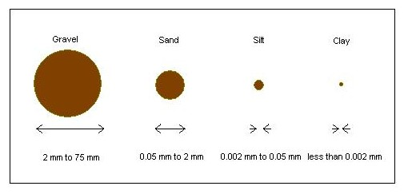
The rocks that have been weathered high in the mountains are weathered into smaller and smaller pieces by the action of the water and other rocks. The silt and clay are the smallest pieces of sediment and they are suspended near the top of the river. Sand is larger than silt and clay and so is suspended between the top and the bottom of the river. The larger gravel and rocks roll and slide along the bottom of the river.

Watch the following video and find the silt, clay, gravel and rocks.
http://highered.mcgraw-hill.com/olcweb/cgi/pluginpop.cgi?it=swf::640::480::/sites/dl/free/0072402466/30425/10_14.swf::Fig.%2010.14%20-%20Modes%20of%20Sediment%20Transport
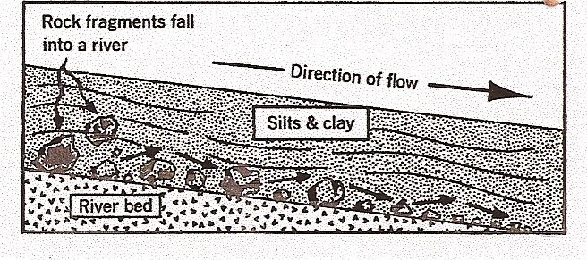
1. Color the silts and clay yellow.
2. Color the sand brown.
3. Color the rocks orange.
4. What will happen to the sliding rock when the rolling rock hits it? _____________________________________
5. Predict where all this sediment will end up. __________

Erosion occurs along the beach, too. Ocean and tidal currents bring sand to the beach. This sand comes from the sediments that have been carried to the ocean by rivers. Storms such as hurricanes take sand away from the beach and out into the Gulf. As a result of all of these processes, beaches change from day to day, month to month and year to year. Some beaches get smaller and other beaches get larger.
What To Do:
Observe the following pictures and put them in order from beginning to end.
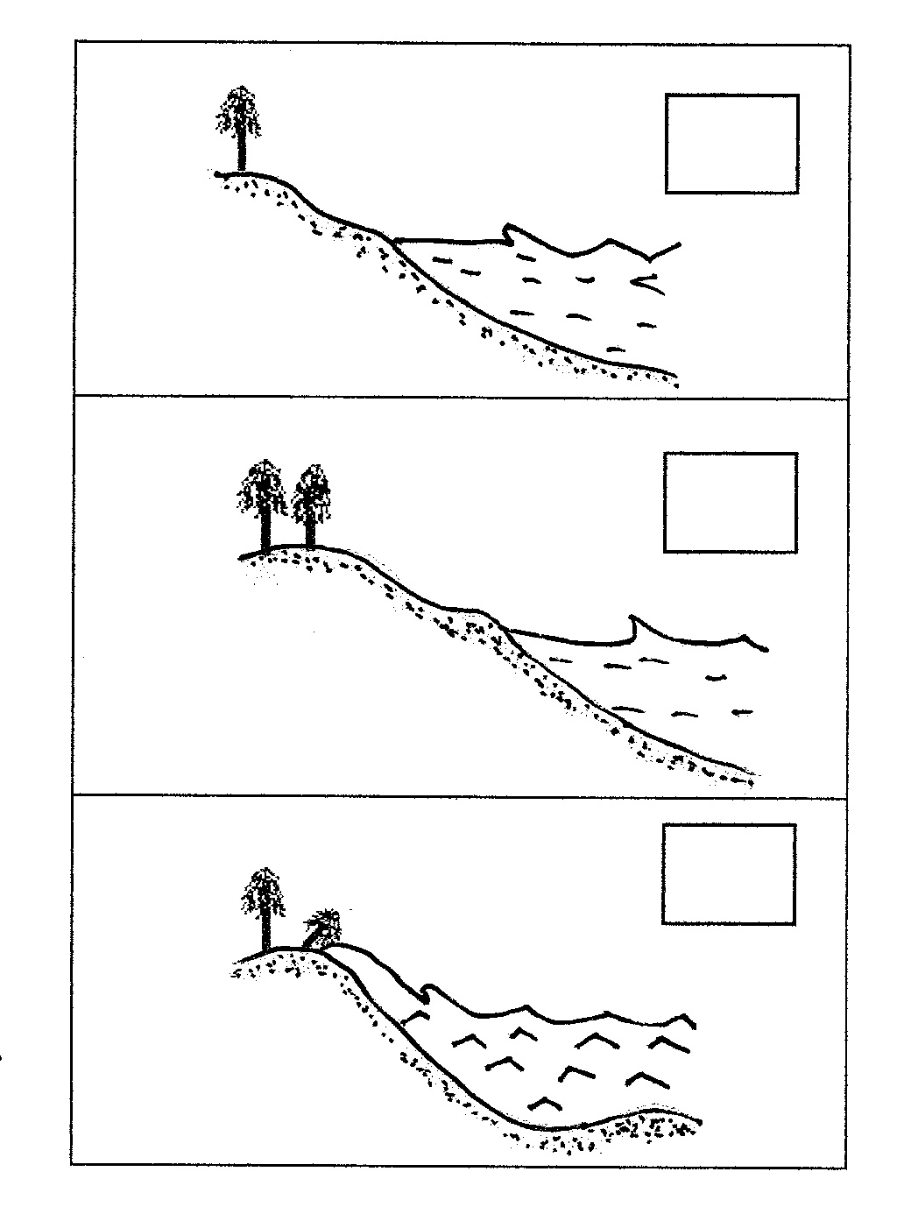
Explain what happened in the pictures.
___________________________________
___________________________________
___________________________________

Headlands jutting out into the sea are attacked on all sides by waves. The surf weathers and erodes the softer rock and fractured rock more quickly than the surrounding rock. At first sea caves may form. When two caves on opposite sides of the headland join, a sea arch is formed. When the sea arch falls in, an isolated feature called a sea stack remains. Eventually, the ceaseless surf will also erode the sea stack.
What To Do:
1. Color the water blue.
2. Color the Sea Cave orange.
3. Color the rock of the Sea Arch yellow.
4. Color the Sea Stack purple

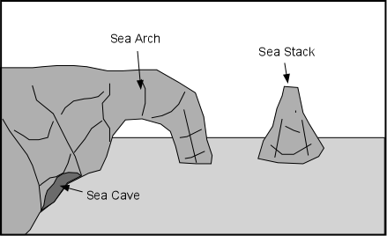

73

Watch the video on Sea Stacks from www.missdoctorbailer.com and place the steps of Sea Stack formation in proper order.
____Rocks continue to weather and erode forming a Sea Arch
____Rocks are cracked
____Ocean pounds the rock causing it to fall into the sea
forming a Sea Stack
____Ocean weathers and erodes the rock forming a Sea Cave

Name ______________ period _______
EXIT TICKET
Erosion by Water

1. The process by which natural forces move rock from
one place to another is called –

A. Weathering
B. Erosion
C. Succession

2. The process by which natural forces break down rock is
called –

A. Weathering
B. Erosion
C. Succession
3. What is the main agent of erosion?

A. Wind
B. Water
C. Ice

4. Which particle is largest?

A. Sand
B. Clay
C. Gravel

5. Which particle is smallest?

A. Sand
B. Clay
C. Gravel

Name ______________ period ______
EXIT TICKET
Erosion by Water

1. What is the main agent of erosion?

A. Wind
B. Water
C. Ice

2. Which particle is largest?

A. Sand
B. Clay
C. Gravel

3. Which particle is smallest?

A. Sand
B. Clay
C. Gravel

4. The process by which natural forces move rock from one place to another is called –

A. Weathering
B. Erosion
C. Succession

5. The process by which natural forces break down
rock is called –

A. Weathering
B. Erosion
C. Succession

Print 1 page for every 4 students

