Sediments and Deposition

We have learned that weathered rock becomes a number of different types of sediments. We observed silt and clay near the top of a river, sand in the middle of the water and rocks at the bottom. When moving water drops a load of sediment in a new place, it is called deposition.
Deposition occurs anytime the moving water slows down enough to allow the sediments to sink to the bottom of the river. The heavier sediments settle out first and the lighter sediments settle out last. When a river reaches a larger body of water it slows down and drops all its sediment. This sediment builds the delta.

Materials: Gravel, sand, silt (clay), tea leaves, water bottle with tight fitting cap, water
What To Do:
1. Watch as your teacher fills the water bottle with gravel, sand, silt and tealeaves until about ½ full.
2. Fill the rest of the bottle with water.
3. Place the cap on the bottle and make sure it is closed tightly.
4. Shake the bottle for about a minute.
5. Leave on your desk without touching until the next class.
6. Observe the sediment bottle. Draw and measure the height of each layer of sediment.
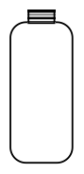

Day 1 Day 2 Day 3

Questions:
1. Which sediments are on the bottom of the bottle?
______________________________________
2. Why did they settle there? _________________
3. Which sediment is on the top of the bottle?
_______________________________________
4. Why is it on top? _________________________
5. What do the tea leaves represent? ___________

Watch the Power Point about different kinds of landforms made by deposition.

1. Write a complete sentence about a delta.
__________________________________________
__________________________________________

2. Write a complete sentence about a sandbar.
__________________________________________
__________________________________________
3. Write a complete sentence about an alluvial fan.
__________________________________________
__________________________________________
4. Write a complete sentence about Death Valley.
__________________________________________
__________________________________________

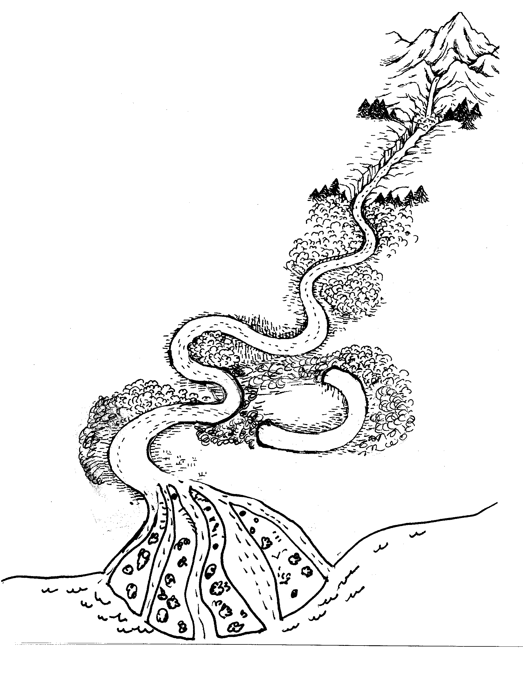

Sandbars
Color the picture of the sand bar and glue it in this area.
When a river flows around a curve in a river, the water travels more slowly on the inside curves than the outside curve. The loss of speed on the inside curve causes a deposit of sediment to build up along the inside bank of the river. This accumulation of sediment is called a
sandbar.
Color the picture of the delta and glue it in this area.
Deltas
When a river flows into a relatively large, still body of water such as a lake or a bay, the river water slows down as it mixes with the water of the larger body of water. The loss of speed causes a deposit to build up at the mouth of the river. This accumulation of sediment is called a delta.

Alluvial Fans
Color the picture of the alluvial fan and glue it in this area.
A river that flows from the mountains into a desert valley that has no lake or bay loses speed very rapidly. The loss of speed causes a deposit of sediments, rock and sand to build up along the edge of the mountain. This accumulation of sediment is called an alluvial fan.

Question:
1. If you were looking at a satellite picture from space
how you tell the difference between a delta and an
alluvial fan? _________________________________

What To Do:
1. Draw and color 4 sandbars orange along the river.
2. Color the delta green.
3. Circle where an alluvial fan might be found in red.
4. Color the ocean blue.
Questions:
1. Where did the sediment to make the delta come from? ____________________________________
2. Why does the sediment build up in the delta?
_______________________________________

Name ___________________ period _____
EXIT TICKET
Sediments and Deposition
1. Which of the following landforms is not formed by
deposition?

a. alluvial fan
b. delta
c. river valley

2. Which of the following landforms is found at the end
of a river where it enters a large body of water?

a. alluvial fan
b. delta
c. sandbar

3. How can you tell the difference between a delta and an alluvial fan?

A. An alluvial fan is at the bottom of a mountain
B. A delta is at the bottom of a mountain
C. Deltas only occur in deserts

4. Why do sandbars for in the curve of a river?

A. The river speed up and drops the sand
B. The river loses speed and drops the sand
C. There is a pile of rocks that catches the sand

5. Which of these processes is in the correct order?

A. weathering, deposition, erosion
B. deposition, weathering, erosion
C. weathering, erosion, deposition

Name ___________________ period _____
EXIT TICKET
Sediments and Deposition
1. How can you tell the difference between a delta and an alluvial fan?

A. An alluvial fan is at the bottom of a mountain
B. A delta is at the bottom of a mountain
C. Deltas only occur in deserts

2. Why do sandbars for in the curve of a river?

A. The river speed up and drops the sand
B. The river loses speed and drops the sand
C. There is a pile of rocks that catches the sand

3. Which of these processes is in the correct order?

A. weathering, deposition, erosion
B. deposition, weathering, erosion
C. weathering, erosion, deposition

4. Which of the following landforms is not formed by
deposition?

a. alluvial fan
b. delta
c. river valley

5. Which of the following landforms is found at the
end of a river where it enters a large body of water?

a. alluvial fan
b. delta
c. sandbar

