Exploring Erosion and Deposition

in a Stream Table

Erosion is the movement of weathered rock and soil from one place to another by natural forces. Water is the major agent of erosion that has shaped Earth’s land surface. As it rains on the earth, the water moves over the land. This moving water is called runoff. The water from runoff eventually forms a stream and then a river. Through erosion, a river creates many landforms by cutting away the sand and the rock and carrying it downstream. Rivers carry this sediment toward the ocean and deposit it where they enter the ocean,
forming a landform called a delta.

Materials: Mini Stream Table, Rainmaker,
30 mL graduated cup, plastic spoon, cup of water
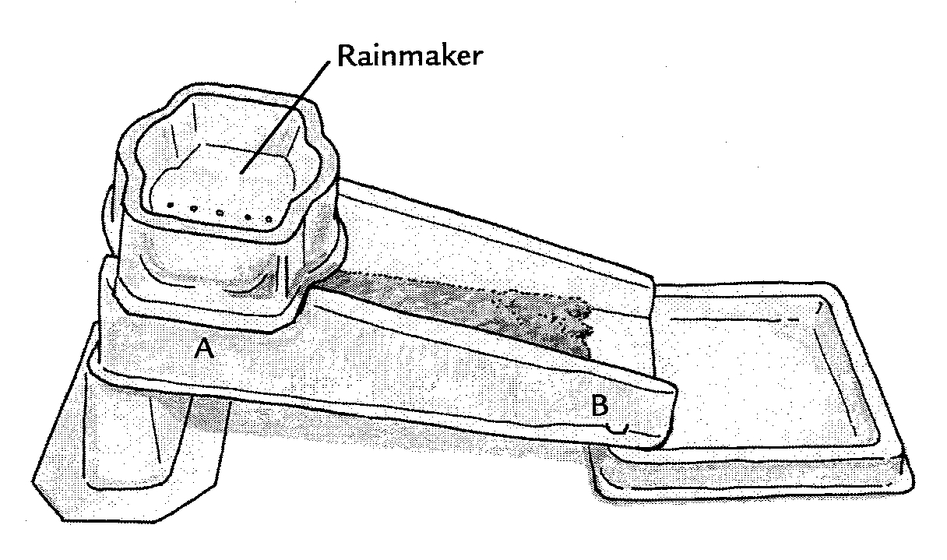
Catch basin
What To Do:
1. Set up your Mini Stream Table
as shown in the diagram.
2. Add three 30-mL cupfuls
of dampened sand to the middle
of the streambed.
3. Use the spoon or your fingers to pack the sand into an even layer
that covers the streambed from point A to point B.
4. Use your finger to draw a shallow channel in the middle of the sand to start the river.
5. Place the Rainmaker over point A as shown in the diagram.
6. Add one 30-mL cup of water to the Rainmaker and observe.

7. Use the space below to sketch the patterns produced
by the flowing water.
Observations:
Draw what you observe looking down on the stream table.

Point A Point B
Edge of Rainmaker

7. Add another 30-mL cup of water to the Rainmaker and observe.
8. Use the space below to sketch the patterns produced by the flowing water.

Point A Point B

9. Add a third 30-mL cup of water to the rainmaker and observe.

10. Use the space below to sketch to patterns produced by the flowing water.
11. Be sure to draw the deposits of sand in the catch basin.
Catch basin

Point A Point B

Questions:
1. What happened to the sand each time 30-mL of rain fell
on the streambed?______________________________
2. Where did the greatest amount of erosion occur? ___________________________
3. Where did the greatest amount of deposition occur? ________________________
4. What landform was created in the catch basin? ___________________________________________
5. Where did this sand come from? ________________

Watch the stream table video from www.missdoctorbailer.com. Pay special attention to
how the river changes course over time.
When river channels change course they also change the location of their mouths and the resulting delta.

Below is a picture showing the different locations of the Mississippi River delta over the last 7500 years.
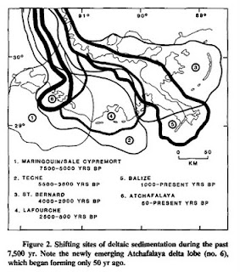
Directions:
1. Color each delta location a different color. – your choice
Questions:
1. About how long does each delta form? _____________
2. Which lobe of the delta is forming at this time? ______
3. Why do the deltas move? ______________________
4. What process causes the river channels to change course? ____________________________________
5. What did you observe in your stream table that is similar to this? ________________________________________
Name __________________ period _____

EXIT TICKET
Erosion in Stream Tables

In the diagram below label the following landforms.

Delta River Ocean Mountains
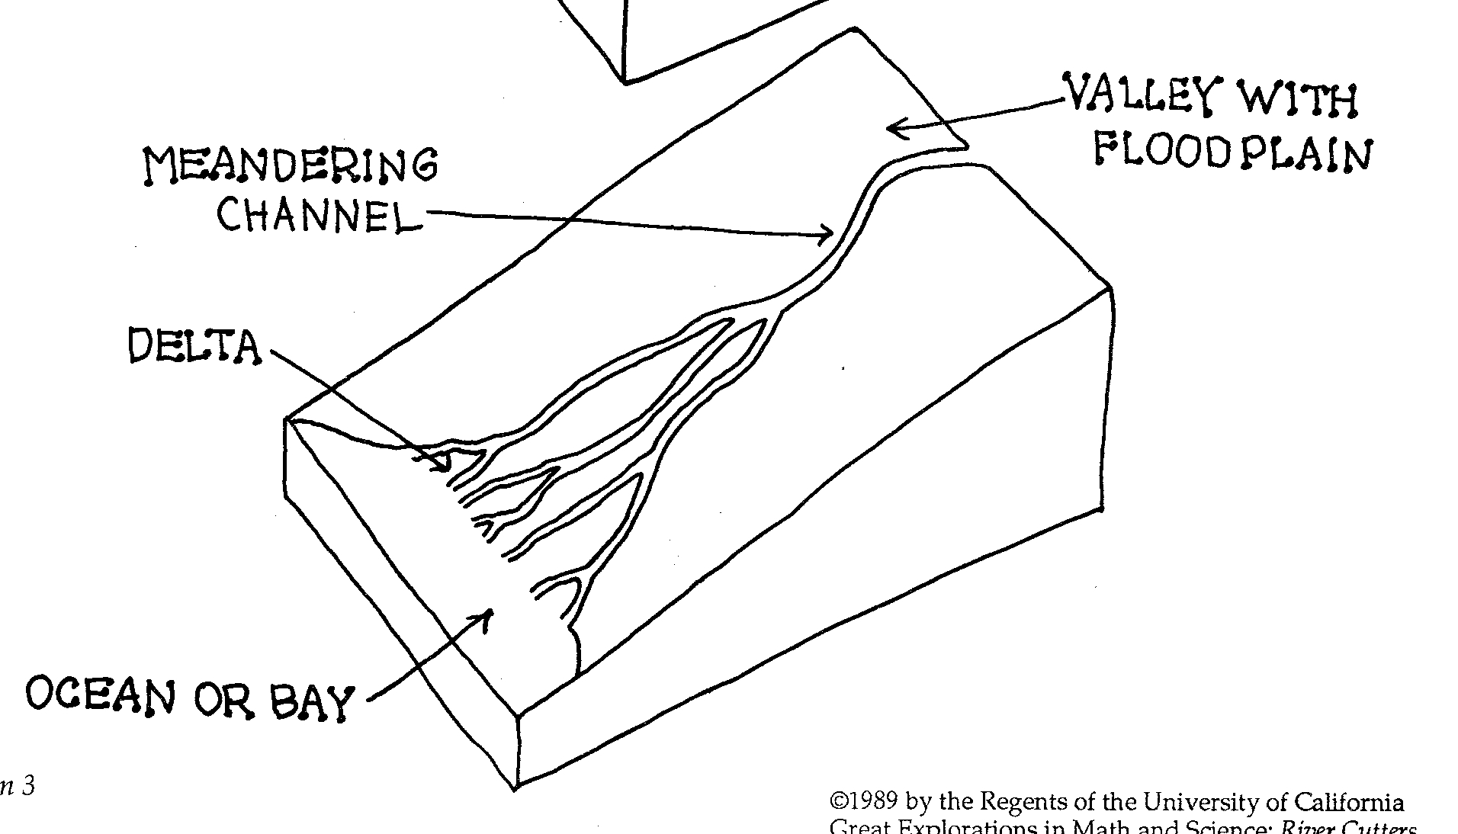

5. In which landform above is the greatest erosion occurring? ______________________________

6. In which landform above is the greatest deposition occurring? ______________________________

Name __________________ period _____

EXIT TICKET
Erosion in Stream Tables

In the diagram below label the following landforms.

Delta River Ocean Mountains

5. In which landform above is the greatest erosion occurring? ________________________________

6. In which landform above is the greatest deposition occurring? ________________________________

