Watersheds and Surface Water

After a rainstorm or snowstorm, some water evaporates immediately and returns to the air. Some water seeps into the ground. Some water flows over the surface as runoff.
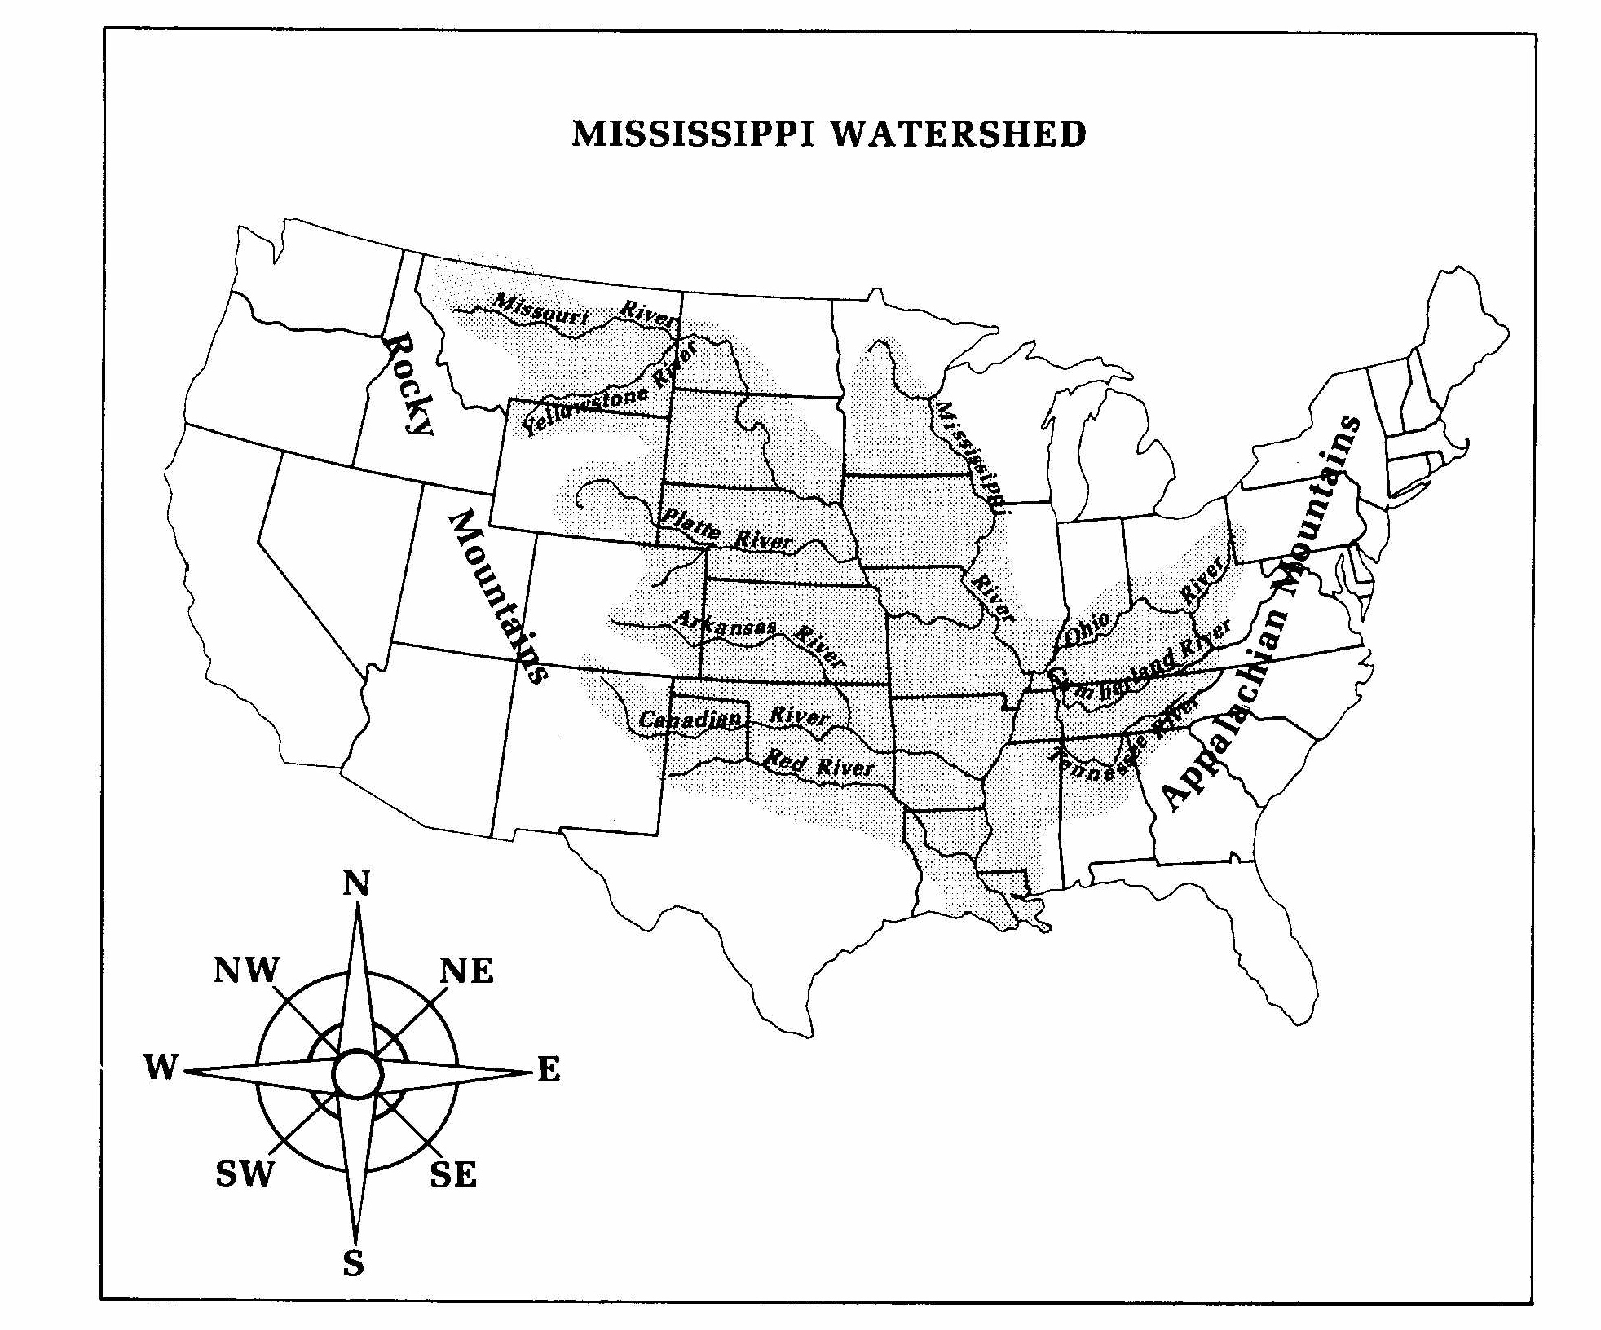
Runoff water forms small streams and rivers. These streams and rivers join a larger river and add their water to it. Small rivers that join a larger one are called tributaries. The whole area of land in which runoff water drains into a large river or river system is called a watershed. The highest point at the edge of a watershed is called a divide.
A divide is any line of high land where runoff runs down one side or the other. Water that runs down each side of a divide forms small streams, which eventually form rivers. Together these bodies of flowing water form a drainage system that takes all the water to the ocean.

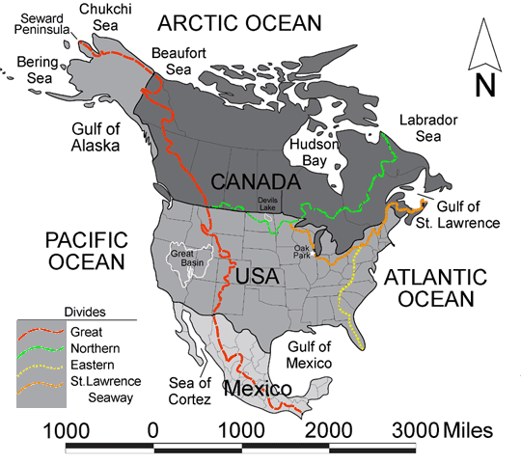
What To Do:
116
1.Trace the Great Divide in red.
2. Trace the Northern Divide in green
3. Trace the Eastern Divide in yellow.
4. Trace the St. Lawence Seway Divide in orange.
What To Do:
1. Trace the Mississippi River in a blue colored pencil.
2. Trace the tributaries that come from the west in green colored pencil.
3. Trace the tributaries that come from the east in orange colored pencil.

Questions:
1. Name the six tributaries that flow eastward into the Mississippi River.
________________________________________________
________________________________________________

2. Name the four tributaries the flow westward into the Mississippi River.
________________________________________________
________________________________________________

3. What are the approximate eastern and western boundaries of the Mississippi watershed?
________________________________________________

4. Which mountain chain causes the Great Divide? _______

5. Which mountain chain causes the Eastern Divide? _____

Human Impacts on Watersheds
Since most major cities around the world developed along waterways and those that didn't are still within a watershed, everyday human activities impact watersheds. The most significant however, is the pollution of watersheds.
Watershed pollution occurs in two ways: point source and nonpoint source. Point source pollution is pollution that can be traced to a specific point such as a disposal site or leaking pipe. Recently, laws and technological advances have made it possible to detect point source pollution and its problems are being reduced.

Nonpoint source pollution occurs when pollutants are found in water running off of crops, parking lots and other lands. In addition, it can also be caused when small solids called particulates in the atmosphere fall onto the land with precipitation.

We can also create nonpoint source pollution. When we fertilize our yard it can runoff into the storm drain. Any thing but water that goes into the storm drain causes nonpoint source pollution. All of these things will pollute streams and rivers and cause animals to die.

Circle the 5 types of nonpoint source pollution in the picture below.
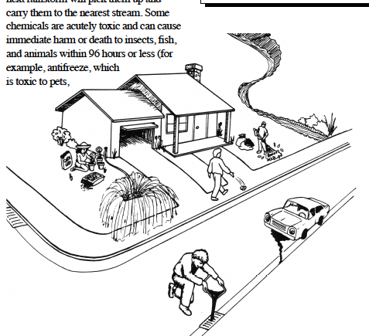

Many cities and towns get their drinking water from

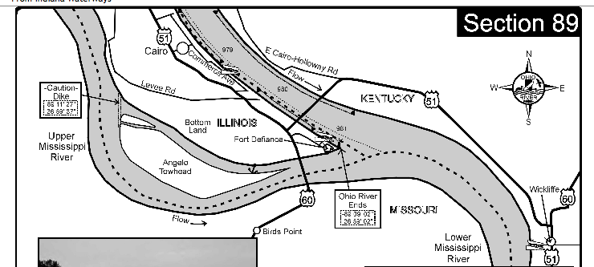
rivers. A little pollution comes from tugboats on the
rivers but not much. A great deal of chemical pollution
comes from farm runoff. Some chemicals cannot be
filtered out of the water and they end up in the drinking
water.
1. Find the city of Cairo and color it green.
2. Find the city of Wickliffe and color it purple.
3. Color the rivers blue.
4. Find Fort Defiance and color it yellow.
5. Draw a tugboat in the river.
6. The area called Bottomland has very rich soil.
Color it orange.

The state of Kentucky wants to give a permit to a chemical company to build a chemical plant next to the river on highway 51 where it joins highway 60. The plant would use river water to make its chemicals and return “clean” waste water back to the river.
Questions:
1. Which city might get pollution from the chemical plant in its drinking water? __________________
2. Why do you think so? ____________________

The area called Bottomland has farms that use fertilizers to help the plant grow and produce more corn.
Questions:
1. Would the city of Cairo be affected by the fertilizer runoff from these farms? ____________________________
2. Explain your thinking. _________________________
3. What type of pollution would the chemicals from the plant be called? ________________________________
4. What type of pollution would the fertilizers from the farm be called? _________________________________

Name ______________ period _____

EXIT TICKET
Watersheds and Surface Water
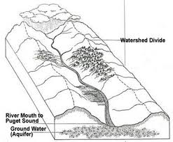
1. The watershed divide is
where –

A. rain stops falling
B. the only place plants
will grow
C. Where surface water
begins to enter the
watershed

2. A chemical company wants to build a factory
somewhere in this watershed. The state is concerned
about polluting the watershed if a chemical spill occurs.
Where would be the best place to build the factory so that
any damage to the watershed done by a chemical spill is
minimized?

A. high in the mountains
B. near a curve in the river
C. near the river mouth

3. The type of pollution from the chemical company would be considered-

A. nonpoint source pollution
B. point source pollution
C. not real pollution

Name ______________ period _____

EXIT TICKET
Watersheds and Surface Water

1. A chemical company wants to build a factory
somewhere in the watershed pictured below. The state
is concerned about polluting the watershed if a chemical
spill occurs. Where would be the best place to build the
factory so that any damage to the watershed done by a
chemical spill is minimized?

A. high in the mountains
B. near a curve in the river
C. near the river mouth

2. The watershed divide is where –

A. rain stops falling
B. the only place plants
will grow
C. Where surface water
begins to enter the
watershed

3. The type of pollution from the chemical company would be considered-

A. nonpoint source pollution
B. point source pollution
C. not real pollution

