Groundwater
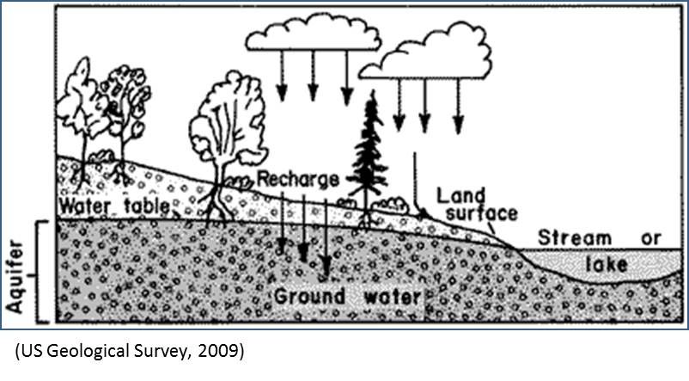
Groundwater is water that comes from the ground. Amazingly, many people use groundwater but don't even know it. In fact, half of everyone in the United States drinks groundwater everyday! Groundwater is even used to irrigate crops that grow food for tonight's dinner.
Where does groundwater come from? Groundwater comes from rain, snow, sleet, and hail that soaks into the ground. The water moves down into the ground because of gravity, passing between particles of soil, sand, gravel, or rock until it reaches a depth where the ground is filled, or saturated, with water. The area that is filled with water is called the saturated zone and the top of this zone is called the water table. The water table may be very near the ground's surface or it may be hundreds of feet below.
Think about this: have you ever dug a hole in sand next to an ocean or lake? What happens? As you're digging, you eventually reach water, right? That water is groundwater. The water in lakes, rivers, or oceans is called surface water...it's on the surface. Groundwater and surface water sometimes trade places. Groundwater can move through the ground and into a lake or stream. Water in a lake can soak down into the ground and become groundwater.

What To Do:
1. Color the groundwater blue.
2. Color the land surface brown.
3. Trace the water table in red.
4. Color the trees and bushes green.

Watch the Groundwater animation from www.missdoctorbailer.com

1. When it says the water is used over and over again what does this mean?
_________________________________________

_________________________________________
2. What kept the rain from soaking into the ground?
_________________________________________

3. What did it show that could help the rain soak into the ground around parking lots and streets?

________________________________________

________________________________________

Groundwater is stored in the ground in materials like gravel or sand. It's kind of like the earth is a big sponge holding all that water. Water can also move through rock formations like sandstone or through cracks in rocks.
An area that holds a lot of water, which can be pumped up with a well, is called an aquifer. Wells pump groundwater from the aquifer and then pipes deliver the water to cities, houses in the country, or to crops. There are two major types of aquifers – confined and unconfined.
A confined aquifer is between two layers of rock that water cannot flow through. These layers are called impermeable. An unconfined aquifer is lacking the top layer of rock. Where the aquifer meets soil is called the recharge zone.
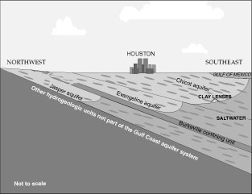

1. Color the confined aquifer orange.
2. Color the unconfined aquifers purple.
3. Draw a well close to Houston that pumps water
from the Evangeline aquifer.
Aquifer in a Cup

Materials:
Clear plastic cup, modeling clay, sand, gravel, water
What To Do:
1. Pour ¼ inch of sand in the cup making sure to cover
the bottom.
2. Add enough water to the sand so it is wet but no
water is standing on top of it. Observe the water and
the sand.
3. Flatten the modeling clay (like a pancake) and cover
½ of the sand with the clay. Be sure to press the
clay to the side of the cup to seal off that side.
4. Pour a small amount of water on to the clay and
observe the water.
5. Place the pea gravel over the sand and clay, covering
the entire container. Slope the rocks forming a high
hill and valley.
6. Pour water into the aquifer until the water in the
valley is about 1 cm from the top of the hill.
7. Draw your aquifer below and label your drawing
with the following words:

Groundwater, water table, lake, impermeable layer

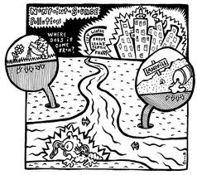
Questions:

1. What happened to the water you pour on the sand?
_______________________________________

2. What happened to the water you poured on the clay?
______________________________________

3. Why did they interact differently?
_______________________________________

4. What does the clay represent?

______________________________________

5. What is the top of the aquifer called?

_______________________________________

6. In what area was the surface water located?

______________________________________

7. Where does the surface water come from?

______________________________________

Explain what the cartoon above is showing.

_________________________________________

_________________________________________

_________________________________________

_________________________________________

_________________________________________

Name ________________ period _______
EXIT TICKET
Groundwater

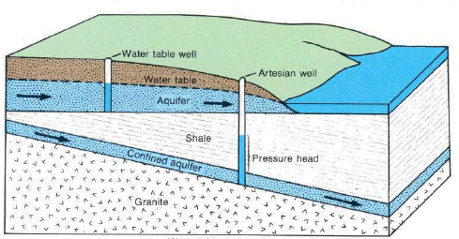
City

1. Place the letter G in the two areas on the diagram the represents groundwater.

2. Place the letter S in the area of the diagram the represents surface water.

3. If the city gets its drinking water from the wells what will happen to the water table if there are 15 more wells put in.

A. It will go up and flood the land above it.
B. It will soak into the shale layer.
C. It will go down because all the water is being pumped out.
D. It will get more water from the confined aquifer.

Name ________________ period _______

EXIT TICKET
Groundwater

1. If the city gets its drinking water from the wells what will happen to the water table if there are 15
more wells put in.

A. It will go up and flood the land above it.
B. It will soak into the shale layer.
C. It will go down because all the water is being pumped out.
D. It will get more water from the confined aquifer.
City
2. Place the letter G in the two areas on the diagram
the represents groundwater.

3. Place the letter S in the area of the diagram the represents surface water.

