Unit 12

7th Grade
Characteristics of Our Solar System

SCI.7.9A Analyze the characteristics of objects in our solar system that allow life to exist such as the proximity of the Sun, presence of water, and composition of the atmosphere.
SCI.7.9B Identify the accommodations, considering the characteristics of our solar system that enabled manned space exploration.

Activity 1 The Goldilocks Principal

Materials: About 100 jelly beans of each of the following colors: Red, green, purple, white and about 200 yellow for each group. Five different types of beans or pony beads from the craft store can be substituted. 3 re-sealable bags per group.

Help students determine the amounts for Venus and then allow them to complete Earth and Mars independently.
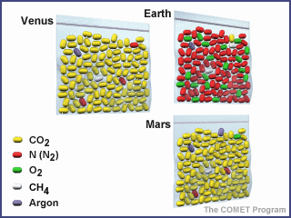
Answers for Venus - See picture
Carbon Dioxide 97 yellow jellybeans (96.8%)
Nitrogen 31/2 red jellybeans (3.5%)
Oxygen - small piece of a green jellybean
Argon - small piece of a purple jelly bean
Methane - none

Focus: I can analyze characteristics of our solar system that allows life to exist such as the composition of the atmosphere.

Language Objective: I can read an article and summarize it using questions.

Activity 2 What Makes a Planet Habitable?

Materials: none needed

Focus: I can analyze characteristics of our solar system that allows life to exist such as the proximity of the Sun, presence of water and the presence of an atmosphere.

Language Objective: I can read and analyze data tables with my partners.

Activity 3 Accommodations for Manned Space Exploration

Materials: none needed

Focus: I can identify the accommodations, considering the characteristics of our solar system that enabled manned space exploration.

Language Objective: I can listen and watch a video and answer questions about it.

