What Makes a Planet Habitable?

The presence of liquid water at the surface of a planet appears to be one of the central characteristics that distinguish whether or not a planet can harbor life. This requires that the planet be at a distance from the central star where the temperature is not too low to cause all water to freeze nor too high to cause all water to boil. The region around a star where the temperature is “just right” is known as the zone of habitability. For a star like our Sun the zone of habitability has been identified as between .84 AU and 1.7 AU.

Astronomers use the AU (Astronomical Unit) to describe distances in our Solar System based on the average distance between Earth and the Sun (approx. 149,570,000 km).

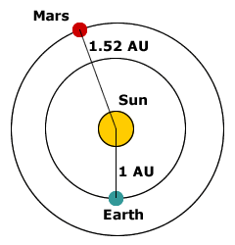

Directions: Look at the chart below.

Object | Distance (AU)
Mercury | 0.4
Venus | 0.7
Earth | 1
Mars | 1.5
Ceres | 2.8

Questions:
1. Which of the planets/asteroids are in the Zone of Habitability? ____________________________
2. Where do you think Ceres is located? _________

Additionally, the star of the solar system can’t be too hot or too cold. Stars are classified by their temperature and the type of elements found in them. There are seven main types of stars. In order of decreasing temperature they are: O, B, A, F, G, K and M. An easy mnemonic for remembering these is: “Oh Be A Fine Girl/Guy, Kiss Me.”
The temperature of our sun is 5778 K. Notice, it does not have a º symbol next to it. The kelvin scale is used in the measure of the color temperature of light sources, such as stars.

Directions: Look at the chart on the next page and answer the questions below it to determine what class our sun would be found in.

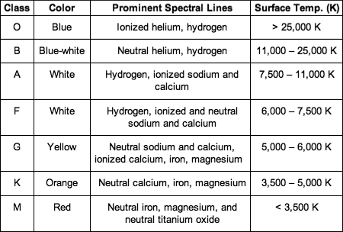
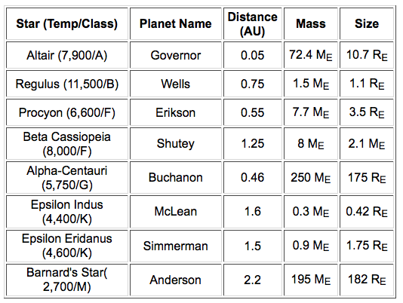

1. What is the surface temperature of our sun? __________
2. What color is our sun? ___________________________
3. What class is our sun found in? ____________________
4. What other classes have surface temperatures that could support life? ____________________________________

In addition to distance from the sun and the temperature of the sun in consideration the planet must have a suitable atmosphere. Planets that are too small will not have enough gravity to hold an atmosphere. This requires that the planet have a mass between 0.5 and 10 Earth masses with a radius between 0.8 and 22 times that of Earth. Planets that are larger will have an atmosphere too thick to support life, as we know it.

Directions: Observe the chart below.
Questions:
1. On which of these hypothetical planets would you search for Earth-like life? Explain your reasoning.
________________________________________________
________________________________________________
________________________________________________
2. What are the characteristics that make a planet habitable?
________________________________________________
________________________________________________
________________________________________________

Name _______________ period _____
EXIT TICKET
What Makes a Planet Habitable?

1. What is the main characteristic that would make a planet habitable for human life?
A. The presence of rocks
B. The presence of liquid water
C. The presence of Argon in the atmosphere

2. What determines the “Habitable Zone” for a planet?
A. The distance from the Sun
B. The thickness of the atmosphere
C. The size of the planet

3. Which of the following is written correctly?
A. kº
B. Kº
C. K

4. Why don’t small planets have an atmosphere?
A. They are too far from the Sun
B. They don’t have enough gravity
C. The star is the wrong color

5. What happens to the atmosphere of large planets?
A. It is too thin to support life.
B. It is too thick to support life.
C. Most large planets don’t have an
atmosphere.

Name _______________ period _____
EXIT TICKET
What Makes a Planet Habitable?

1. What happens to the atmosphere of large planets?
A. It is too thin to support life.
B. It is too thick to support life.
C. Most large planets don’t have an
atmosphere.

2. What determines the “Habitable Zone” for a planet?
A. The distance from the Sun
B. The thickness of the atmosphere
C. The size of the planet

3. Which of the following is written correctly?
A. kº
B. Kº
C. K

4. Why don’t small planets have an atmosphere?
A. They are too far from the Sun
B. They don’t have enough gravity
C. The star is the wrong color

5. What is the main characteristic that would make a planet habitable for human life?
A. The presence of rocks
B. The presence of liquid water
C. The presence of Argon in the atmosphere

