Accommodations for Manned

Space Exploration

Human spaceflight started with suborbital flights. Later goals reached were the launching of a single astronaut in orbit, the launching of several astronauts, the meeting and docking of two spacecraft, spacecraft, making a lunar orbit, and landing of an astronaut on the moon.
The American Mercury program had its first orbital success in February 1962, when John Glenn circled the earth three times in a space capsule named Freedom 7.
The first launch of the Gemini program, carrying two American astronauts, occurred in March of 1965. There were a total of 12 missions.
The Apollo program was the biggest scientific project in history and started in 1967. Its goal was to put a man on the moon. On July 20, 1969, astronauts Neil A. Armstrong and Edwin Aldrin, Jr., stepped on the moon.
Skylab was a research space station that orbited the earth. It was launched in 1973. The purpose of Skylab was to get information about the earth and to test man's reactions to long stretches of time in space.
The first space shuttle was launched in 1981. Astronauts conducted research and supplied the space stations.
The International Space Station, which was a joint effort of the United States, Russia, Japan, Canada, Brazil, and the ESA, was started in 1998. It continues to be manned by astronauts of many countries.

Directions:
In the space below make a timeline of the history of manned space exploration from the article you read on the preceding page.

Watch the NASA video, “ Mercury thru Apollo” from www.missdoctorbailer.com and pay special attention to what the astronauts are wearing.

1. Why did the astronauts wear helmets? __________
____________________________________________
2. Why did the astronauts have all those tubes when they spaced walked? _______________________________
_____________________________________________
3. Why did the Apollo astronauts have that big backpack on their spacesuits? ______________________________
_______________________________________________

Watch the slide show presentation on Accommodations for Space Exploration from www.missdoctorbailer.com and takes notes in the graphic organizer on the next page.

Glue the appropriate pictures on the front of each of the flaps.
Cut apart before gluing into notebook.

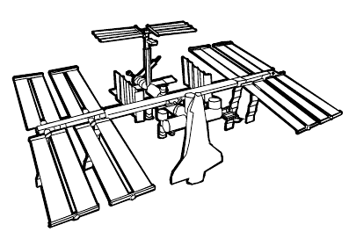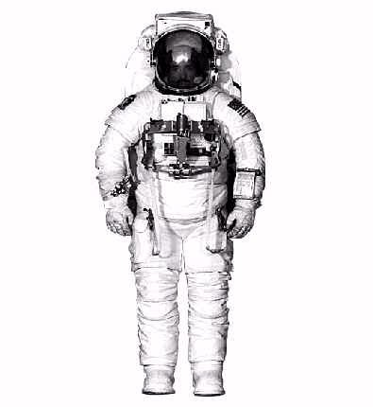

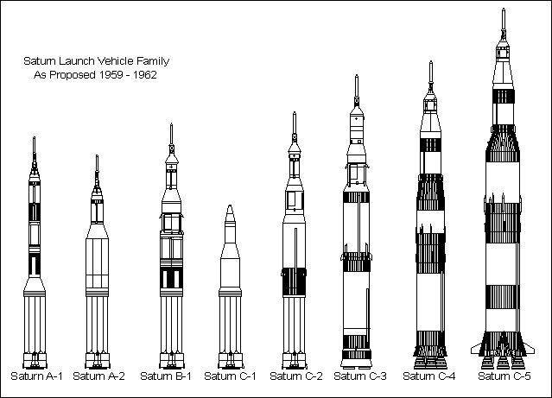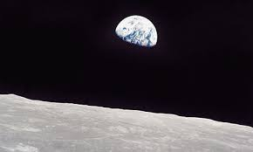

DO NOT GLUE INTO NOTEBOOK until instructed by teacher.

Glue to notebook | Conditions  in Space | Space Stations | Glue to notebook
 | Space Craft | Space Suits

Name _______________ period _____
EXIT TICKET
Accommodations for Manned Space Exploration

1. What condition in space requires the accommodation of a space suit?
A. Lack of sunlight
B. Lack of water
C. Lack of oxygen

2. What condition in space requires the accommodation of a spacecraft?
A. Lack of matter/air pressure
B. Lack of water
C. Lack of sunlight

3. What condition in space requires the accommodation of a space station?
A. Presence of sunlight
B. Presence of cosmic radiation
C. Presence of water

4. How do astronauts get into space?
A. By riding an elevator
B. By riding a rocket
C. By riding a bicycle

5. Which of the following is NOT an American space program?
A. Apollo
B. Pluto
C. Mercury

Name _______________ period _____
EXIT TICKET
Accommodations for Manned Space Exploration

1. Which of the following is NOT an American space program?
A. Apollo
B. Pluto
C. Mercury

2. What condition in space requires the accommodation of a spacecraft?
A. Lack of matter/air pressure
B. Lack of water
C. Lack of sunlight

3. What condition in space requires the accommodation of a space station?
A. Presence of sunlight
B. Presence of cosmic radiation
C. Presence of water

4. How do astronauts get into space?
A. By riding an elevator
B. By riding a rocket
C. By riding a bicycle

5. What condition in space requires the accommodation of a space suit?
A. Lack of sunlight
B. Lack of water
C. Lack of oxygen

