Evidence of Plate Tectonics

For many years it geologists believed that the location of the continents was fixed. These scientists thought that the continents were developed as the Earth formed many billions of years ago. It was thought that the continents were simply areas where the crust was too high for the oceans to cover them over.

Modern scientific discoveries have helped us understand that this view of the Earth is inaccurate. There is a long history of observing, gathering evidence and proposing theories that has led us to the theory of plate tectonics.

Many people use the word theory the same way that they use the word guess. In science when we used the word theory we mean an explanation of a set of facts. So the theory of plate tectonics is not a guess it is an explanation of the evidence that has been gather over several hundred years.

**Materials:** Timeline of Plate Tectonics

**What To Do:**

1. Read through the timeline and answer the following questions.

**Questions:**

1. What was the profession of Abraham Ortelius?

_______________________________________

2. What did he observe?

_____________________________________________

3. What did his observations lead him to believe?

_______________________________________________

4. Who proposed the Law of Superposition?

______________________________________________

5. What does the Law of Superposition state?

______________________________________________

6. What evidence did James Hutton find?

______________________________________________

7. What did this evidence lead him to believe?

______________________________________________

8. Who proposed that the continents were once joined in a super continent? ________________________________

9. What did idea he propose? ______________________________________________

10. Why was his idea rejected? ____________________

______________________________________________

11. What mechanism for the movement of the continents did Arthur Holmes propose? ______________________

12. What are mid-ocean ridges? ___________________

13. What idea did Harry Hess develop? ______________

______________________________________________

14. What did Robert S. Dietz call Hess’ idea?

______________________________________________

15. What did the global sensors that were installed in the mid-1960s discover about earthquake activity?

______________________________________________16. What was the Glomar Challenger’s mission?

_____________________________________________

17. What was discovered by this information?

_____________________________________________

18. Who proposed the Theory of Plate Tectonics?

_____________________________________________

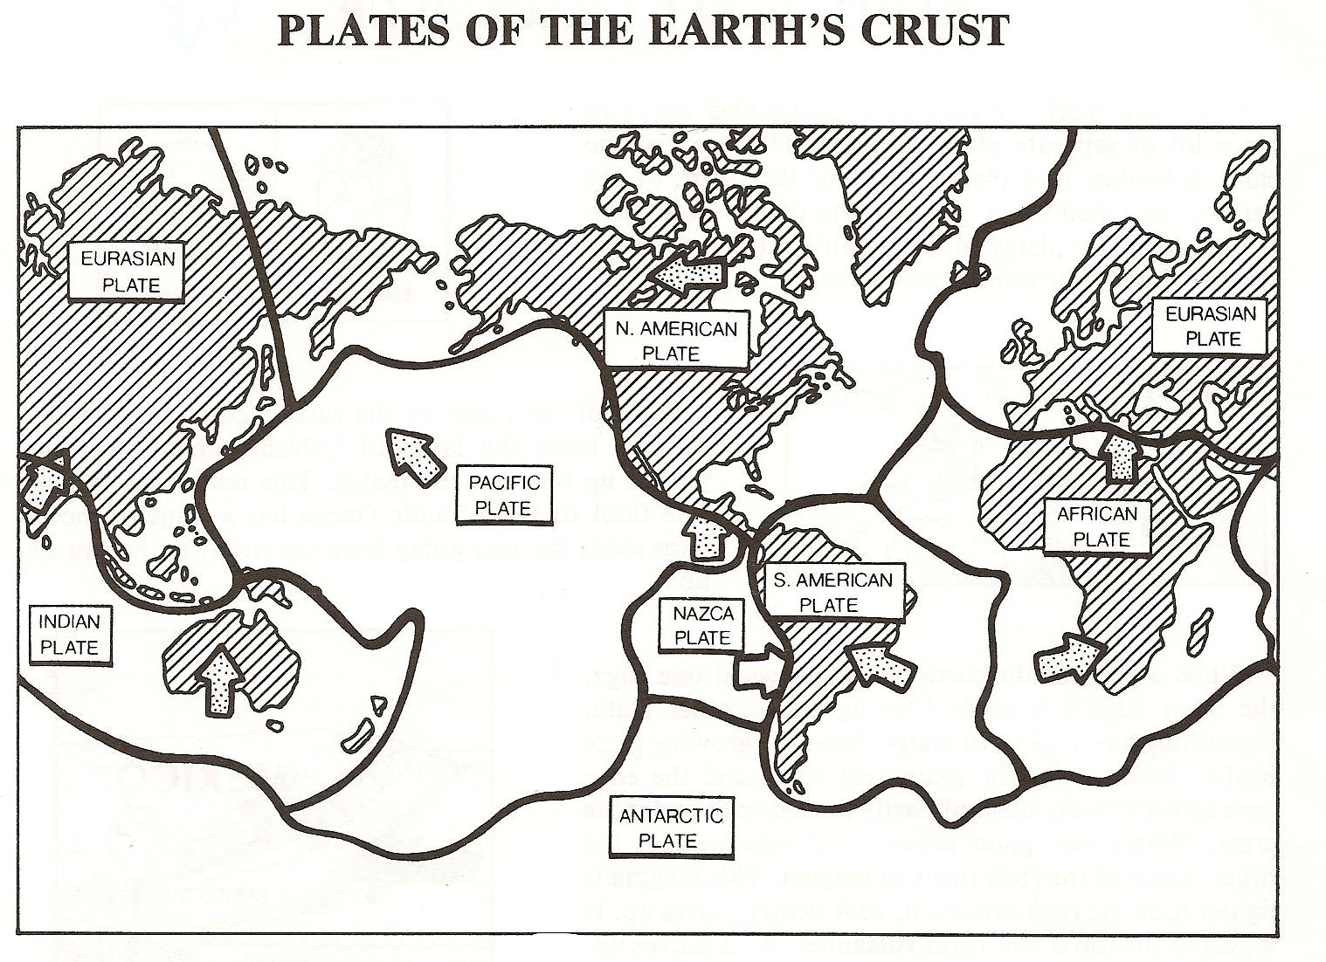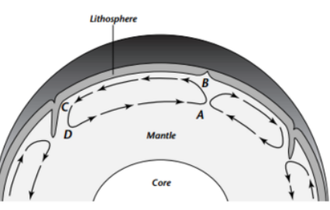

**Where are the plates?**

There are eight major plates on the surface of the Earth and a number of minor plates. They constantly move around the Earth a few centimeters per year. The plates make up the top layer of the Earth called the lithosphere. Directly under that layer is asthenosphere, which is the upper part of the mantle. The asthenosphere is an area of molten rock heated by the Earth’s core by the process of convection.

Observe the diagram below. At point A the heated magma begins to rise until it gets to point B where it begins to spread out carrying the plate above it along. At point C

the magma has cooled enough that it sinks back to be reheated at point D. It then spreads across to A where the process starts again.

**Materials:** colored pencils, Plate Boundary Map

**What To Do:**

1. Don’t glue in the map your teacher gives you until you are finished coloring it.

2. Find all the arrows on the map (10) and color them orange.

3. Find the Nazca Plate and lightly color it blue.

4. Find the South American Plate and color the continent green and the ocean blue.

5. Find the mid-Atlantic Ridge with the help of your teacher and trace it in red.

6. Color the ocean on either side of the mid-Atlantic Ridge blue.

Name ____________________ Period _____

EXIT TICKET

*Evidence of Plate Tectonic*

1. Which of the following is NOT important in the development of the theory of plate tectonics?

A. Harry Hess

B. Alfred Wegner

C. Charles Darwin

2. On which plate does the United States sit on?

A. North American

B. Eurasian

C. South American

3. What is the mechanism that drives plate tectonics?

A. convection

B. conduction

C. radiation

4. Which of the following is a piece of evidence that supports the theory of plate tectonics?

A. We can observe the plates move past each other

B. The continents look like pieces of a puzzle that go

together.

C. The is only one mid-ocean ridge

5. Which of the following is NOT a plate?

A. Indian plate

B. Arctic plate

C. African plate

Name ____________________ Period _____

EXIT TICKET

Evidence of Plate Tectonics

1. What is the mechanism that drives plate tectonics?

A. convection

B. conduction

C. radiation

2. Which of the following is a piece of evidence that supports the theory of plate tectonics?

A. We can observe the plates move past each other

B. The continents look like pieces of a puzzle that go

together.

C. The is only one mid-ocean ridge

3. Which of the following is NOT important in the development of the theory of plate tectonics?

A. Harry Hess

B. Alfred Wegner

C. Charles Darwin

4. On which plate does the United States sit on?

A. North American

B. Eurasian

C. South American

5. Which of the following is NOT a plate?

A. Indian plate

B. Arctic plate

C. African plate