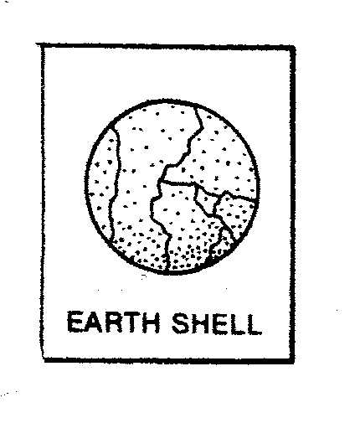

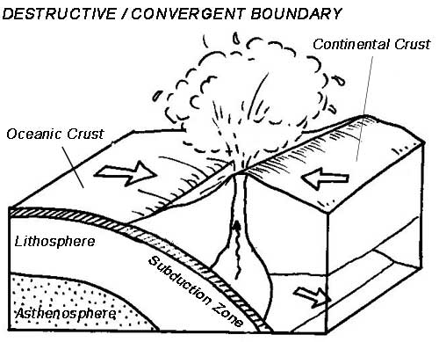

4. What type of Plate Boundary is shown?

______________________

5. What type of effects does this type of boundary have on the area around it?

_______________________

_______________________

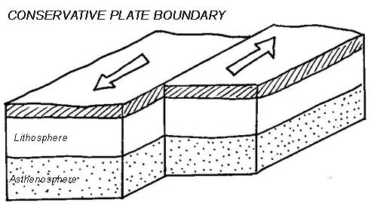

6. What type of Plate Boundary is shown?

______________________

7. What type of effects does this type of boundary have on the area around it?

_______________________

_______________________

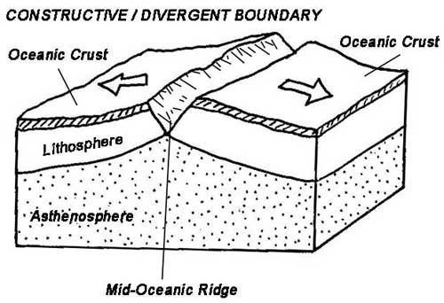

8. What type of Plate Boundary is shown?

______________________

9. What type of effects does this type of boundary have on the area around it?

_______________________

_______________________

Your teacher will show you a Power Point called Types

of Plate Boundaries.

**Questions:**

1. How do convergent boundaries move? _____________

2. How do transform boundaries move? ______________

3. How do divergent boundaries? ___________________

The Theory of Plate Tectonics explains all of this movement. Plate tectonics is what causes major crustal features such as mountains, volcanoes, fault lines and ocean basins.

When the plates move toward each other the land crumbles and form high mountain ranges. The Himalayan Mountains were formed with the Indo-Australian plate slammed into the Eurasian plate. When plates pull apart ocean basins are formed such as the Atlantic Ocean. When plates slide past each other it causes fault lines to appear such as the San Andreas fault in California. Volcanoes and earthquakes also occur around many plate boundaries.

Watch the Plate Tectonics video from [www.missdoctorbailer.com](http://www.missdoctorbailer.com) and answer the following questions.

**Questions:**

1. What was Pangaea? _____________________

2. What two continents fit together like a puzzle? ________________________________________

3. What did Alfred Wegner call his theory?

___________________________________________

The cracks between the plates are called plate boundaries. Along plate boundaries the plates slide past each other, pull apart or move together.

Formation of Crustal Features

The earth’s crust is broken up into many pieces called plates. These plates move along the top of the asthenosphere. The plates move very slowly-at rates of several centimeters a year.

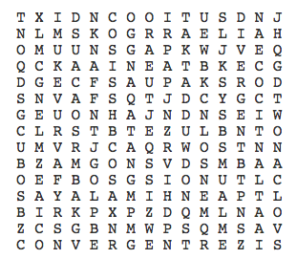

Atlantic Ocean convergent divergent

earthquake Himalayas mountains

ocean basin San Andreas Fault transform

volcano

**Materials:** scissors, glue, colored pencils

**What To Do:**

1. Cut out the next page on the heavy lines.

2. Glue the anchor tab into your notebook.

3. On the back flap of the foldable place the following information:

a. A location where this boundary might be found.

b. How that boundary moves.

4. On the lined page of your notebook underneath the flap place the following information:

a. Events that occur along this boundary

b. A drawing of the crustal features that are found at

this type of boundary.

**Crustal Features**

|  |  |
| --- | --- |
|  | CONVERGENT  BOUNDARIES |
| DIVERGENT  BOUNDARIES |
| TRANSFORM  BOUNDARIES |

Name ____________________ Period _____

EXIT TICKET

*Formation of Crustal Features*

1. The only place you can see the Mid-Atlantic Ridge

on land is

A. The Himalayan Mountains

B. The Andes Mountains

C. Iceland

2. Which large fault zone can be seen in California?

A. The Himalayas

B. The Andes

C. The San Andreas

3. Convergent plate boundaries cause what type of crustal feature?

A. Ocean basins

B. Mountains

C. River Valleys

4. Divergent plate boundaries cause what type of crustal feature?

A. Ocean basins

B. Mountains

C. River Valleys

5. Transform plate boundaries cause what type of crustal feature?

A. Ocean basins

B. Volcanoes

C. Glaciers

Name ____________________ Period _____

EXIT TICKET

Formation of Crustal Features

1. Convergent plate boundaries cause what type of crustal feature?

A. Ocean basins

B. Mountains

C. River Valleys

2. Divergent plate boundaries cause what type of crustal feature?

A. Ocean basins

B. Mountains

C. River Valleys

3. Transform plate boundaries cause what type of crustal feature?

A. Ocean basins

B. Volcanoes

C. Glaciers

4. The only place you can see the Mid-Atlantic Ridge

on land is

A. The Himalayan Mountains

B. The Andes Mountains

C. Iceland

5. Which large fault zone can be seen in California?

A. The Himalayas

B. The Andes

C. The San Andreas