Topographic Maps

Most maps show a view of Earth from directly above. Some maps show streets and other show borders between towns, counties and states. A topographic map shows the elevation, or height above sea level, of natural features of a region. On a topographic map, features are represented using lines and symbols. The most important function of a topographic map is to show elevation. Lines on a topographic map that connect areas with the same elevation are called contour lines.
Topographic maps display three-dimensional features of the land on a flat map. The diagram below shows a simple topographic map. Look at the map and answer the following questions.
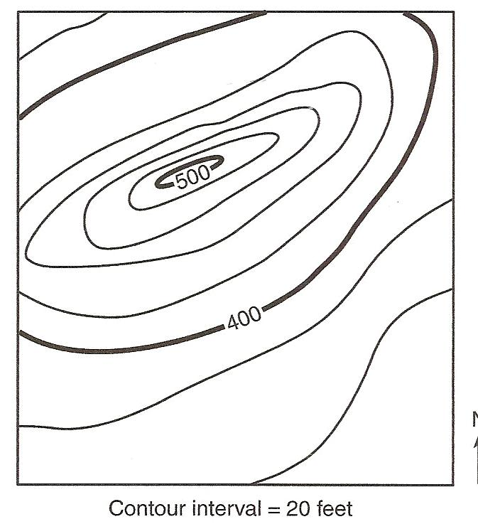
1. This map is a hill. What two elevations are labeled?
___________________
2. The elevations lines without numbers can be determined by knowing the contour interval. What is the contour interval on this map? ___________
3. Label the contour lines with their elevations.
4. It is important to know that when the contour lines

are close together, the land is steep. When the contour lines are far apart the slope of the land is less steep. Place an X where on the map where the land is steepest.
5. Place a Y on the map where an elevation of 430 ft. could be located.

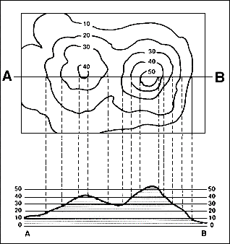
The diagram shows how a topographic map is related to the shape of the land.

Answer the questions below.

1. Which is higher, hill A or hill B? ____________
2. Which hill is steeper, hill A or hill B? ________
3. What is the contour interval of this map? ______
4. How tall is hill A? _______________________
5. How tall is hill B? ________________________
6. The bottom part of the map – the side view- shows hill B taller than 50 feet. Why isn’t this shown on the topographic map? _______________

A key, or legend, accompanies a map. Look at the key below and label what you see on the map.
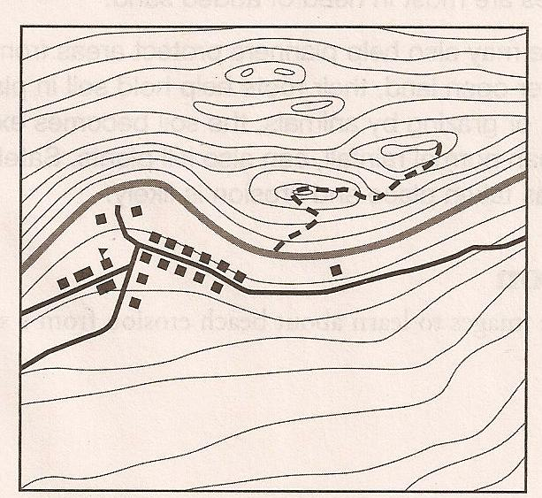
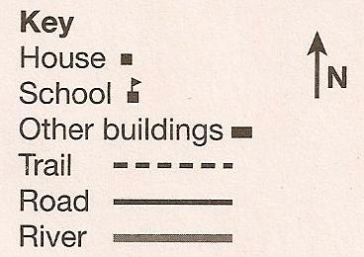

Questions:

1. How many houses are on this map? ___________
2. How many other buildings? _________________
3. Is the trail north or south of the river? _________
4. Is the steeper land north or south of the river? _____
5. How do you know? __________________________
6. If you were walking on the trail what type of land would
you expect to see? _____________________________
7. What leads you to this conclusion? ______________________________________________
Match the following pictures with their topographic maps. State two reasons why you think that map matches that picture.
Picture | Map | Reasons
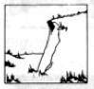
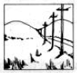
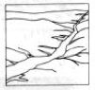

Materials: 1 topographic map per student, 1 foam craft sheet 6” x 8” per student, scissors, glue, pin per table

What To Do:
1. Each member of your table will be given a different topographic map and a different color of foam sheet to cut.
2. Make a red dot near the middle of your map. If you have two high areas place a red dot in the middle of both.
3. Cut along the 0 m elevation line on your topographic map sheet.
4. Place this close to the edge of your foam sheet and trace around the lines.
5. Make a pinhole through the red dot and into the foam.
6. Cut along the 20 m elevation line on your topographic map and then place this very close to the first drawing on the foam.
7. Trace around the lines and make another pinhole through the red dot.
8. Continue until you have all the contour lines traced on your foam sheet.
9. Cut out each piece of the foam sheet and use the pinholes to line up all the pieces correctly.
10. Observe all the members of your table’s 3-D maps.

Identify which 3-D map matches the diagram below.
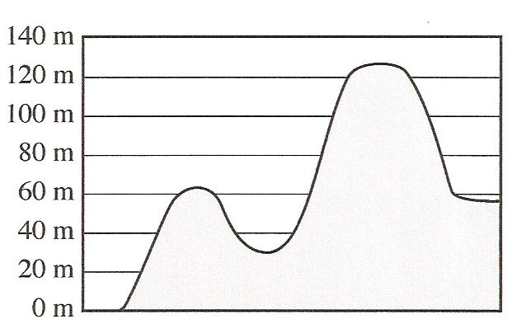

Topographic Map Match

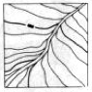
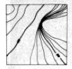
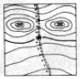

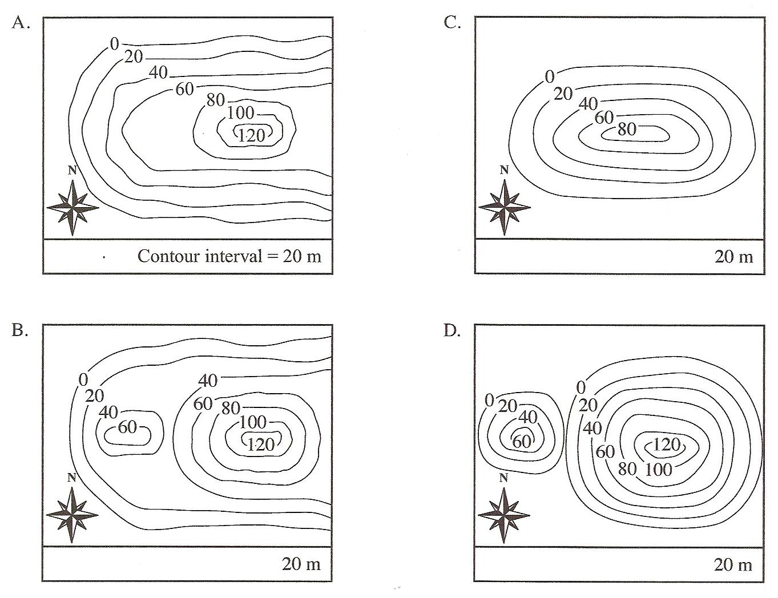

Name ___________________ period _____

EXIT TICKET
Topographic Maps

1. What does it mean when a topographic map shows contour lines far apart?
A. The land is steeply sloped
B. A river runs through the area
C. The land is nearly flat

2. Which of the statements about contour lines is false?
A. Contour lines never cross
B. Contour lines show elevation above sea level
C. Contour lines always have the same space
between them.
Write the letter of the profile that matches the topographic map in the box.
3. _____  4. _____  5. _____  6. _____  7.______  8.______ | 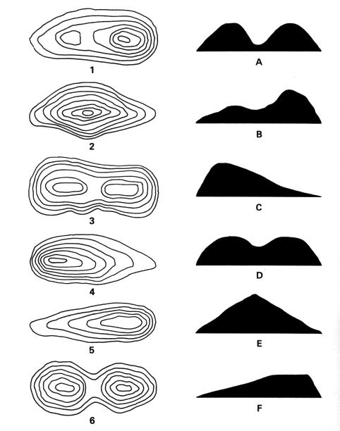

Name ___________________ period _____
EXIT TICKET
Topographic Maps
Write the letter of the profile that matches the
topographic map in the box.
1. _____

2. _____

3. _____

4. _____

5.______

6.______

7. What does it mean when a topographic map shows contour lines far apart?
A. The land is steeply sloped
B. A river runs through the area
C. The land is nearly flat

8. Which of the statements about contour lines is false?
A. Contour lines never cross
B. Contour lines show elevation above sea level
C. Contour lines always have the same space between
them

