Using Satellite Imagery

Satellite imagery is made of pictures of Earth and other planets collected by satellites. Governments and businesses around the world operate imaging satellites. We use satellite imagery when we use apps such as Google Earth and Google Maps.

The first satellite pictures of Earth were made in 1959. The first satellite pictures of the Moon were also taken in 1959 by a Russian satellite. In 1972 a very famous picture was taken of Earth from the Apollo 17 spacecraft. It is called The Blue Marble. It is one of the most reproduced images in the world.

Satellite images have many applications in weather, oceanography, geology, map making and intelligence. Images can be seen in natural colors and in other spectra.

Geologists and other scientists study before and after pictures to determine how weathering and erosion affect an area.

In September of 2006 Hurricane Ike hit the Texas Gulf Coast near Galveston. From the coast to over 15 km inland, salt water from the storm surge saturated the soil. Most residents of Galveston had evacuated before the hurricane and when they were allowed to return three weeks later they found their houses in ruins or no houses left at all.

Take a look at the pictures in the presentation your teacher shows you and answer the questions on the next page.

**Questions:**

**Blue Marble**

1. Name three major things you can observe in this picture.

______________________________________________

______________________________________________

2. What continents do you observe?

_____________________________________________

3. Why do you think this is such a famous picture?

______________________________________________

**Galveston, TX photographs**

1. How do we know these are pictures from the same area? _______________________________________

2. What two geologic processes did the storm surge cause?_______________________________________

3. What evidence leads you to believe this?

_____________________________________________

**Galveston, TX from satellite**

1. What surface features let you know these are pictures from the same area? ____________________________

2. What do you predict will happen to the land around the various bodies of water with little vegetation? _________

______________________________________________

3. The area known as High Island still has vegetation (pink). Why do you think this is so? ________________

______________________________________________

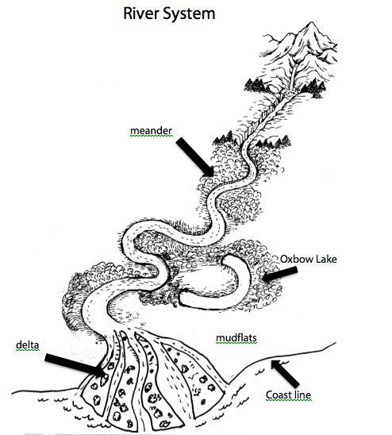

river channel

Scientists have been searching for life on other planets of our solar system. One ingredient needed for life is water. Scientists believe that for life to exist a planet must have water so they look for evidence of water on other planets.

**Materials:** Laminated color picture of river system, vis-à-vis marker

**What To Do:**

1. On the next page is a labeled diagram of a river system.
2. Identify each of the landforms by how they were created.
3. Label them erosion or deposition.
4. Your teacher will give you a color picture of a river system that is either laminated or in a sheet protector.
5. Identify the landforms in the color picture from the labeled diagram. Label them with a marker.
6. Next your teacher will give you a satellite image of an area of Mars taken by NASA”s Mars Reconnaissance Orbiter.
7. Identify and label as many landforms as possible on the picture of Mars.

**Questions:**

1. What landforms were you able to find on the picture of Mars? __________________________________
2. What evidence do you observe that there is a delta in this picture of Mars? __________________________
3. When rivers go across flat land they make curves called meanders. What evidence do you observe that tells you this land area is flat? ___________________________
4. If liquid water was available on Mars predict which of the landforms would be weathered first. ___________
5. Explain your thinking. _________________________

_______________________________________________

Name ______________________ period ______

EXIT TICKET

*Using Satellite Imagery*

The satellite photo below shows San Francisco, California, which has many miles of coastline and an inland bay.

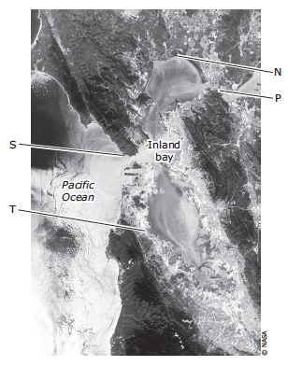

1. Which area of the coastline has most likely experienced the least erosion from waves over hundreds of years?

A. Area N B. Area P

C. Area S D. Area T

2. Which area of the coastline has most likely experience the greatest erosion from waves over hundreds of years?

A. Area N B. Area P

C. Area S D. Area T

Name ______________________ period ______

EXIT TICKET

Using Satellite Imagery

The satellite photo below shows San Francisco, California, which has many miles of coastline and an inland bay.



1. Which area of the coastline has most likely experienced the greatest erosion from waves over hundreds of years?

A. Area N B. Area P

C. Area S D. Area T

2. Which area of the coastline has most likely experience the least erosion from waves over hundreds of years?

A. Area N B. Area P

C. Area S D. Area T