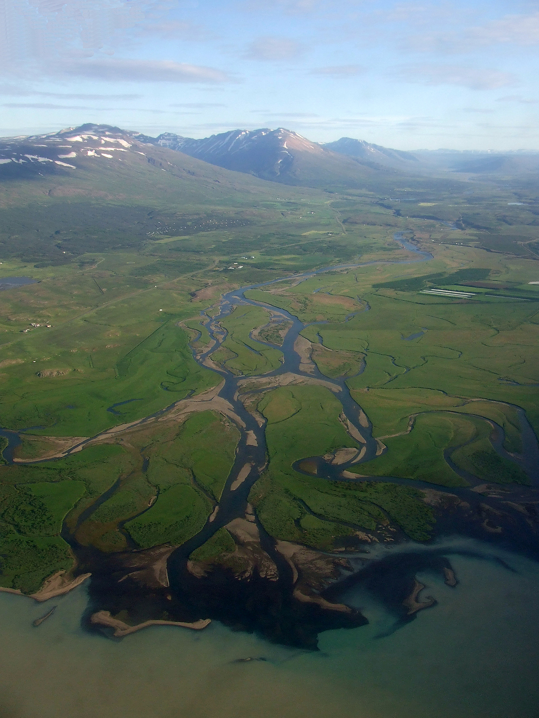
River System

A color-enhanced image of landforms in Jezero Crater. The large round features are impact craters from asteroids hitting Mars.
