Freshwater Ecosystem

  Bacteria | 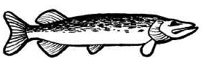  Northern Pike
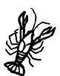  Crayfish |   Frog
  Larvae | Blue Gill
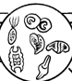  Phytoplankton | 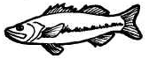  Trout
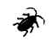  Water Beetle | 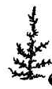Water Plant
  Water Snail | 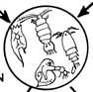  Zooplankton
FYI – Phytoplankton is a producer and is eaten by small animals and Zooplankton. Smaller animals eat zooplankton.

