Terrestrial Ecosystem
Temperate Deciduous Forest

Predict what each organism below will eat. Make several food chains and combine them into a food web.

Remember the Rules of Food Chains/Webs.

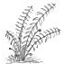Fern | 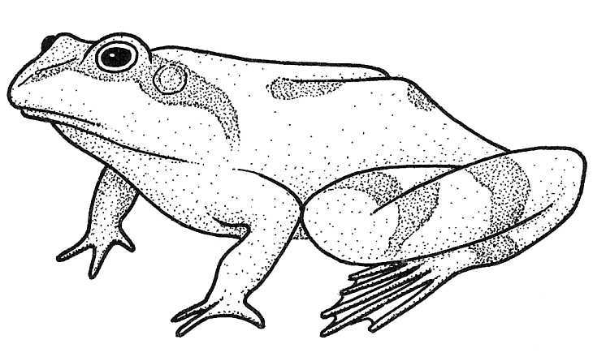  Frog | 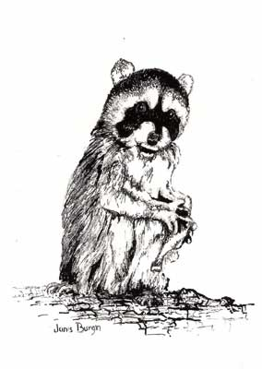Raccoon
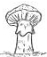Mushroom | 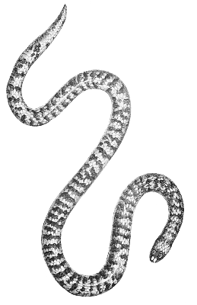  Snake | 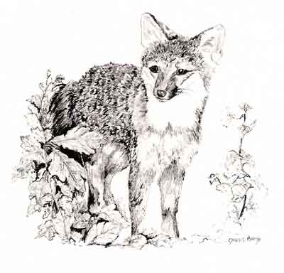Fox
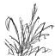Grass | 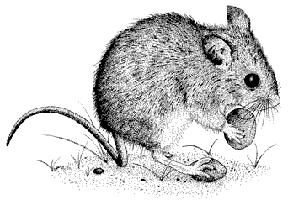  Mouse | 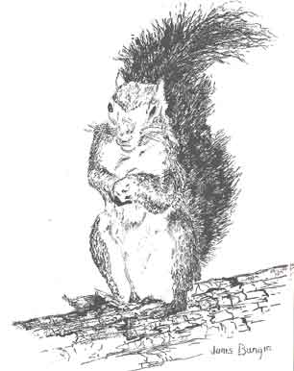Squirrel
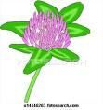Clover | Rabbit | 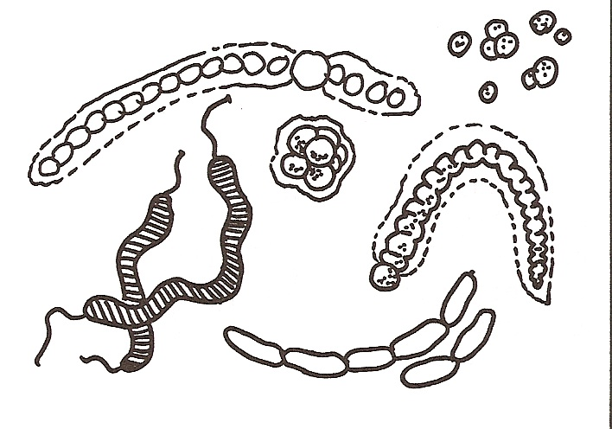  Bacteria
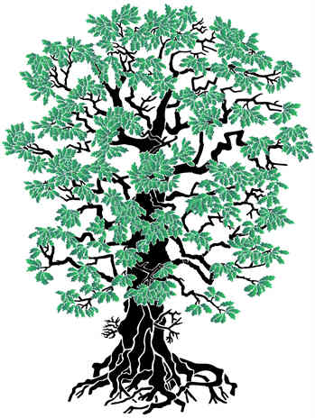  Oak tree | 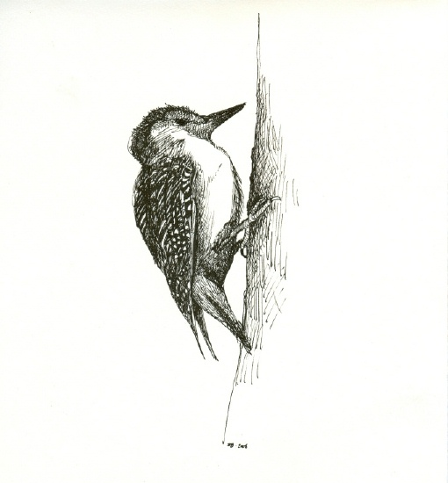  Woodpecker | 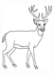Deer

Terrestrial Ecosystem
Desert
Predict what each organism below will eat. Make several food chains and combine them into a food web.
Remember the Rules of Food Chains/Webs.

  Desert Mallow | 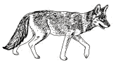  Coyote | 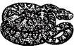  Mojave Rattlesnake
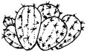  Prickly Pear Cactus | 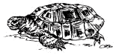  Desert Tortoise | 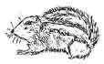  Squirrel
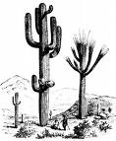  Saguaro Cactus | 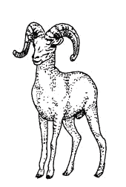  Big Horn Sheep | 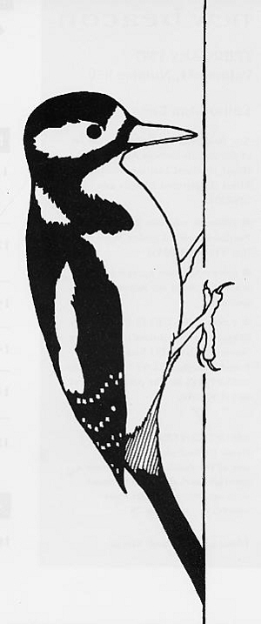Woodpecker
Bacteria | 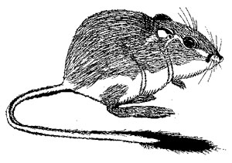  Kangaroo Rat | 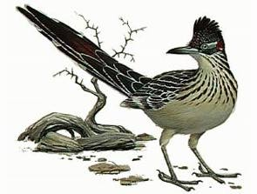  Roadrunner
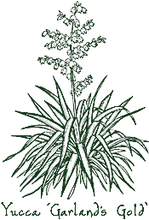Yucca | 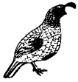  Quail | 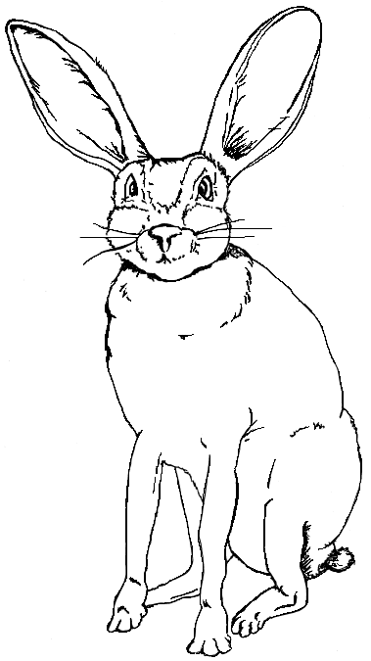  Jack Rabbit

Terrestrial Ecosystem
Tropical Rain Forest
Predict what each organism below will eat. Make several food chains and combine them into a food web.

Remember the Rules of Food Chains/Webs.

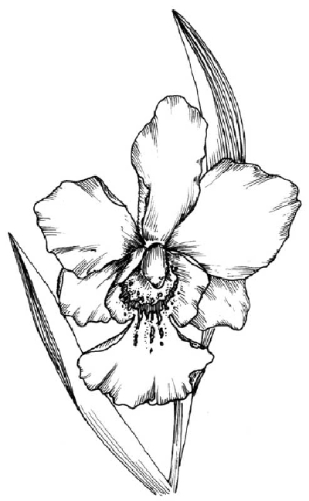Orchid | 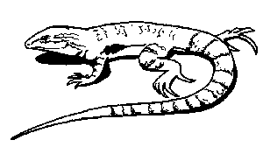  Lizard | 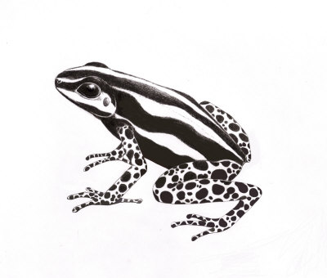  Poison dart frog
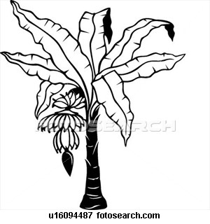  Banana tree | 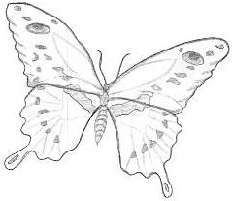  Butterfly | 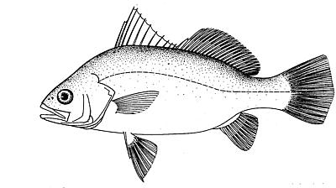  Fish
  Mangrove tree | 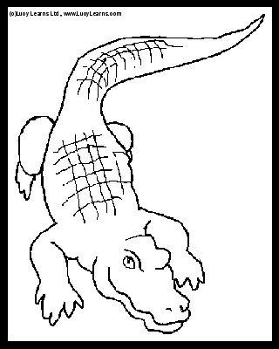  Alligator | 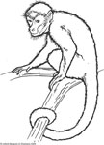  Spider monkey
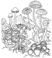  Mushrooms | 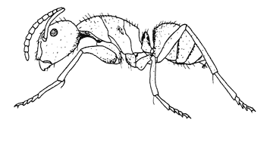Ant | 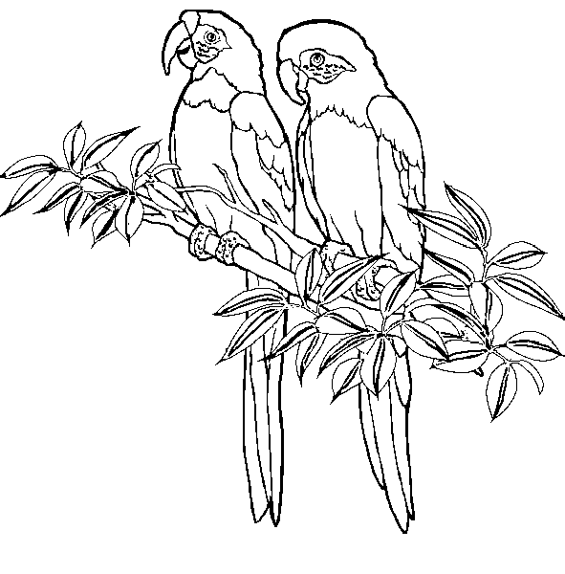  Parrot
Fern | 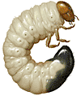Grub | 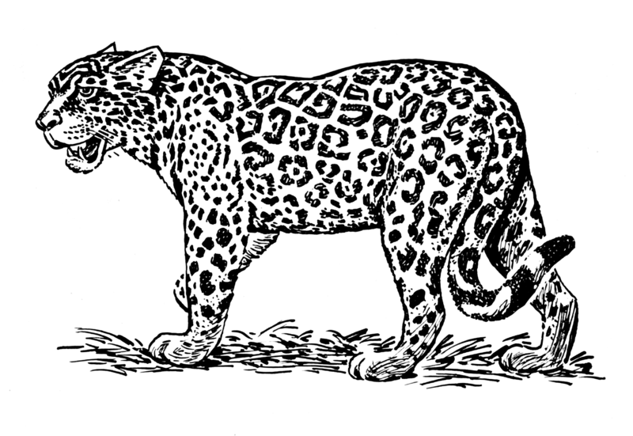  Jaguar

Terrestrial Ecosystem
Tundra
Predict what each organism below will eat. Make several food chains and combine them into a food web.

Remember the Rules of Food Chains/Webs.

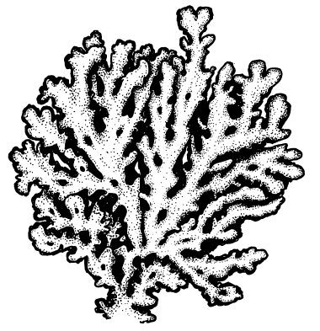  lichen | 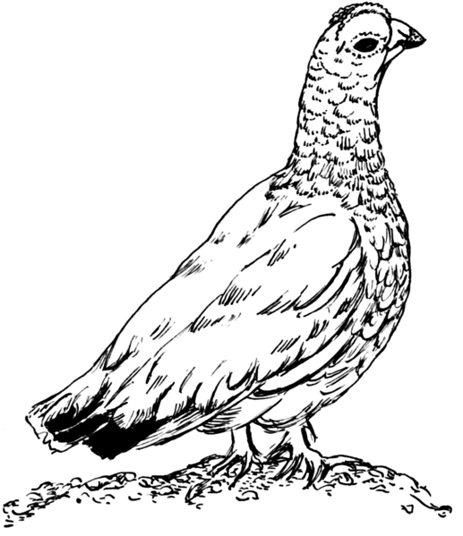  ptarmigan | 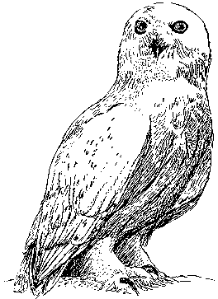  Snowy owl
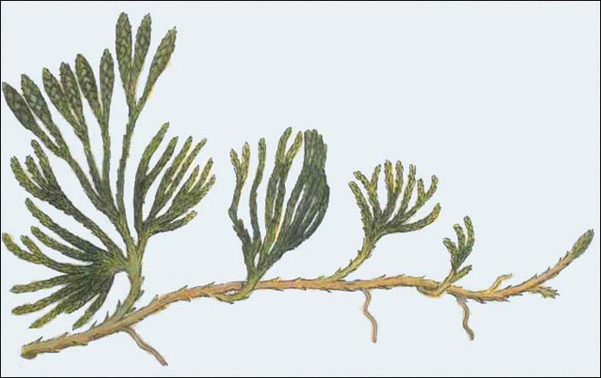  arctic willow | 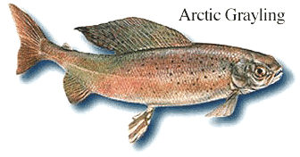  arctic greyling | Bighorn sheep
  arctic poppy | 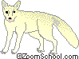  arctic fox | 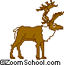  Caribou
mushroom | 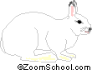  arctic hare | 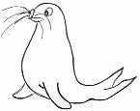  seal
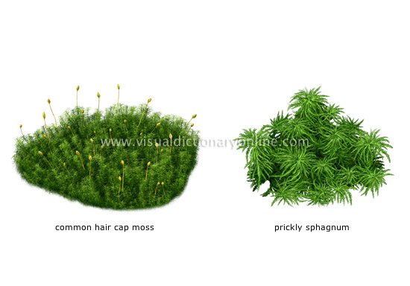  mosses | 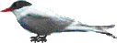  arctic tern | 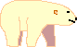  polar bear

