Parasites and Hosts

In the relationship called parasitism, one organism benefits, and the other is harmed. The organism that benefits is called the parasite. The other organism is called the host. Parasites live on or in their hosts.
Most parasites use the host as a source of food. They feed off the host and may weaken it. So of these parasites live inside the hosts’ body. For example, tapeworms are parasites that live in the intestines of other organisms. Although a parasite takes food from its host, it rarely kills the host. This is important because if the parasite killed the host, the parasite would die, too.
People who study parasites classify them into two broad groups: parasites that live inside their host and parasites that live outside. Parasites living inside their host are called endoparasites. Endoparasites are divided into two large groups: protozoans (microscopic single-celled animals) and worms. Parasites that live outside their hosts are called ectoparasites. Ectoparasites are divided into several large groups: mites, ticks, mosquitoes, leeches and flies.

What To Do:
1. Read the Parasite Mysteries and determine which of the Clue Cards goes with each mystery.
2. Cut them out and glue them in the question boxes below each mystery.
3. Use the parasite I.D. cards to determine which of the parasites is described in the mystery and glue it in by folding it on the middle line and gluing just the bottom side.
4. Add at least one of the “left over” parasites to each of your food webs and fill in the boxes on the back of the food webs.

Solve the Parasite Mysteries
1. Ryan and Daniel went on a camping trip with their family. They discovered while eating lunch they have forgotten to bring something to drink. They decided to drink the water out of the trout stream. Several weeks later Daniel began complaining of severe stomachaches and diarrhea. They went to the doctor and were told they both had parasites in their feces.

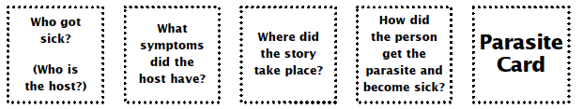

2. Kelly’s parents took her to San Francisco for her birthday. After a full day of shopping they went to a sushi restaurant. All of her family ordered cooked fish but Kelly decided to try the sushi. The next evening Kelly got a terrible stomach ache. The doctor diagnosed Kelly with a parasite infection.

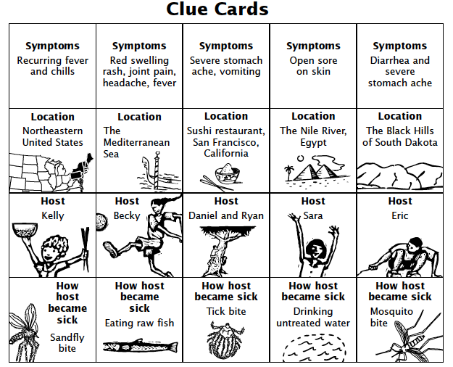
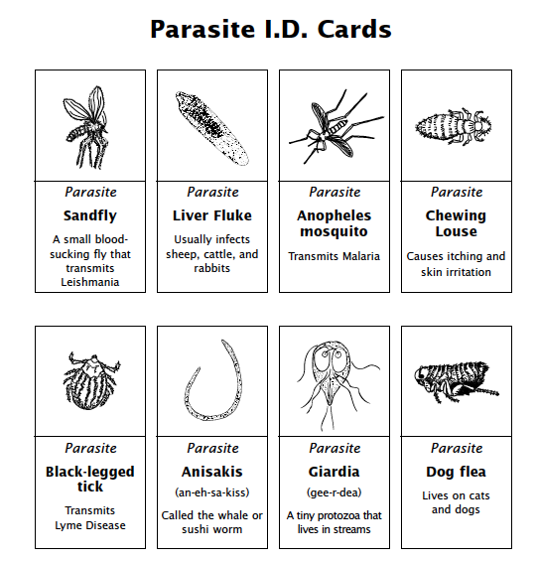
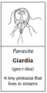
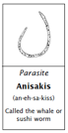

3. Eric and his father were on a Mediterranean cruise when they decided to add an overland hiking trip. They slept in a sandy area in sleeping bags under the stars – no tent. That night Eric awoke to the sound of a fly buzzing around his head and felt a stinging sensation around his mouth. When they returned home he noticed a big sore around his mouth. His parents took him to the doctor and found he had a parasitic infection.

4. Sara and her family traveled to Egypt during summer vacation. They took a boat trip down the Nile River. One night they slept out on the deck of the boat. When they woke up they found they had many insect bites. Sara became ill with fever and chills. Then they went away. A few days later Sara became ill again.

Questions:

1. Which two diseases were caused by ectoparasites?
__________________________________________

2. Which two diseases were caused by endoparasites?
___________________________________________

\

Name ____________________ period _____
EXIT TICKET
Parasites and Hosts

1. In the relationship called parasitism which of the
organisms benefits?

A. parasite B. Host

2. In the relationship called parasitism which of the
organisms is harmed?

A. parasite B. Host

3. How do most parasites use the host?

A. As a playground
B. Has a source for food
D. As a landing spot

4. What are parasites that live inside the host called?

A. endoparasites B. ectoparasites

5. What are parasites that live outside the host called?

A. endoparasites B. ectoparasites

Name ____________________ period _____
EXIT TICKET
Parasites and Hosts

1. What are parasites that live inside the host called?

A. endoparasites B. ectoparasites

2. What are parasites that live outside the host called?

A. endoparasites B. ectoparasites

3. In the relationship called parasitism which of the organisms benefits?

A. parasite B. Host

4. In the relationship called parasitism which of the organisms is harmed?

A. parasite B. Host

5. How do most parasites use the host?

A. As a playground
B. Has a source for food
D. As a landing spot

