Competition –Another Relationship
Within ecosystems of any kind, from forests to open plains to coral reefs, some of the resources that support survival and growth are limited. Nature is an amazing thing. It has the ability to regulate itself in order to promote a healthy habitat for all living things. In order to maintain a healthy environment nature has a natural cycle of population increases and decreases.
If a population becomes too crowded the plants or animals must compete for the resources (food, water shelter and space) available. This creates an unhealthy environment, which causes the plants and/or animals to suffer.
Access to sunlight is important for plants; such as in forests with canopies that block out sunlight from reaching the ground and limited water causes plants to grow long roots. Competition occurs when many organisms within an ecosystem want to use the same resources and there isn't enough to go around.
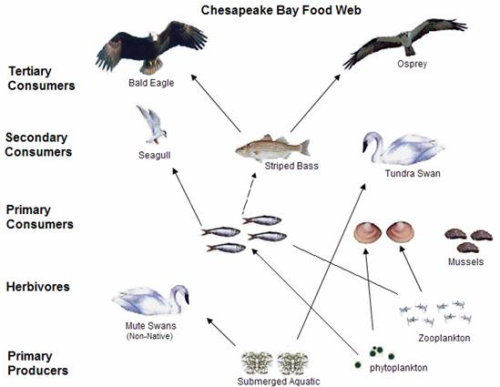

Look at the Food Web and answer the questions below

1. What animals are competing for Phytoplankton and Zooplankton? ___________

2. What animals are competing for submerged aquatic plants? __________________________
3. What animals are competing for the striped bass? _______________________________________

In the rainforest, many plants compete for sunlight. For example, strangler fig seedlings begin growing on other trees, itself around the host tree.

Watch the David Attenborough’s BBC video on strangler figs from youtube.com.
On the lines below tell how the strangler fig competes for sunlight.

Materials: brown paper lunch bag, Fruit Loops cereal, plastic zip-lock bag, timer/watch with second hand
What To Do:
1. You will be conducting two tests to compare interactions in ecosystems without competition to interactions in ecosystems with competition.
2. You teacher will bring a brown lunch bag that is filled with Fruit Loops cereal.
3. One student from each group will reach into the bag without looking and carefully remove a handful of cereal.
4. Count the number of each color drawn from the bag and record the information in the data table below under “Without Competition.” Do not count broken or crushed pieces.
5. Place the cereal back inside the bag.
6. Your teacher will take you outside to a grassy area and scatter all of the cereal.
7. You will be give a plastic zip-lock bag for your collection.
8. You will have one minute to collect the resources from the environment. Do not push or take resources from other students.
9. Return to the classroom and count your cereal.
10. Combine your numbers with your group and place them in the data table under “With Competition.”
11. Make a double bar graph of your information on the next page. Make a key.

 | Blue | Orange | Green | Red | Yellow | Purple
Without
Competition
With competition

Resources
Blue-water
Orange- shelter
Yellow -sunlight
Green - food
Red - nutrients
Purple - space

Use the information in the box for each resource and answer the following questions.

Questions:
1. Compare the without competition and the with competition numbers. What differences do you see? _______________
_______________________________________

2. Which resource is needed most by plants? ___
3. Which resource is needed most by animals? _______________________________________
4. What happens if there is not enough of this resource? _______________________________

Name ___________________ period _____
EXIT TICKET
Competition
1. Black walnut trees produce a nontoxic chemical that becomes highly toxic when it is exposed to air or soil. How does this chemical help black walnut trees compete with plants growing nearby?

A. By attracting herbivores to the other plants
B. By suppressing the growth of the other plants.
C. By limiting the amount of water to other plants

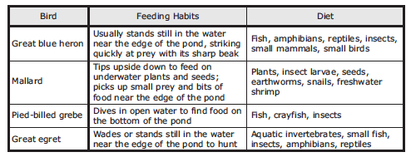

2. Which of the birds in the chart above will compete with each other?

A. The Great Blue Heron and the Mallard
B. The Great Blue Heron and the Pied-bill grebe
C. The Great Blue Heron and the Great egret

3. What resource are they in direct completion for?

A. Food
B. Space
C. Water

Name ____________________ period ____

EXIT TICKET
Competition

1. Which of the birds in the chart above will compete with each other?

A. The Great Blue Heron and the Mallard
B. The Great Blue Heron and the Pied-bill grebe
C. The Great Blue Heron and the Great egret

2. What resource are they in direct completion for?

A. Food
B. Space
C. Water

3. Black walnut trees produce a nontoxic chemical that becomes highly toxic when it is exposed to air or soil. How does this chemical help black walnut trees compete with plants growing nearby?

A. By attracting herbivores to the other plants
B. By suppressing the growth of the other plants.
C. By limiting the amount of water to other plants

