Measures of Science

Imagine a world where we did not know the boiling point of water. What if we could not record growth of plants and animals? How would you know the weekend had begun if you could not keep count of days, weeks and months? Measurement has been an important part of our lives for centuries, and it is the reason that scientists are able to compare objects and events quantitatively. Scientists rely on measuring to describe comparisons numerically by using standard tools.
Before standard tools like rulers, clocks and scales, people used everyday objects to help find measurements or quantities of other objects. Today scientists use various tools like rulers, graduated cylinders and balances to measure in metric units. Graduated cylinders are used to measure the volume of small objects in milliliters. Balances and scales can be used to measure the mass of objects in grams. Scientists also use thermometers to measure changes in the earth's temperature over time in degrees Celsius (ºC) and rulers and meter sticks are used to measure length in centimeters and meters.

Materials: triple beam balance, double pan balance,
electronic scale, lab thermometer, short thermometer,
metric ruler, meter stick, yard stick,
various sizes of graduated cylinders

What To Do:
1. You teacher has set up 4 stations around the room.
2. Your group will visit each station and observe the
science measuring tools located there.
3. Look at the tools and answer the questions for each station.

Station 1 - Balances and Scales
Questions:
1. What is the unit used on the triple beam balance? _____
2. What is the range of numbers on the first beam? ______
3. What is the range of numbers on the second beam? _____
4. What is the range of numbers on the third beam? _______
5. What is the unit used on the double pan balance? _______
6. What is the range of numbers on the beam? __________
7. What happens to either balance when one of the riders
is moved? ____________________________________
8. Go as a team to the teacher’s desk and observe the
electronic scale. What are the units used? ___________

Station 2 - Thermometers
Questions:
1. What unit(s) are used on the short thermometer? ______
2. What unit(s) are used on the long thermometer? _______
3. What is the highest number on the short thermometer? ___
4. What is the lowest number on the short thermometer? ____
5. What is the highest number on the long thermometer? ___
6. What is the lowest number on the long thermometer? ___

Station 3 - Ruler, Meter Stick and Yard Stick
Questions:
1. What metric units do you find on the ruler? ____________
2. What is the range of numbers on the metric ruler? _______
3. What units do you find on the meter stick? ___________
4. What is the range of numbers on the meter stick? ______
5. What units do you find on the yardstick? ____________
6. What is the range of numbers on the yardstick? ________
7. Which is longer the meter stick or the yardstick? ______

Station 4 - Graduated Cylinders
Questions:
1. What unit do you find on the graduated cylinders? ______
2. What is the range of numbers on the large graduated cylinder? ________
3. What is the range of numbers on the small graduated cylinder? _______
4. How many milliliters does each line represent on the large graduated cylinder? _______
5. How many milliliters does each line represent on the small graduated cylinder? _______

What To Do:
1. In the reading below find the definitions of the
following words: Length, volume, mass and
temperature.
2. Color code the definitions with the following colors
Length – red, volume – yellow, mass – blue,
temperature - green

Length, or the distance between two points, can be measured using tools such as rulers, yardsticks and meter sticks. In science lab, we will generally use the units of
meters (m), centimeters (cm), and millimeters (mm) when measuring length.
Volume is the physical property that measures the amount of space an object takes up. A graduated cylinder is used to measure the volume of liquids in milliliters (mL).
Mass is another important physical property that requires measurement with a tool. The double pan balance or the triple beam balance measures mass or the amount of matter in an object. When measuring mass, we will use the unit of grams (g).
A thermometer measures the property of temperature.
Temperature is the average heat energy of the particles
found in the substance. We use (ºC) degrees Celsius to
measure temperature in science.

DO NOT GLUE THIS PAGE!
Cut on the solid lines and fold on the dotted lines.

1. Write the name of each piece of equipment above the picture.
2. Write three things you learned about the equipment beneath the flap.

Glue to notebook | 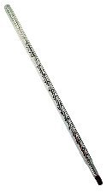 | 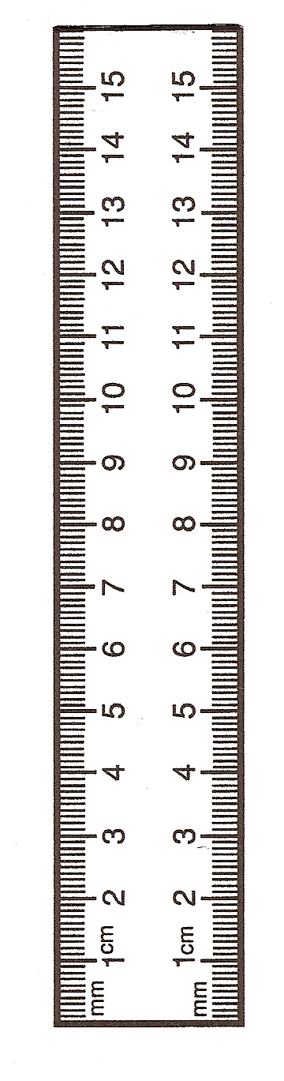 | Glue to notebook
 | 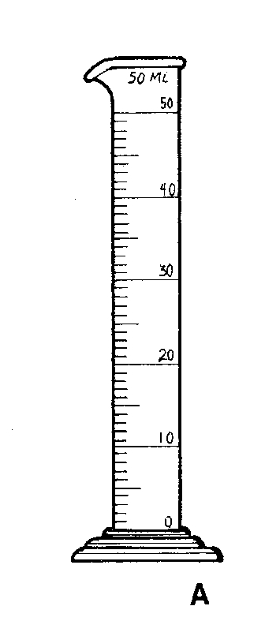 | 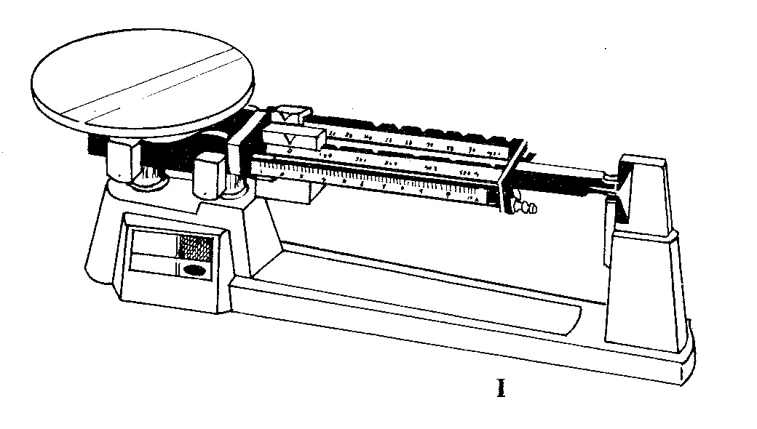

Name ____________________ period _____
Exit Ticket
Measures of Science
What is it? ______________________
What does it measure? _____________
What units? ___________________

What is it? ______________________
What does it measure? _____________
What units? ___________________

What is it? ______________________
What does it measure? _____________
What units? ___________________

What is it? ______________________
What does it measure? _____________
What units? ___________________

Name ____________________ period _____
Exit Ticket
Measures of Science
What is it? ______________________
What does it measure? _____________
What units? ___________________

What is it? ______________________
What does it measure? _____________
What units? ___________________

What is it? ______________________
What does it measure? _____________
What units? ___________________

What is it? ______________________
What does it measure? _____________
What units? ___________________

