Measuring Mass

Balances and scales are used in science to find the mass of an object. Mass measures the amount of matter in an object. Mass is different from weight because weight depends on gravity and mass does not. So when you fly in the Space Shuttle there is little gravity and you are almost weightless. You may have lost your weight but you did not lose your mass. Weight is measured in pounds and ounces, while mass is measured in grams.
In the science laboratory we use a triple beam
balance to measure mass. It has a pan to place the
object to be massed and three beams to calculate the mass. On the beams are movable objects called riders. On the right side is a pointer that tells you when the riders are balanced.

Use the words in the word bank to label the parts of the balance below.
Word Bank
Beams Riders Pan Pointer

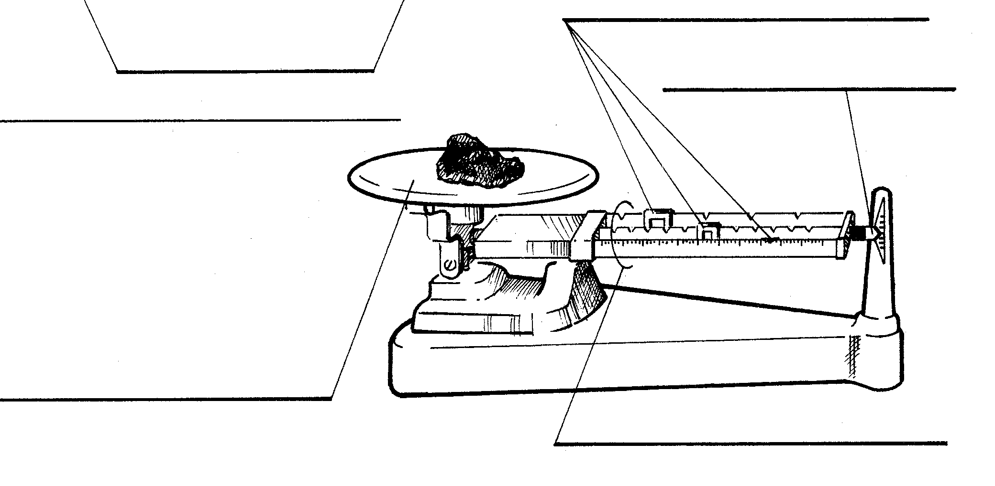

Materials: triple beam balance, pair of scissors, rock, block of wood, small graduated cylinder, notebook paper, beaker, plastic bottle, pencil, paper towel, pen
What To Do:
1. Before you start to measure anything with a balance
you must ZERO the balance.
2. To zero the balance you must do the following steps:
a. Make sure all riders are set on zero
b. Make sure nothing is on the pan
c. Make sure the pointer is pointing at the zero line.
3. If you have tried to zero your balance and it will not
zero, get the teacher to help you.

4. Find the mass of an object by doing the following
steps:
a. Place the object on the pan
b. Move the largest rider across the beam until the
pointer drops.
***Make sure the rider is pointing at a number - it
can’t be between numbers.
c. Then move this rider back one.
d. Move the next rider until the pointer goes down –
then move it back one space.
e. Move the smallest rider until the pointer is as the
zero line.
f. Add up all the riders to calculate the mass of the
object.

5. Find the mass of the objects listed below. Don’t forget
to write the unit for mass!

Object | Mass
1. Pair of scissors
2. Rock

Object | Mass
3. Block of wood
4. Small graduated cylinder
5. Piece of notebook paper
6. Beaker
7. Plastic bottle
8. Pencil
9. Paper towel
10. Pen

Directions: Sequence how to find the mass of an object by completing the following:

1. In the beginning ____________________________
____________________________________________.

2. Then you must ____________________________
____________________________________________.

3. Next you should ____________________________
____________________________________________.

4. After that you should _______________________
____________________________________________.

5. Finally you should ____________________________
____________________________________________.

Directions:
1. Watch the video “The Elephant Mass Song” from www.missdoctorbailer.com
2. Place the items that are listed in the song in the correct boxes.

Larger Mass

Elephant | 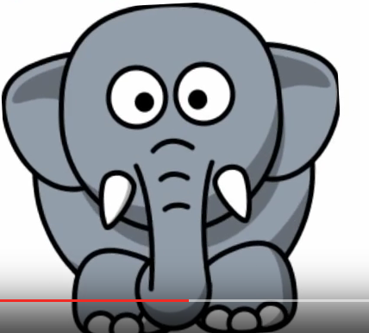
Smaller Mass

Exit Ticket

Measuring Mass

1. What is wrong with this measurement? 14 ¼ g. ____________________________________
2. What is wrong with this measurement? 234 _____________________________________
A
D
C
B

3. Which letter is pointing to the riders? ___________
4. Which letter is pointing to the pan? ______________
5. Which letter is pointing to the beams? ___________

Conclusion: ( triple beam balance, mass, weight, weightless, gram,)
In the science laboratory the amount of matter in an object is known as its ________. The unit for mass is _______. The instrument we use to measure mass is the _______ _______ _________. The pull of gravity determines an object’s ________. In space someone can be come ____________ but will not lose their mass.

Exit Ticket

Measuring Mass

1. What is wrong with this measurement? 14 ¼ g. ____________________________________
2. What is wrong with this measurement? 234 _____________________________________
A
D
C
B

3. Which letter is pointing to the riders? ___________
4. Which letter is pointing to the pan? ______________
5. Which letter is pointing to the beams? ___________

Conclusion: ( triple beam balance, mass, weight, weightless, gram,)
In the science laboratory the amount of matter in an object is known as its ________. The unit for mass is _______. The instrument we use to measure mass is the _______ _______ _________. The pull of gravity determines an object’s ________. In space someone can be come ____________ but will not lose their mass.

