Taking Temperature

Thermometers are useful in our daily life. They tell us if it is hot or cold outside and that tells us what type of clothing to wear. In the science laboratory we use laboratory thermometers. These thermometers typically more accurate than the ones we have at home.
Many thermometers use mercury in a glass chamber. Mercury is an element that is silver in color and is liquid at normal temperatures. It is very sensitive to heat and cold. However, many thermometers today may have different substances in them because if mercury gets into your body it can cause long term nerve damage. So the thermometers we use have what many refer to as “spirit thermometers.” The spirit is methyl alcohol and is colored red.
Laboratory thermometers have a major difference than the ones we have at home. The thermometers that are used to take your temperature from the mouth have a constriction in the chamber that does not allow the mercury to go back down without shaking it. Laboratory thermometers do not have a constriction so the second you take the thermometer out of the substance you are measuring, it changes temperature.
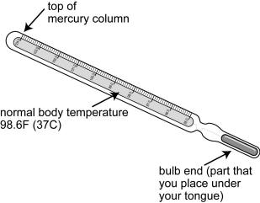
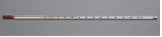
Laboratory Thermometer
Household Thermometer

Materials: beaker of water, cup of hot water, cup of ice water, laboratory thermometers

What To Do:
1. Observe the thermometer and determine where the top of the alcohol is located.
2. Place the thermometer in each place listed below and leave it for at least 1 minute so it can adjust to the new temperature.
3. Find the temperature in ºC for each of the following items.
4. Don’t forget to write the unit next to each number.

Temperature
1. Room temperature tap water
2. Hot water
3. Room air
4. Top of your table
5. Ice water
6. Inside your fist
7. Shaded grassy area
8. Sunny grassy area
9. Shaded sidewalk
10. Sunny sidewalk

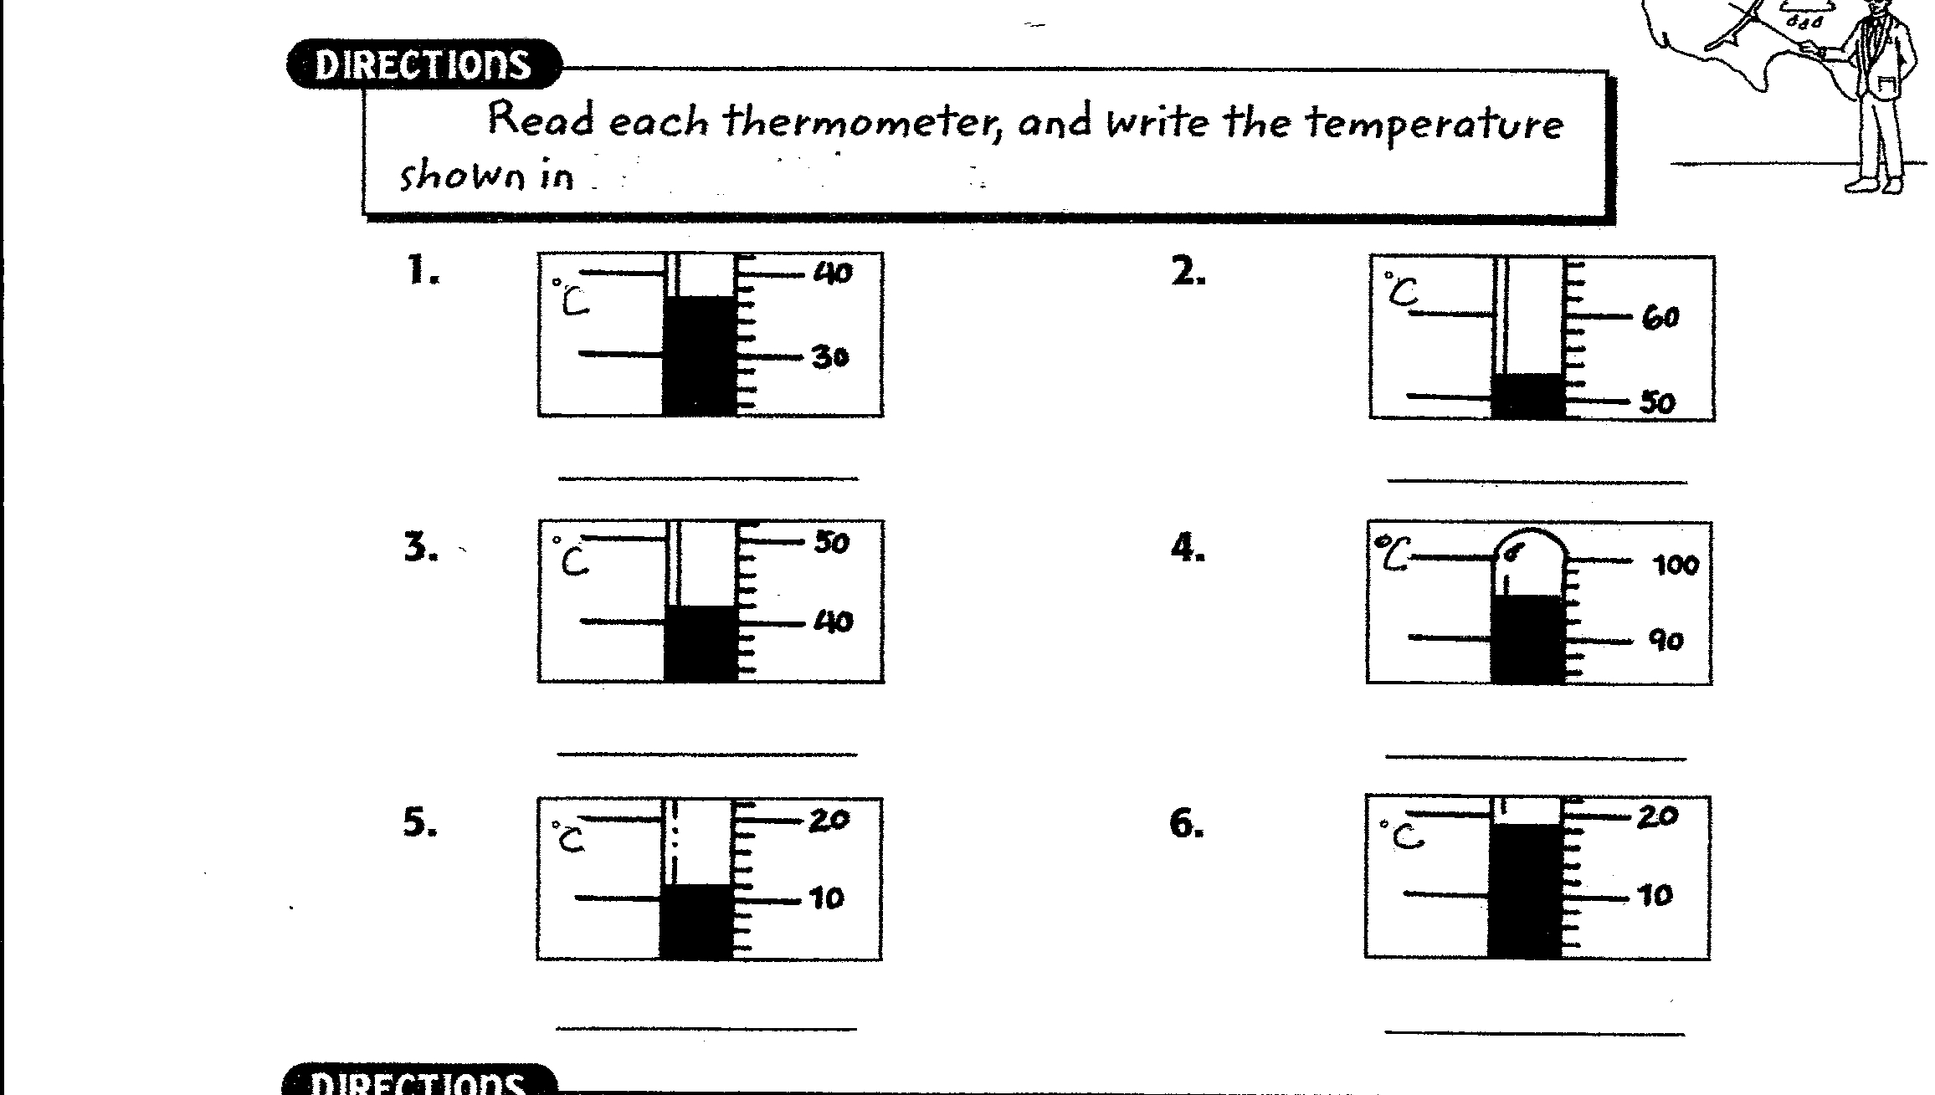

Questions:
1. What unit is use to indicate temperature in the metric system? ____________________________________
2. What substance is inside the laboratory thermometer? ___________________________________________
3. Why don’t we use mercury anymore? ___________________________________________

Directions:

1. Watch the video “Temperature Scales” from www.missdoctorbailer.com.
2. Answer the following questions.

Questions:
1. What scale is used by scientists? _________________
2. What is the Celsius scale base upon? _______________
______________________________________________
3. What is the freezing point of water on the Celsius scale?
________________________________________________
4. What is the boiling point of water on the Celsius scale?
________________________________________________
5. What scale do we use in the United States?
________________________________________________
6. What is the third temperature scale? ________________
7. What is the Kelvin scale base upon? ________________
8. What temperature is absolute zero? _________________
9. What happens at absolute zero? ___________________
________________________________________________
10. What temperature is freezing water on the Kelvin scale?
________________________________________________
11. What temperature is boiling water on the Kelvin scale?
________________________________________________

Name _________________ period _____

EXIT TICKET
Taking Temperature

1. What is wrong with this measurement? 87 ½ ºC

_________________________________________

2. What is wrong with this measurement? 34

_________________________________________

3. What is wrong with this measurement? 78 F

_________________________________________

4. What happens at 32ºF? ___________________
5. What happens at 212 ºF? ___________________
6. What happens at 0ºC? _____________________
7. What happens at 100ºC? ___________________

Conclusion: (accurate, constriction, thermometer)

When using a laboratory ___________ it is important to keep it inside the substance until it is read because it does not have a _____________. Laboratory thermometers are more __________ than the ones we have at home.

Name _________________ period _____

EXIT TICKET
Taking Temperature

1. What is wrong with this measurement? 87 ½ ºC

_________________________________________

2. What is wrong with this measurement? 34

_________________________________________

3. What is wrong with this measurement? 78 F

_________________________________________

4. What happens at 32ºF? ___________________
5. What happens at 212 ºF? ___________________
6. What happens at 0ºC? _____________________
7. What happens at 100ºC? ___________________

Conclusion: (accurate, constriction, thermometer)

When using a laboratory ___________ it is important to keep it inside the substance until it is read because it does not have a _____________. Laboratory thermometers are more __________ than the ones we have at home.

